Section 1.8 Absolute Value Equations and Inequalities

When solving an absolute value equation or inequality, it is necessary to first isolate the absolute value expression.

# Objective 1: Solving an Absolute Value Equation

The absolute value of a number *x*, written as , represents the **distance** from a number *x* to 0 on the number line. Consider the equation . To solve for *x*, we must find all values of *x* that are 5 units away from 0 on the number line. The two numbers that are 5 units away from 0 on the number line are  as shown in the figure below. Therefore, the solution set for  is .

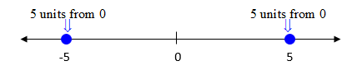

# Objective 2: Solving Absolute Value Inequalities

**Solving an Absolute Value “Less Than” Inequality**

The solution to the inequality consists of all values of *x* whose distance from 0 is less than 5 units on the number line. See the figure below.

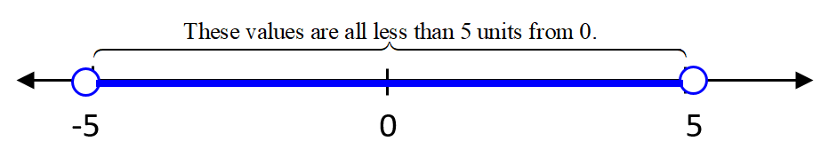

If , then  The solution set is in set builder notation or  in interval notation.

**Solving an Absolute Value “Greater Than” Inequality**

For the solution to the inequality, notice that we are now looking for all values of *x* that are more than 5 units away from 0. The solution is the set of all values of *x* greater than 5 combined with the set of all values of *x* less than -5. See the figure below.

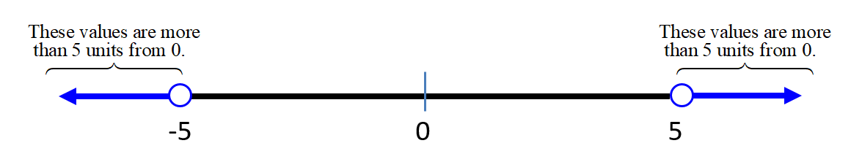

If , then . The solution set is in set builder notation or  in interval notation.

 is NOT equivalent to . In addition, a common error on this type of problem is to write  for the first inequality instead of . Think carefully about the meaning of the inequality before writing it.

**ABSOLUTE VALUE EQUATIONS AND INEQUALITY PROPERTIES**

Let *u* be an algebraic expression and let *c* be a real number such that, then:

1.  is equivalent to 

2.  is equivalent to 

3.  is equivalent to 