Section 10.1 Angle Measures of Polygons and Regular Polygon Tessellations

*Proofs of theorems and corollaries in this section are left as exercises.*

# Objective 1: Find the Measures of Interior Angles of Polygons

Polygons are named according to the number of sides they have:

|  |  |
| --- | --- |
| **Number of Sides** | **Name of Polygon** |
| 3 | triangle |
| 4 | quadrilateral |
| 5 | pentagon |
| 6 | hexagon |
| 7 | heptagon |
| 8 | octagon |
| 9 | nonagon |
| 10 | decagon |
| 12 | dodecagon |
| *n* | *n*-gon |

We know that the sum of the measures of the interior angles of a triangle is 180°. We have also used the fact that the sum of the measures of the interior angles of a quadrilateral is 360°,and we visualized this by drawing one diagonal inside the quadrilateral to show two triangles. We want to find a formula for the sum of the interior angles of any convex polygon. Draw a convex polygon with 5 sides. Then choose a vertex and draw all of the possible diagonals from that vertex. Make a note of the number of sides the polygon has, the number of triangles formed by drawing all diagonals from one vertex, and the sum of the measures of the angles of the polygon. Repeat this process, increasing the number of sides by one, and look for a pattern.

**Theorem: Polygon Interior Angle-Sum Theorem**

The sum of the measures of the interior angles of a convex *n*-gon is .

Recall that in a **regular polygon**, all sides are congruent and all interior angles are congruent.

**Corollary: Regular Polygon Interior Angle Corollary**

The measure of each interior angle of a regular *n*-gon is  or .

a. Find the sum of the measures of the interior angles of a 15-gon.

b. Find the missing angle measures.

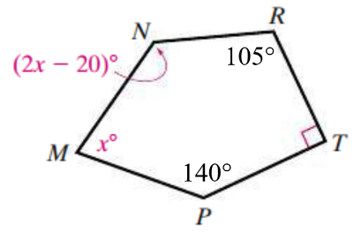

c. The sum of the interior angle measures of a polygon with *n* sides is 2880°. Find the value of *n*.

d. Find the measure of one interior angle in a regular dodecagon.

e. One interior angle of a polygon measures 165°. How many sides does the polygon have?

# Objective 2: Find the Measures of Exterior Angles of Polygons

We have previously studied the exterior angles of a triangle. We can extend our definition of exterior angle to any convex polygon. The angles that are adjacent to the interior angles of a convex polygon are the **exterior angles of the polygon**.

**Theorem: Polygon Exterior Angle-Sum Theorem**

The sum of the measures of the exterior angles of a convex polygon, one exterior angle at each vertex, is 360°.

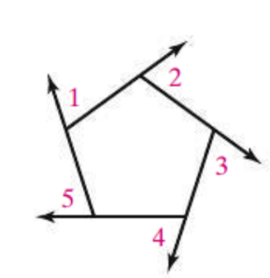

**Corollary: Regular Polygon Exterior Angle Corollary**

The measure of each interior angle of a regular *n*-gon is  or .

a. Find the measures of the exterior angles.

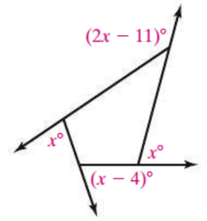

b. What is the measure of an exterior angle of a regular decagon?

c. The measure of an exterior angle of a regular polygon is 18°. Find the measure of an interior angle and the number of sides.

# Objective 3: Determine Whether a Tessellation of Regular Polygons Is Formed

A **tessellation**, or tiling, is a repeating pattern of figures that completely covers a plane without gaps or overlaps. Tessellations can be made with polygons or figures of your imagination. To form a tessellation of regular polygons, we make sure that the sum of the measures of the angles where the polygons meet is 360°.

a. Check the tiling, which is made of squares and equilateral triangles, to determine if there would be gaps or overlaps.

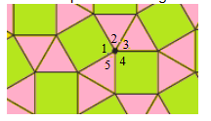

b. Does a regular hexagon tessellate a plane? Does a regular pentagon tessellate a plane?