Section 10.2 Areas of Triangles and Quadrilaterals

Recall that the **perimeter** *P* of a geometric figure is the distance around the figure. Perimeter is measured in units such as feet or meters.

**Area** is the number of square units a geometric figure encloses.

# Objective 1: Find Areas of Squares, Rectangles, Parallelograms, and Triangles

**Postulate: Area Congruence Postulate**

If two polygons are congruent, then their areas are the same.

**Postulate: Area Addition Postulate**

The area of a region is the sum of the areas of its nonoverlapping parts.

**Postulate: Area of a Square**

The area of a square is the square of its side length.



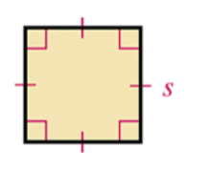

**Theorem: Area of a Rectangle**

The area of a rectangle is the product of its base and its height.



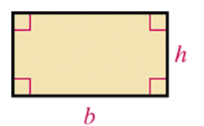

**Theorem: Area of a Parallelogram**

The area of a parallelogram is the product of a base and its corresponding height.



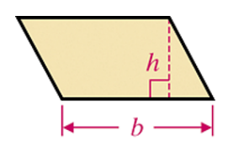

A **base of a parallelogram** can be any one of its sides. The corresponding **height** is the perpendicular distance from the side opposite the chosen base to the line containing the base.

**Theorem: Area of a Triangle**

The area of a triangle is half the product of a base and its corresponding height.



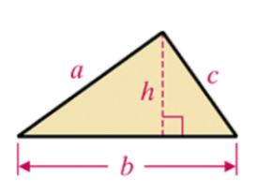

A **base of a triangle** can be any of its sides. The corresponding **height** is the length of the segment from the vertex opposite the chosen base perpendicular to the line containing that base.

a. Find the area of each figure. Figures are not drawn to scale.

i.

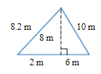

ii.

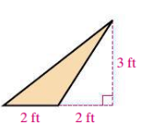

iii.

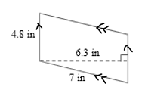

iv.

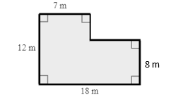

v.

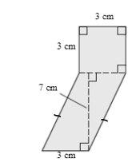

b. Graph the lines , , and . Then find the area of the triangle enclosed by the lines.

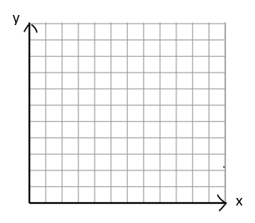

# Objective 2: Find the Areas of Trapezoids, Rhombuses, and Kites

**Theorem: Area of a Trapezoid**

The area of a trapezoid is half the product of the height and the sum of the bases.



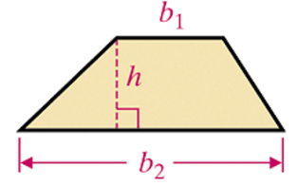

The **height** of a trapezoid is the perpendicular distance between the bases.

**Theorem: Area of a Rhombus or a Kite**

The area of a rhombus or a kite is half the product of the lengths of its diagonals.



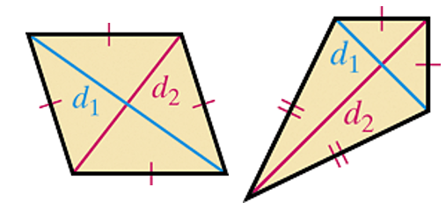

a. Find the area of each figure. Figures are not drawn to scale. If the answer is not a whole number, leave it in exact, simplified radical form.

i.

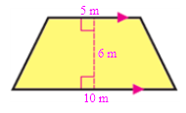

ii.

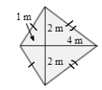

iii.

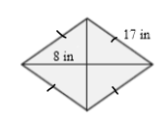

iv.

