Section 10.3 Areas of Regular Polygons

# Objective 1: Find the Area of a Regular Polygon

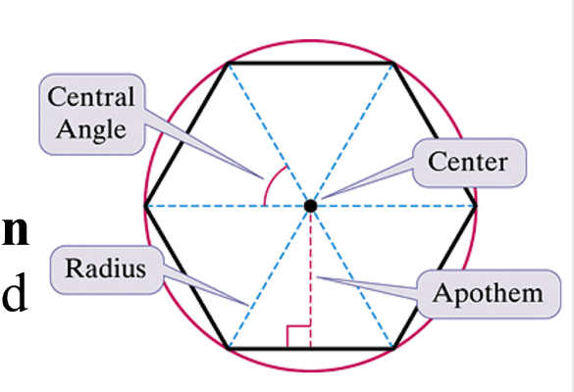

We can circumscribe a circle about any regular polygon. The **center of a regular polygon** is the center of the circumscribed circle. The **radius of a regular polygon** is the distance from the center to a vertex. The **apothem** is the perpendicular distance from the center to a side. A **central angle of a regular polygon** is an angle whose vertex is the center of the polygon and whose sides contain two consecutive radii. (Note that radii is the plural of radius.)

a. Find the measure of each numbered angle in the regular polygon.

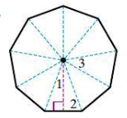

**Theorem: Area of a Regular Polygon**

The area of a regular polygon is half the product of the apothem, *a*, and the perimeter, *P*.



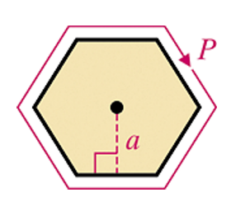

b. Find the exact area of a square with apothem  cm.

c. Find the exact area of a regular hexagon with side length 30 feet.

d. Find the exact area of an equilateral triangle with radius  cm.

# Objective 2: Find the Area of a Regular Polygon Using Trigonometric Ratios

a. Find the area of a regular decagon with radius 4 mm. Round to the nearest tenth of a square millimeter.

b. Find the area of a regular octagon with side length 18 cm. Round to the nearest tenth of a square centimeter.