Section 10.5 Arc Measures, Circumferences, and Arc Lengths of Circles

# Objective 1: Find the Measures of Central Angles and Arcs

In a plane, a **circle** is the set of all points equidistant from a given point called the center. We name a circle by its center. Circle *P* is shown below with **diameter** , **radius** , and **central angle** .

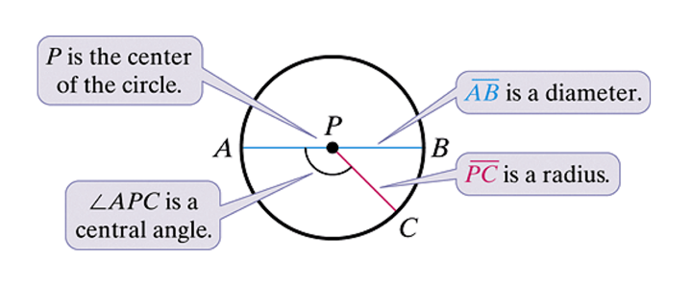

A **diameter** is a segment that contains the center of the circle and has both endpoints on the circle. A **radius** is a segment that has one endpoint at the center and the other endpoint on the circle. The plural of radius is **radii**. Note the relationship between a diameter, *d*, and a radius, *r*, of a circle: .

A circle has many diameters and many radii when discussing segments, but when discussing lengths, a circle has one diameter and one radius.

**Congruent circles** have congruent radii.

A **central angle** is an angle whose vertex is the center of the circle.

An **arc** is a part of a circle. A **semicircle** is half of a circle. A **minor arc** is smaller than a semicircle. A **major arc** is larger than a semicircle. We name a minor arc by its endpoints. We name a major arc or semicircle by its endpoints *and* another point on the arc.

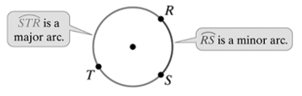

a. Use the figure below to name the following:

A semicircle with endpoint *F*.

Two minor arcs contained within .

Two major arcs containing point *B*.

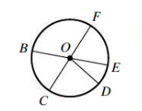

The measure of a semicircle is 180°.

The measure of a minor arc is equal to the measure of its corresponding central angle.

The measure of a major arc is equal to the measure of the related minor arc subtracted from 360°.

**Adjacent arcs** are arcs of the same circle that have exactly one point in common.

**Postulate: Arc Addition Postulate**

The measure of the arc formed by two adjacent arcs is the sum of the measures of the two arcs.

b. Find the measure of each arc in circle P shown below.











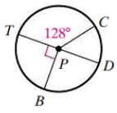

c. The hands of a clock suggest an angle whose measure is continually changing. How many degrees does a minute hand move through during a 27-minute time interval?

# Objective 2: Find the Circumference and Arc Length

Recall that the **circumference** of a circle is the distance around the circle.

**Theorem: Circumference of a Circle**

The circumference, *C*, of a circle with diameter *d* and radius *r* is found using the formula .

The number π is irrational. It cannot be written as a terminating or repeating decimal. To approximate the value of π, we use 3.14, , or the π key on a calculator.

Coplanar circles that have the same center are **concentric circles**.

a. Find the circumference. Give an exact answer in terms of π.

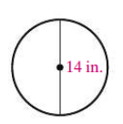

b. The normal-sized tires on a truck have a 15-inch radius. If oversized tires of 18-inch radius are used, how much farther does the truck travel per revolution? Give an exact answer in terms of π and an approximation to two decimal places using .

The measure of an arc is in degrees while the **arc length** is a fraction of a circle’s circumference. For example, an arc of 60° represents  of the circle. Its arclength is  the circumference of the circle.

**Theorem: Arc Length**

The length of an arc of a circle with diameter *d* and radius *r* is the product of the ratio  and the circumference of the circle.

This means the length of .

c. Find the length of in each circle. Give an exact answer in terms of π, an approximation using , and an approximation to two decimal places using the π button on a calculator.

i.

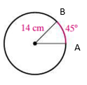

ii.

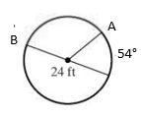

Arcs in different circles can have the same measure but different lengths OR the same length but different measures. **Congruent arcs** are arcs that have the same measure *and* are in the same circle or in congruent circles.

c. A semicircular arch made of wrought iron is being built for the top of a museum entrance. There are two concentric semicircles made of wrought iron with nine 3-foot pieces of wrought iron equally spaced connecting the two semicircles. The diameter of the inner semicircle is 20 feet. What is the total length of wrought iron needed to build this arch? Round to the nearest foot.

