Section 10.6 Areas of Circles and Sectors

# Objective 1: Find the Areas of Circles, Sectors, and Segments of Circles

**Theorem: Area of A Circle**

The area, *A*, of a circle with radius *r* is given by the formula .

a. Find the exact area of the circle.

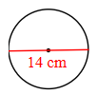

b. Some farmers use a circular irrigation (water sprinkler) method. An irrigation arm acts as the radius of an irrigation circle. How much land is covered with an irrigation arm of 430 feet? Round to the nearest square foot .

c. The area of a circle is 556 square meters. What is the radius of the circle to two decimal places? Use the π button on your calculator.

d. The area of a circular pond is needed. Measuring around the pond gives a circumference of about 88 feet. Find the approximate area of the pond using .

A **sector of a circle** is a region bounded by an arc of the circle and the two radii to the arc’s endpoints. We name a sector using one arc endpoint, the center of the circle, and the other arc endpoint.

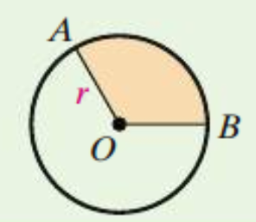

**Theorem: Area of a Sector of a Circle**

The area of a sector of a circle with radius *r* is the product of the ratio  and the area of the circle.

This means the area of sector *AOB* is .

e. Find the exact, simplified area of each shaded sector in terms of π.

i.

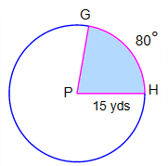

ii.

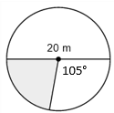

f. In a circle, a 270° sector has area  square inches. What is the exact radius of the circle?

A part of a circle bounded by an arc and the line segment joining its endpoints is a **segment of a circle**.

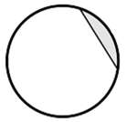

The area of a segment of a circle is found by subtracting the area of the isosceles triangle with vertices at the center of the circle and at the endpoints of the arc from the area of the sector.

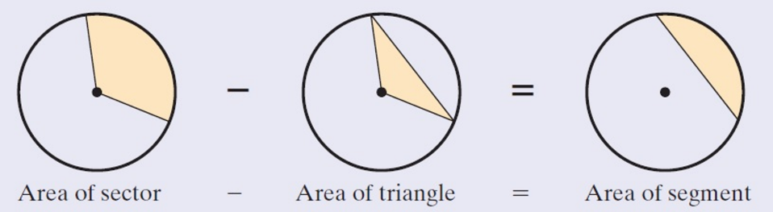

g. Find the area of the shaded segment of the circle rounded to the nearest tenth of a square centimeter. Use the π button on a calculator.

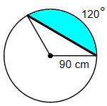

h. Find the area of the shaded region. Given an exact, simplified answer in terms of π.

