Section 10.7 Geometric Probability

# Objective 1: Use Segment and Area Models to Find the Probabilities of Events

The **probability** of an event, written *P*(event) is the likelihood that the event will occur. When the possible outcomes are equally likely, the theoretical probability of an event is the ratio of the number of favorable outcomes to the number of possible outcomes.



The probability of an event is always between 0 and 1, inclusive. A probability of 0 means the event will not occur, and a probability of 1 means the event is certain to occure.

In **geometric probability**, points on a segment or in a region of a plane represent outcomes. The geometric probability of an event is the ratio that involves geometric measures such as length or area.

**Probability and Length**

Points *M* and *N* are on . Point *S* on  is chosen at random. The probability that *S* is on  is the ratio of the length of  to the entire length of .



a. A point on is chosen. Find the probability that the point lies on the indicated segment:

i. 

ii. 

iii. 



b. Using the number line above, find the probability that coordinate *x* of a point chosen at random on  satisfies the inequality .

c. The cycle of a traffic light at an intersection of two streets is 50 seconds green, 6 seconds yellow, and 14 seconds red. If you reach the intersection at a random time, what is the probability that the light is red?

d. The following is observed at a particular bus stop:

When a bus arrives at the stop, it waits 4 minutes before departing.

A bus departs the stop every 24 minutes.

What is the probability that a person arriving at the bus stop at a random time has to wait at least 10 minutes for the next bus to depart? Round to two decimal places.

**Probability and Area**

Region N is part of region R. Point *S* in region R is chosen at random. The probability that *S* is in Region N is the ratio of the area of region N to the entire area of region R.



e. The sectors in the spinner have equal areas.

i. What is the probability the spinner lands on a brown region?

ii. What is the probability the spinner lands in a blue or brown region?

iii. What is the probability the spinner does not land in a yellow section?

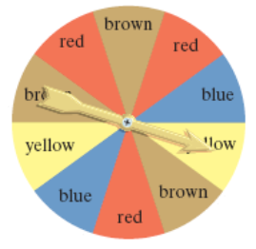

f. A point in the figure is chosen at random. What is the probability it lies in the shaded region? Round to two decimal places.

i.

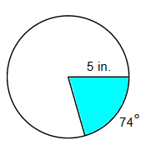

ii.

