Section 11.1 Solids and Cross Sections

# Objective 1: Recognize Polyhedra and Their Parts

A **polyhedron** is a solid, or three-dimensional figure, whose surface is made of polygons. Each polygon is a **face** of the polyhedron. An **edge** is a segment that is formed by the intersection of two faces. A **vertex** is a point where three or more edges intersect. Polyhedrons enclose regions of space. The plural of polyhedron is **polyhedra** or polyhedrons.

a. Identify each solid shown (pyramid, sphere, cone, cylinder, prism) as a polyhedron or not.

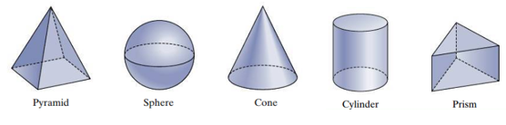

b. How many vertices, edges, and faces are in the polyhedron? Name them.

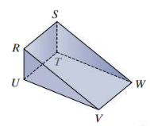

**Euler’s Formula**

The sum of the number of faces (*F*) and vertices (*V)* of a polyhedron is two more than the number of its edges (*E*).



c. Use Euler’s Formula to find the missing number.

i. A polyhedron has 15 edges and 9 vertices. How many faces does it have?

ii. A polyhedron has 8 faces and 16 vertices. How many edges does it have?

Another way to analyze a polyhedron is to draw a **net**. A net is a two-dimensional pattern for a three-dimensional figure. We can cut and fold a net to make a solid. For example, consider the square pyramid shown:

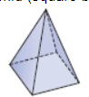

A two-dimensional pattern would consist of the square base and the four congruent triangular lateral faces, one on each side of the base.

d. Draw a possible net for each of the following solids.

i. triangular prism

ii. cylinder

iii. cube

# Objective 2: Visualize Cross Sections of Solids

A **cross-section** is the intersection of a solid and a plane. We can think of a cross section as a very thin slice of the solid.

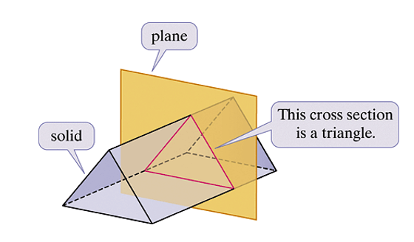

a. What is the cross-section formed by the plane and the solid shown? Assume each plane is perpendicular or parallel to the bases.

i.

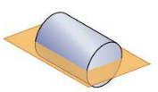

ii.

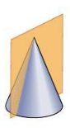

iii.

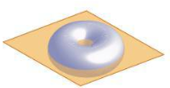

A **topographic map**, or **contour map**, is an application of cross-sections. A topographic map shows elevation contour lines in addition to detailed physical characteristics of the landscape.

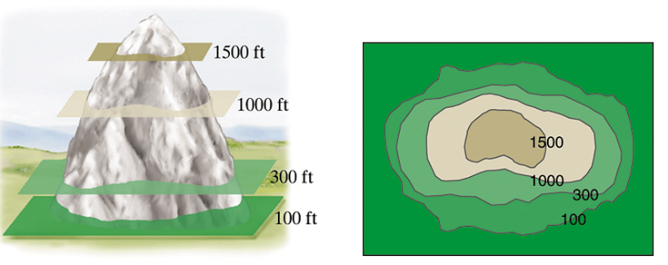

b.

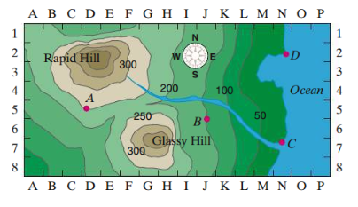

In the contour map shown, elevations are in feet and elevation lines are in increments of 50 feet. Answer the following:

1. What is the elevation at point B?
2. Which hill has the highest elevation?
3. Which side of Rapid Hill is the steepest?

# Objective 3: Visualize Solids Formed by Revolving A Region About a Line

a. What solid is the end result of rotating the plane region about line *l*?

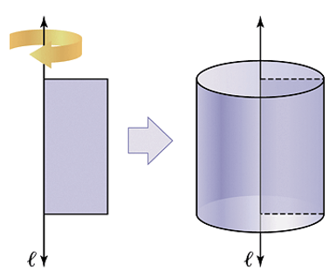

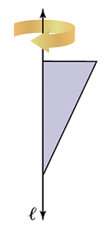

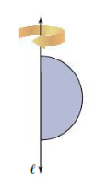

Note that the solids resulting from rotating each of the plane figures above are said to have rotational symmetry.