Section 11.4 Volumes of Prisms and Cylinders

# Objective 1: Find the Volume of a Prism

**Volume** is the space that a figure occupies. It is measured in cubic units such as cubic inches, cubic feet, or cubic centimeters.

**Theorem: Cavalieri’s Principle**

If two solids have the same height and the same cross-sectional area at every level, then they have the same volume.

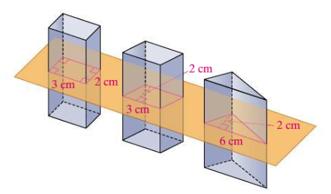

A **prism** is a polyhedron with two congruent, parallel faces called **bases**. The other faces are **lateral faces**. A prism is named using the shape of its bases. An **altitude** of a prism is a perpendicular segment joining the planes of the bases of the prism. The **height** *h* of a prism is the length of an altitude. In a **right prism**, the lateral faces are rectangles. In an **oblique prism**, some or all of the lateral faces are not rectangles. We will assume a prism is a right prism unless otherwise stated. The figure below shows a right rectangular prism and an oblique triangular prism.

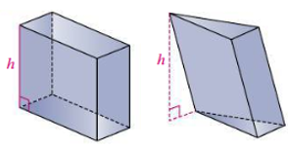

**Theorem: Volume of a Prism**

The volume of a prism is  where *B* is the area of the base and *h* is the height of the prism.

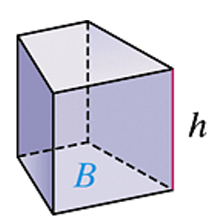

a. Find the volume of the triangular prism

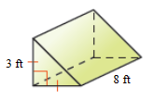

b. A full waterbed mattress is 6 feet by 3 feet by 2 feet. The mattress is to be filled with water that weighs 62.5 pounds per cubic foot. Find the weight of the waterbed to the nearest pound.

# Objective 2: Find the Volume of a Cylinder

A **cylinder** is a solid that has two congruent parallel **bases** that are circles. An **altitude** of a cylinder is a perpendicular segment that joins the planes of the bases. The **height** *h* of a cylinder is the length of an altitude. In a **right cylinder**, the segment joining the centers of the bases is an altitude. In an **oblique cylinder**, the segment joining the center is not perpendicular to the planes containing the bases. We will assume a cylinder is a right cylinder unless otherwise stated.

**Theorem: Volume of a Cylinder**

The volume of a cylinder is  or  where *B* is the area of the circular base (which means ) and *h* is the height of the cylinder.

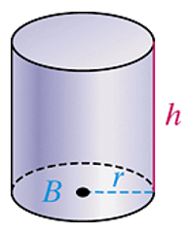

a. Find the volume of the cylinder in terms of π and to the nearest tenth.

i.

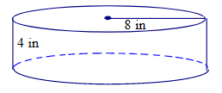

ii.

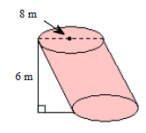

b. A cylinder has a base of diameter 18 centimeters. The volume of the cylinder is  cubic centimeters. What is the height of the cylinder?

c. The plane region shaded below is revolved completely around the y-axis to form a solid of revolution. Describe the solid and find its exact volume.

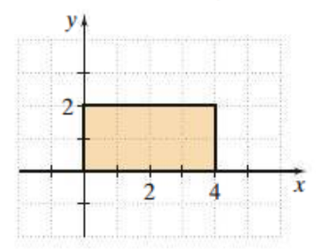

# Objective 3: Find the Volume of Composite Solids

A **composite solid** is a three-dimensional figure that is the combination of two or more simpler figures. We can find the volume of a composite solid by adding the volumes of the figures that are combined.

a. Find the volume of the composite solid to the nearest whole number.

i.

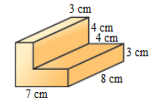

ii.

