Section 11.5 Volumes of Pyramids and Cones

# Objective 1: Find the Volume of a Pyramid

A **pyramid** is a polyhedron in which one face (the **base**) can be any polygon and the other faces (the **lateral faces**) are triangles that meet at a common vertex (called the **vertex** of the pyramid). A pyramid is named using the shape of its base. The **altitude** of a pyramid is the perpendicular segment from the vertex to the plane of the base. The **height** *h* of the pyramid is the length of the altitude.

A **regular pyramid** is a pyramid whose base is a regular polygon and whose lateral faces are congruent isosceles triangles. The altitude is perpendicular to the base at its center. The **slant height** *l* is the length of the altitude of a lateral face of the pyramid. We will assume a pyramid is regular unless stated otherwise. A square pyramid is shown below. Note that the height and the slant height are a leg and the hypotenuse, respectively, of a right triangle.

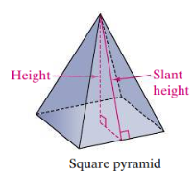

**Theorem: Volume of a Pyramid**

The volume of a pyramid is  where *B* is the area of the base and *h* is the height of the pyramid.

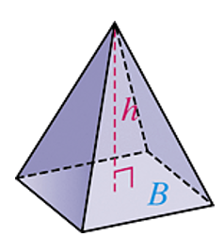

Because of Cavalieri’s Principle, this volume formula is true for all pyramids. In an **oblique pyramid**, the altitude is perpendicular to the plane of base, not at the center of the base. The length of the altitude is the height *h*. An oblique rectangular pyramid is shown below.

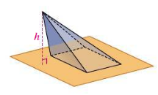

a. Find the volume of each square pyramid to the nearest tenth.

i.

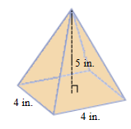

ii.

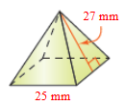

b. Find the exact volume of a pyramid given that the base is an equilateral triangle with sides 16 centimeters long and the height of the pyramid is 18 centimeters.

# Objective 2: Find the Volume of a Cone

A **cone** is a solid that has one **base** that is a circle and a vertex that is not in the same plane as the base. In a **right cone**, the **altitude** is a perpendicular segment from the **vertex** to the center of the base. The **height** *h* is the length of the altitude. The **slant height** *l* is the distance from the vertex to a point on the edge of the base. Note that the height and the slant height are a leg and the hypotenuse, respectively of a right triangle. We will assume a cone is a right cone unless stated otherwise.

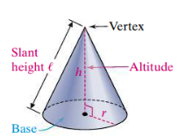

**Theorem: Volume of a Cone**

The volume of a cone is  or  where *B* is the area of the circular base (which means ) and *h* is the height of the cone.

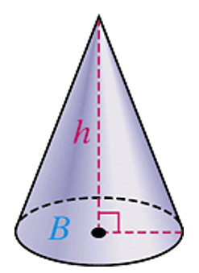

Because of Cavalieri’s Principle, this volume formula is true for all cones. In an **oblique cone**, the altitude is perpendicular to the plane of base, not at the center of the base.

a. Find the volume of the cone in terms of π and then to the nearest whole number.

i.

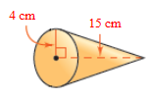

ii.

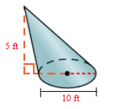

b. Find the radius of a cone with volume  cubic feet and height 7 feet.