Section 11.6 Volumes of Spheres

# Objective 1: Find the Volume of a Sphere

A **sphere** is the set of all points in space equidistant from a given point called the **center**. A **radius** is a segment that has one endpoint at the center and the other endpoint on the sphere. A **diameter** is a segment passing through the center with endpoints on the sphere.

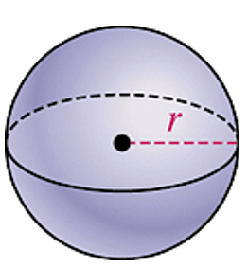

**Theorem: Volume of a Sphere**

The volume of a sphere is  where *r* is the radius of the sphere.

a. Find the volume of the sphere in terms of π and rounded to the nearest cubic foot.

A diagram of a sphere with radius 3 feet



b. A sphere fits snugly inside a cube with 36-inch edges. What is the approximate volume of the space between the sphere and the cube? Round to the nearest cubic inch.

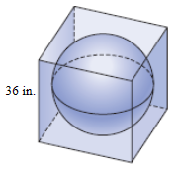

c. A spherical balloon has a 16-inch diameter when it is fully inflated. Half of the air is let out of the balloon. Assume that the balloon remains a sphere. Find the volume of the fully-inflated balloon in terms of π, the volume of the half-inflated balloon in terms of π, and the diameter of the half-inflated balloon to the nearest tenth of an inch.