Section 12.1 Systems of Linear Equations in Two Variables

# Objective 1 Verifying Solutions to a System of Linear Equations in Two Variables

A linear equation in one variable is an equation that can be written in the form  where *a a*nd *b* are real numbers with . This definition can be extended to more variables as follows:

***Definition*:** A **linear equation in *n* variables** is an equation that can be written in the form for variables  and real numbers where at least one of  is nonzero.

For example,  is a linear equation in two variables while is a linear equation in three variables. The important thing to remember is that all variables of a linear equation have an exponent of 1.

***Definition:*** A **system of linear equations in two variables** is the collection of two linear equations considered simultaneously. The solution to a system of equations in two variables is the set of all ordered pairs for which *both* equations are true.

Consider the following three systems of linear equations in two variables.

  

Notice in each of the three systems above that different variables were used. It does not matter what we call the two variables provided that both equations are linear. According to the definition of a system of linear equations in two variables, the solution is the set of all ordered pairs for which both equations are true.

If a linear system has at least one solution, it is said to be **consistent** and the solution is the set of all ordered pairs that satisfy both equations. If the system does not have a solution, it is said to be **inconsistent.**

The solution to a system of two linear equations involving two variables can be viewed geometrically. Since the graph of each equation of the system is a line, we can sketch the two lines and geometrically view the solution. There are only three possibilities for the graph of a linear system of equations involving two variables:

1. The lines can have different slopes and thus intersect at a single point (Figure 1a). The solution is the ordered pair representing the point of intersection. This is **consistent** since it has a solution. The equations are said to be **independent**.

2. The two lines can be parallel (have the same slope but different *y*-intercepts) and thus have no intersecting point (Figure 1b). This system is said to be **inconsistent** and has no solution. The equations are **independent**.

3. The two equations can be different representations of the same line and have the same graph (Figure 1c). In this case there are infinitely many solutions. Because this system has at least one solution, it is **consistent**. The equations are said to be **dependent.**

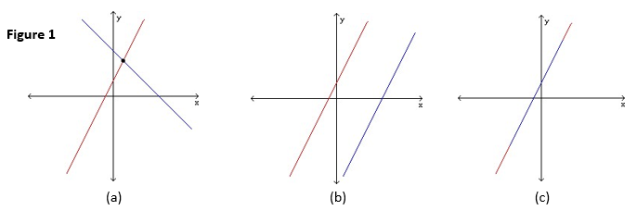

We will learn two algebraic methods used for solving linear systems involving two equations and two variables. These methods are known as the *substitution method* and the *elimination method.*

# Objective 2 Solving a System of Linear Equations Using the Substitution Method

The substitution method involves solving one of the equations for one variable in terms of the other, then substituting that expression into the other equation. The substitution method can be summarized in the following four steps.

**Solving a System of Equations by the Method of Substitution**

**Step 1**: Choose an equation and solve for one variable in terms of the other variable.

**Step 2**: Substitute the expression from step 1 into the other equation.

**Step 3**: Solve the equation in one variable.

**Step 4**: Substitute the value found in step 3 into one of the original equations to find

the value of the other variable.

# Objective 3 Solving a System of Linear Equations Using the Elimination Method

Another method used to solve a system of two equations is called the elimination method. The elimination method involves adding the two equations together in the attempt to eliminate one of the variables. To accomplish this task, the coefficients of one of the variables must differ only in sign. This can be done by multiplying one or both of the equations by a suitable constant. The elimination method can be summarized in the following 5 steps.

**Solving a System of Equations by the Method of Elimination**

**Step 1**: Choose a variable to eliminate.

**Step 2**: Multiply one or both equations by an appropriate nonzero constant so that the

sum of the coefficients of one of the variables is zero.

**Step 3**: Add the two equations together to obtain an equation in one variable.

**Step 4**: Solve the equation in one variable.

**Step 5**: Substitute the value obtained in step 4 into one of the original equations to

solve for the other variable.

# Objective 4 Solving Applied Problems Using a System of Linear Equations

Applied problems sometimes involve two or more unknown quantities. Sometimes we are able to use a single equation involving one variable to solve problems. However, it is often easier to use two variables and create a system of two equations.

**Five Step Strategy for Solving Applied Problems Using Systems of Equations**

**Step 1:** Read the problem several times if necessary until you have an understanding of

what is being asked. If possible, create diagrams, charts, or tables to assist you in

your understanding.

**Step 2:** Choose variables that describe each unknown quantity that is to be found.

**Step 3**: Write a system of equations using the given information and the variables.

**Step 4**: Carefully solve the system of equations using the method of elimination or

substitution.

**Step 5**: Make sure that you have answered the question and check all answers to make

sure they make sense.