Section 12.1 Circle Review and Tangent lines

# Objective 1: Review Circles and Arcs

In a plane, a **circle** is the set of all points equidistant from a given point called the **center**. We name a circle by its center. Circle *P* is shown below with **diameter** , **radius** , and **central angle** .

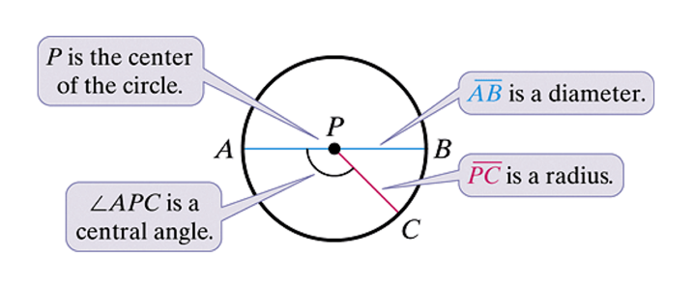

A **diameter** is a segment that contains the center of the circle and has both endpoints on the circle. A **radius** is a segment that has one endpoint at the center and the other endpoint on the circle. The plural of radius is **radii**. Note the relationship between a diameter, *d*, and a radius, *r*, of a circle: .

**Congruent circles** have congruent radii.

A **central angle** is an angle whose vertex is the center of the circle.

An **arc** is a part of a circle. A **semicircle** is half of a circle. A **minor arc** is smaller than a semicircle. A **major arc** is larger than a semicircle. We name a minor arc by its endpoints. We name a major arc or semicircle by its endpoints *and* another point on the arc.

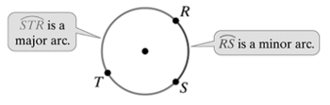

The measure of a semicircle is 180°.

The measure of a minor arc is equal to the measure of its corresponding central angle.

The measure of a major arc is equal to the measure of the related minor arc subtracted from 360°.

Coplanar circles that have the same center are **concentric circles**.

The measure of an arc is in degrees while the **arc length** is a fraction of a circle’s circumference.

**Theorem: Arc Length**

The length of an arc of a circle with diameter *d* and radius *r* is the product of the ratio  and the circumference of the circle.

This means the length of .

**Congruent arcs** are arcs that have the same measure *and* are in the same circle or in congruent circles. It is important to note that it is possible for two arcs in different circles to have the same length but different measures and for two arcs in different circles to have the same measure but different lengths.

a. Use the circle shown below to find each of the following:

i. 

ii. 

iii. length of  in terms of π given  meters

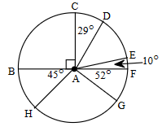

# Objective 2: Use Properties of a Tangent Line to a Circle

A **tangent to a circle** is a line in the plane of the circle that intersects the circle in exactly one point. The point where a circle and a tangent intersect is the **point of tangency**. Segments and rays can also be tangents to a circle.

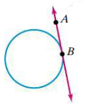

**Theorem: Tangent-Radius Theorem**

If a line is tangent to a circle, then the line is perpendicular to the radius at the point of tangency.

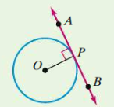

a. Find the value of *x*. Point O is the center of the circle. Assume rays and segments that appear to be tangent are tangent.

i.

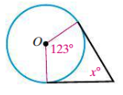

ii.

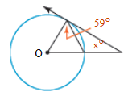

b. Find the exact value of *x*. Point O is the center of the circle. The side of the triangle with length 12 inches is tangent to the circle.

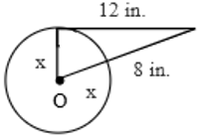

**Theorem: Converse of Tangent-Radius Theorem**

If a line in a plane of a circle is perpendicular to a radius at its endpoint on the circle, then the line is tangent to the circle.

c. In the diagram below, assume the point that appears to be the center of the circle is the center. Is a tangent shown? Explain.

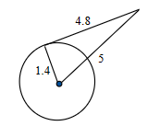

**Common tangents** are lines (or segments or rays) that are tangent to more than one circle.

Given two distinct circles in a plane, the circles will have 0, 1, or 2 points of intersection.

* If the circles have 0 points of intersection, then the circles have either 0 or 4 common tangents.

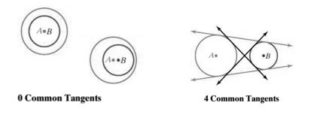

* If the circles have 1 point of intersection, then the circles are tangent to each other and the circles have either 1 or 3 common tangents.

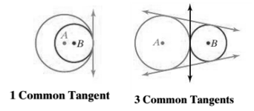

* If the circles have 2 points of intersection, then the circles have 2 common tangents.

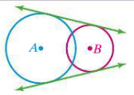

The line that passes through the centers of two circles is called their **line of centers**. If two circles are tangent, internally or externally, then their common point of tangency is on their line of centers, and these circles are called **tangent circles**.

**Theorem: Congruent Tangent Segments**

If two tangent segments to a circle share a common endpoint outside the circle, then the two segments are congruent.

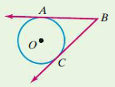

If  and  are tangent to circle *O*, then .

d. Write a proof of the Congruent Tangent Segments Theorem.

e. Find the value of *x* given *E* is the center of the circle and  and  are tangents.

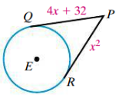

In the figure below, the sides of the triangle are tangent to the circle. The circle is *inscribed in* the triangle. The triangle is *circumscribed about* the circle.

A triangle with a circle in the center such that the circle intersects the triangle exactly 3 times, once on each side of the triangle.



f. Find the perimeter of the polygon circumscribing the circle in the figure below.

