Section 12.2 Chords and Arcs

# Objective 1: Use Congruent Chords, Arcs, and Central Angles

A **chord** is a segment whose endpoints are on a circle. In the figure below, chord  and its associated arc  are shown.

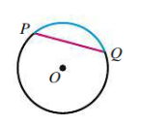

**Theorem: Congruent Central Angles and Arcs**

Within a circle or in congruent circles, central angles are congruent if and only if the associated arcs are congruent.

**Theorem: Congruent Central Angles and Chords**

Within a circle or in congruent circles, central angles are congruent if and only if the associated chords are congruent.

**Theorem: Congruent Chords and Arcs**

Within a circle or in congruent circles, chords are congruent if and only if the associated arcs are congruent.

The circles below are congruent and . Therefore, we know  and . Likewise, if we know , then we also know  and , and if we know , then we also know  and .

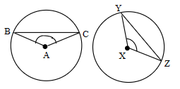

a. In the circle shown, , , and  and  intersect at the center of the circle. Find  and .

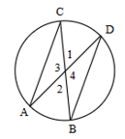

**Theorem**

Within a circle or in congruent circles, chords are congruent if and only if the chords are equidistant from the center(s).

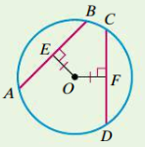

In the circle above with center *O*,  if and only if .

b. Point *O* is the center of the circle. Find the value of *x*.

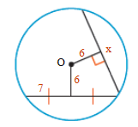

# Objective 2: Use Perpendicular Bisectors to Chords

**Theorems about Chords of Circles**

In a circle,

* if a diameter is perpendicular to a chord, then it bisects the chord and its arc.
* if a diameter bisects a chord (that is not a diameter), then it is perpendicular to the chord.
* the perpendicular bisector of a chord contains the center of the circle.

a. Construct the center of a circle given two chords that are not diameters.

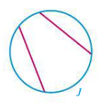

b. Find the value of *x* to the nearest tenth.

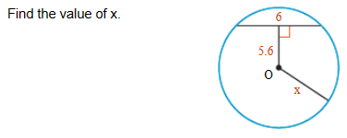

c. The centers of the congruent circles are *A* and *B*.  is a chord of both circles. If inches and inches, how long is the radius?

