Section 12.3 Inscribed Angles

# Objective 1: Find the Measure of an Inscribed Angle

An angle whose vertex is on the circle and whose sides are chords of the circle is an **inscribed angle**. An arc with endpoints on the sides of an inscribed angle and whose other points are in the interior of the angle is an **intercepted arc**. In the diagram, inscribed  intercepts .

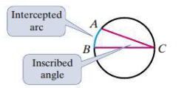

**Theorem: Inscribed Angle Theorem**

The measure of an inscribed angle is half the measure of its intercepted arc.

In the figure above, .

a. Find the value of the variable. The dot represents the center of the circle.

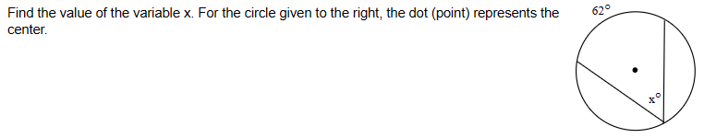

**Corollaries to the Inscribed Angle Theorem**

1) Two inscribed angles that intercept the same arc are congruent.

2) An angle inscribed in a semicircle is a right angle.

3) The opposite angles of a quadrilateral inscribed in a circle are supplementary.

b. Find the value of each variable. The dot represents the center of the circle. (figure not to scale)

i.

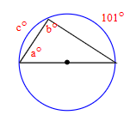

ii.

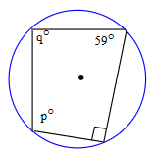

# Objective 2: Find the Measure of an Angle Formed by a Tangent and a Chord

**Theorem**

The measure of an angle formed by a tangent and a chord is half the measure of the intercepted arc. In the figures below, .

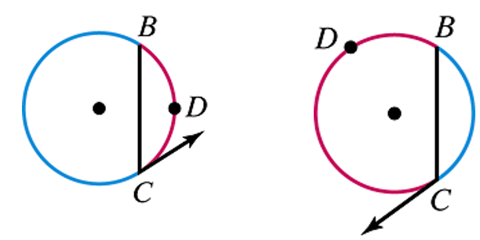

a. Find the value of each variable. Lines that appear to be tangent are tangent.

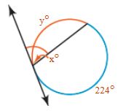

b. Find the value of each variable. The dot represents the center of the circle. Lines that appear to be tangent are tangent.

