Section 12.4 Additional angle Measures and Segment Lengths

# Objective 1: Find Measures of Angles Formed by Chords, Secants, and Tangents

**Theorem: Angle Measure—Lines Intersecting Inside a Circle**

The measure of an angle formed by two lines that intersect inside a circle is half the sum of the measures of the intercepted arcs.

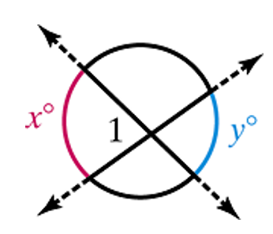



**Theorem: Angle Measure—Lines Intersecting Outside a Circle**

The measure of an angle formed by two lines that intersect outside a circle is half the difference of the measures of the intercepted arcs.

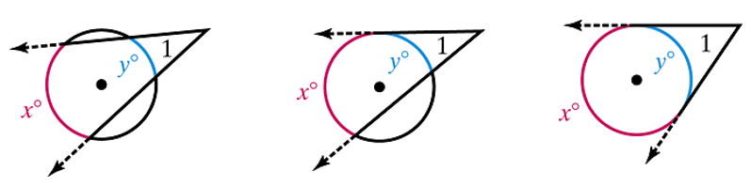



A **secant** is a line that intersects a circle at two points. Secants can also be segments or rays. A chord is part of a secant.

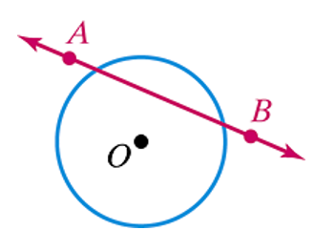

a. Find the value of each variable.

i. Lines that appear tangent are tangent.

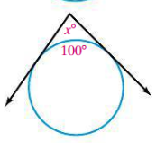

ii.

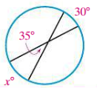

iii. *y*° represents the measure of the congruent arcs, and *x*° represents the measure of the angle between the tangent line and the side of the regular hexagon.

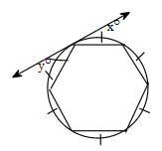

iv. The dot is the center of the circle.

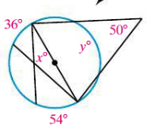

# Objective 2: Find the Lengths of Segments Associated with Circles

**Theorem: Segment Products—Inside or Outside a Circle**

From a circle and a point not on the circle, the product of the lengths of the two segments from the point to the circle is constant along any line through the point and circle.

Circle 1: Two chords intersect at point P inside the circle.  the two segments of the first chord are labeled a and b.  The two segments of the second chord are labeled c and d.  a times b equals c times d.  Circle 2: Two secants are shown intersecting at Point P outside the circle.  one secant is comprised of segment x inside the circle and segment w outside.  The other is comprised of segment z inside the circle and segment y outside the circle.  W times the sum of w and x equals y times the sum of y and z.  Circle 3:  a tangent of length t and a secant intersect at point P outside the circle.  The length of the secant segment inside the circle is z and the length of the segment outside the circle is y.  y times the sum of y plus z equals t squared.


I. The products of the chord segments are equal.

II. The products of the secant segments and their outer segments are equal.

III. The product of a secant segment and its outer segment equals the square of the tangent segment.

a. Find the values of the variables. Give exact, simplified answers. (figures not to scale)

i.

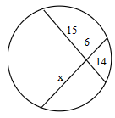

ii.

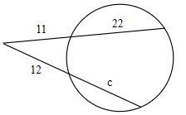

b. Find the length of the diameter to one decimal place. *O* is the center of the circle. The segment that appears to be a tangent is a tangent.

