Section 12.5 Circles in the Coordinate Plane

# Objective 1: Write an Equation of a Circle

We can use the distance formula to find an equation of a circle with center and radius *r*. Let  be any point on the circle. Then, the radius *r* is the distance from  to .

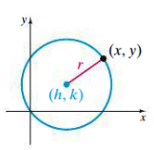

 Use the distance formula.

 Square both sides.

**Theorem: Equation of a Circle**

The **standard form of an equation of a circle** (or **standard equation of a circle**) with center and radius *r* is .

a. Write the standard equation of a circle with center  and radius 6.

b. Write the standard equation of a circle with center  passing through the point .

c. Write the standard equation of a circle given the endpoints of its diameter are  and .

d. The area of a circle with center  is . Write the standard form of the equation of the circle.

# Objective 2: Find the Center and Radius of a Circle Written in Standard Form

If we know the standard equation of a circle, then we can describe the circle by naming its center  and radius *r*. We can use this information to graph the circle. Start by plotting the center point. Then, you can use a compass to draw the circle or plot a few convenient points *r* units up, down, left, and right from the center to use to sketch the circle.

a. Find the center and the radius. Then, graph the circle.

i. 

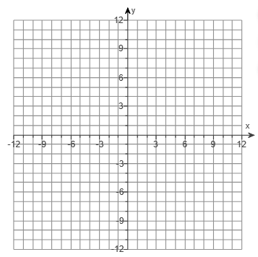

ii. 



# Objective 3: Complete the Square to find the Center and Radius of a Circle

Sometimes the equation of a circle is given in the form where

are real numbers, , , and .

By completing the square on both x and y, we can write this form of the equation of a circle in standard form.

a. Find the center and the radius of the circle. Then, graph the circle.

i. 



ii. 

