Section 2.1 The Rectangular Coordinate System

Throughout chapter one, we solved several types of equations including linear equations, quadratic equations, rational equations, etc. Each of these equations had something in common. They were all examples of **equations in one variable**. In this chapter, we will study **equations involving two variables**. A solution to an equation involving two variables consists of a *pair of numbers*, an *x*-value and a *y*-value for which the equation is true.

Each pair of values is called an **ordered pair** because the order does matter. We use the notation to represent an ordered pair. Notice that the x-coordinate or **abscissa** is first, followed by the y-coordinate or **ordinate** listed second. To represent an ordered pair graphically, we use the rectangular coordinate system also called the Cartesian coordinate system named after the French mathematician René Descartes. The plane used in this system is called the **coordinate plane** or **Cartesian plane**. The horizontal axis (*x*-axis) and the vertical axis (the *y*-axis) intersect at the **origin** *O* and naturally divide the Cartesian plane into 4 quadrants labeled quadrants I, II, III and IV. The quadrants are numbered counterclockwise beginning with quadrant I in the upper right.

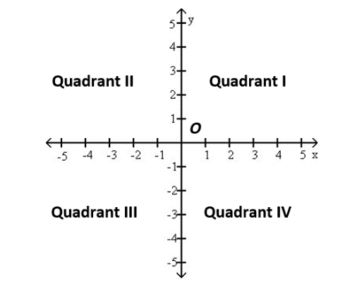

# Objective 1: Plotting Ordered Pairs in the Cartesian Plane

To plot the point, go 2 units to the left of the origin on the *x*-axis then move 3 units up parallel to the *y*-axis. The point corresponding to the ordered pair  is located in Quadrant II.

# Objective 2: Graphing Equations by Plotting Points

One way to sketch the graph of an equation is to find several ordered pairs which satisfy the equation, plot those ordered pairs then connect the points with a smooth curve. We choose arbitrary values for one of the coordinates then solve the equation for the other coordinate.

# Objective 3: Finding Intercepts of a Graph Given an Equation

***Definition*:** The **intercepts** of a graph are points where a graph crosses or touches a coordinate axis.

A **y-intercept** is the y-coordinate of a point where a graph touches or crosses the y-axis.

An **x-intercept** is the x-coordinate of a point where a graph touches or crosses the x-axis.

**Algebraically finding x-intercepts and y-intercepts given an equation in two variables**

**Finding x-intercepts:** Set all values of the variable y equal to 0 and solve for x.

**Finding y-intercepts**: Set all values of the variable x equal to 0 and solve for y.

# Objective 4: Finding the Midpoint of a Line Segment using the Midpoint Formula

Suppose we wish to find the midpoint  of the line segment from  and . To find this midpoint, we simply “average” the *x* and *y* coordinates respectively. In other words, the *x* coordinate of the midpoint is  while the *y*-coordinate of the midpoint is .

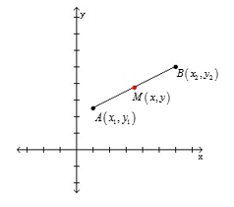

**Midpoint Formula:** The midpoint of the line segment from  to  is .

# Objective 5: Finding the Distance between Two Points using the Distance Formula

Recall that the Pythagorean Theorem states that in a right triangle with legs *a* and *b* and hypotenuse *c*, .

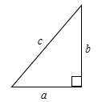

To find the length *d* of the line segment from to point , consider the point  which is on the same vertical line segment as point *A* and the same horizontal line segment as point *B*. The triangle formed by points *A, B* and *C* is a right triangle whose hypotenuse has length *d*. The horizontal leg of the triangle has length  while the vertical leg of the triangle has length . See the figure below.

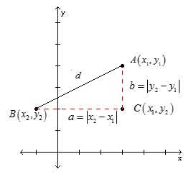

By the Pythagorean Theorem, . We obtain the distance formula by taking the positive square root of both sides, since distance must be positive, and recalling that for any quantity *A*, .

**The Distance Formula:** The distance *d* between any two points and is given by the formula .