Section 2.1 Perimeter, Circumference, and Area

The **perimeter** *P* of a geometric figure is the distance around the figure. The distance around a circle is given a special name, called its **circumference** *C*. The **area** *A* of a geometric figure is the number of square units it encloses.

**Perimeter, Circumference, and Area Formulas**

A **square** with side length *s* has perimeter  and area .

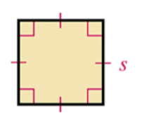

A **rectangle** with length *l* and width *w* has perimeter  and area .

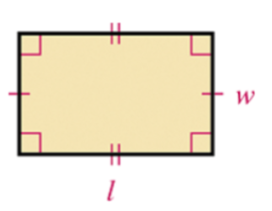

A **triangle** with side lengths *a*, *b*, and *c* and height *h* corresponding to base *b* has perimeter  and area .

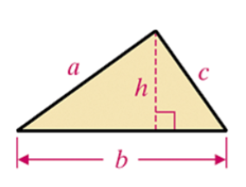

A **circle** with radius r and diameter d has circumference  and area .

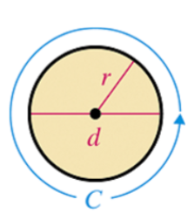

# Objective 1: Finding the Perimeter or Circumference of Basic Geometric Figures

Find the perimeter of each figure.

a.

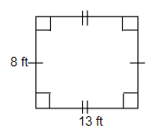

b.

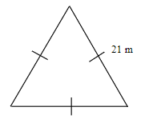

c. Find the circumference of the circle. Give the exact circumference and then an approximation using .

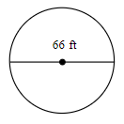

# Objective 2: Finding the Area of Basic Geometric Figures

Find the area of each figure.

a.



b.

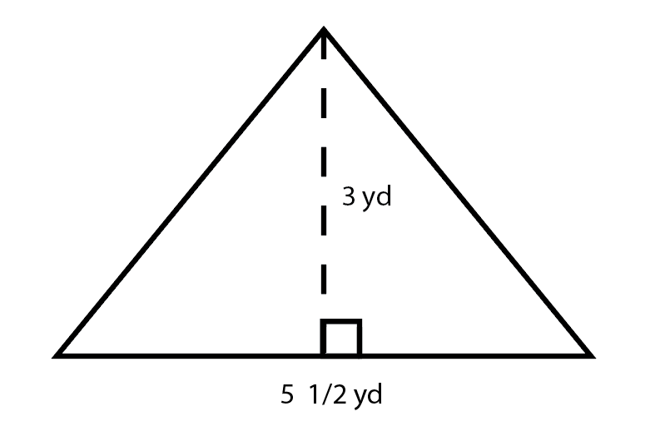

c.

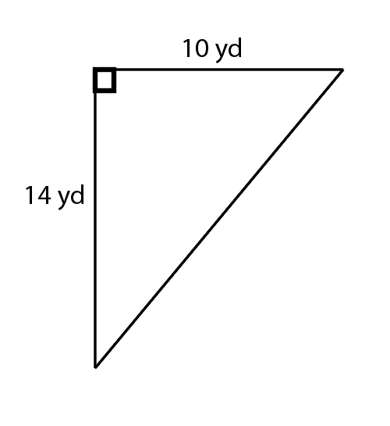

d. Find the area of the circle. Give the exact area and then an approximation using .



e. A pool measures 13 feet by 26 feet, and it is surrounded by an 8-foot deck. How much fencing is needed to fence the outside of the deck? How much outdoor carpet is required to cover the deck?

The figure shows two nested rectangles.  The inside rectangle has dimensions 13 feet by 26 feet.  The sides of the outer rectangle are 8 feet from the sides of the inner rectangle.


f. Plot the points A(-2,5), B(-5,5), C(-5,-5), and D(-2, -5) in the coordinate plane. What geometric figure is formed? Find the perimeter and area of this figure.

g. On a coordinate plane, draw the polygon with vertices A(1,1), B(10, 1), C(10, 8), D(7,6), E(3,6), F(3,9), and G(1,9). Find the perimeter and area of the polygon.

h. The area of a square is found to be  square units. What is the perimeter of the square in terms of *x*? (Assume that $2x-3>0$.)

i. What is the area of a circle that has center A(-2, 3) and passes through the point B(1,1). Give an exact answer in terms of π.