Section 2.2 Circles

A **circle** is the set of all points in the Cartesian plane that are a fixed distance *r* from a fixed point . The fixed distance *r* is called the **radius** of the circle and the fixed point  is called the **center** of the circle. To derive the equation of a circle, we use the distance formula that was discussed in the previous section.

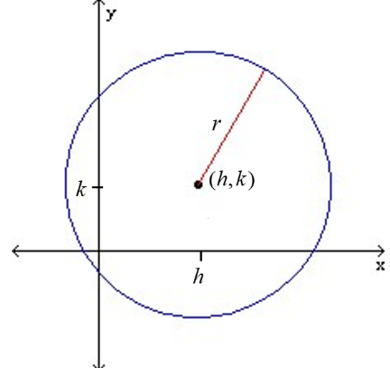

The **standard form of an equation of a circle** with center and radius *r* is .

The standard form of an equation of a circle centered at the origin with radius *r* is .

# Objective 1: Writing the Standard Form of an Equation of a Circle

**N**ote that when given the diameter of a circle, we can use the midpoint formula to determine the center and the distance formula to find the radius.

# Review of Solving Quadratic Equations by Using the Square Root Property

See Section 1.4a, objective 2.

# Objective 2: Sketching the Graph of a Circle

Once we know the center and radius of a circle, we can easily graph the circle. For additional points, find any intercepts and plot the points.

Note that the *y-*coordinate of the center of the circle  is  because .

# Review of Squaring Binomials

***LSU Video “Special Products” (0:00 – 8:20)*** *is found on the course website.*

There are two identities that can be used to square a binomial.





# Review of Factoring Perfect Square Trinomials

***LSU Video “Perfect Square Trinomials”*** *is found on the course website.*

A trinomial is a **perfect square trinomial** if it can be written so that its first term is the square of some quantity $a$, its last term is the square of some quantity $b$, and its middle term is twice the product of the quantities $a$ and $b$.

The two identities from above that we used to square a binomial can also be used to factor a perfect square trinomial.

# Review of Creating a Perfect Square Trinomial

We have previously used the square root property to solve quadratic equations such as . Notice that one side of the equation is a quantity squared and the other side is a constant.

Consider the equation . To solve this equation by using the square root property, we need the left side of the equation to be a perfect square trinomial, meaning it can be written as a binomial squared. We can do this by adding $1$ to both sides of the equation.







The process of rewriting the equation so that one side is a perfect square trinomial is called **completing the square**.

# Objective 3: Converting the General Form of a Circle into Standard Form

The **general form of the equation of a circle** is where

are real numbers, , , and .

By completing the square, the equation of a circle can be rewritten from general form to standard form.