Section 2.3 Lines

# Objective 1: Determining the Slope of a Line

In mathematics, the steepness of a line can be measured by computing the line’s **slope.** Every non-vertical line has slope. Vertical lines are said to have no slope.

A line going up from left to right has **positive slope**, a line going down from left to right

has **negative slope,** and a horizontal line has **zero slope**. We use the variable *m* to represent slope.

The slope can be computed by comparing the vertical change (the **rise)** to the horizontal change (the **run**). Given any two points on the line, the slope *m* can be computed by taking the quotient of the rise over the run.

***Definition*:** If , the **slope** of a line passing through distinct points  and is

.

# Objective 2: Sketching a Line Given a Point and the Slope

If we know a point on a line and the slope, we can quickly sketch the line.

# Objective 3: Finding the Equation of a Line Using the Point-Slope Form

The **Point-Slope Form of the Equation of a Line** passing through the point and having slope *m* is given by .

# Objective 4: Finding the Equation of a Line Using the Slope-Intercept Equation

The slope-intercept form of the equation of a line is extremely important since every non-vertical line has exactly one slope-intercept equation.

The **Slope-Intercept Form of the Equation of a Line** with slope *m* and y-intercept *b* is given by .

# Objective 5: Writing the Equation of a Line in Standard Form

**The Standard Form of an Equation of a Line** is given by  where *A, B* and *C*

are real numbers such that *A* and *B* are not both zero.

Note that every equation of a line in two variables can be written in standard form. Furthermore, fractions can always be eliminated by multiplying the equation by the least common denominator. Therefore, the standard form of the equation of a line seen in this text will always include non-fractional coefficients and A will always be greater than or equal to zero.

# Objective 6: Finding the Slope and the *y*-intercept of a Line in Standard Form

Suppose we are given the standard form of the equation of a line  with  and wish to solve for *y*. To do this, we subtract  from both sides and divide by *B* to obtain  which is the equation of the line in slope-intercept form. Thus, given the standard form of the equation of a line  with, the slope of the line is  and the y-intercept is .

# Objective 7: Sketching Lines by Plotting Intercepts

The *x-*intercept is found by setting and solving for *x.*

The *y-*intercept is found by setting  and solving for y.

# Objective 8: Finding the Equation of a Horizontal Line and a Vertical Line

**Horizontal Lines**

Suppose we wish to determine the equation of the horizontal line that contains the point . To

find this equation we must first determine the slope. Since the line must also pass through the

point , we see that the slope of this line is . Using the slope-intercept form

of a line with  and *y*-intercept *b*, we see that the equation is  or .

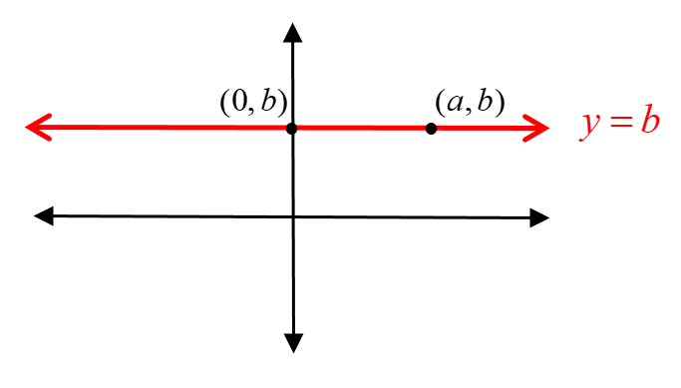

Therefore, we know that for any horizontal line that contains the point , the equation of that line is and the slope is .

**Vertical Lines**

Vertical lines have **no slope** or **undefined slope**. We can see this by looking at the vertical line that passes through the point . Because this line also passes through the *x-*intercept at the point , we see that the slope of this line is  which is not a real number since division by zero is not defined. Since the *x-*coordinate of this vertical line is always equal to *a* regardless of the *y*-coordinate, we say that the equation of a vertical line is 

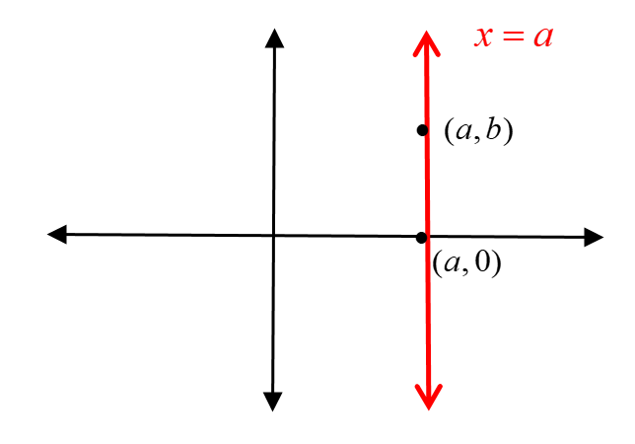

Therefore, we know that for any vertical line that contains the point , the equation of that line is , and the slope is undefined.

**SUMMARY OF FORMS OF EQUATIONS OF LINES**

| **Equation** | **Name** | **Details** |
| --- | --- | --- |
|  | Point-Slope Form | Slope is *m* and is a point on the line. |
|  | Slope-Intercept Form | Slope is *m* and *y*-intercept is*b*. |
|  | Standard Form | *A, B* and *C* are real numbers with *A* and *B* not both 0 and. |
|  | Horizontal Line | Slope is 0 and *y*-intercept is *b*. |
|  | Vertical Line | Undefined slope and *x*-intercept is *a*. |