Section 2.7 Proving Theorems About Angles

# Objective 1: Prove and Use Theorems About Angles

When writing a proof, it is often helpful to write the statement in “if-then” form. The **given** is the **hypothesis** and follows the word “if”. What we **want to prove** is the **conclusion** and follows the word “then”.

In addition to two-column proofs, we will also write **paragraph proofs** in this section. As the name indicates, a paragraph proof is written as a paragraph.

**Theorem: Equal Complements Theorem**

Complements of the same angle (or of equal angles) are equal in measure.

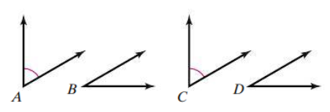

a. Prove the Equal Complements Theorem. (two-column proof)

Given:  and  are complementary.

 and  are complementary.



Prove: 

**Theorem: Equal Supplements Theorem**

Supplements of the same angle (or of equal angles) are equal in measure.

b. Write the Equal Supplements Theorem in “if-then” form.

**Theorem: Linear Pair Theorem**

If two angles form a linear pair, then the angles are supplementary.

c. Prove the Linear Pair Theorem. (two-column proof)

Given:  and  form a linear pair.

Prove:  and  are supplementary angles.

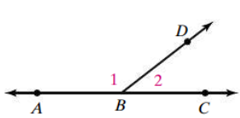

**Theorem: Vertical Angles Theorem**

Vertical angles are congruent.

d. Prove the Vertical Angles Theorem. (two-column proof)

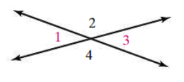

Given:

Prove:

**Theorem: Right Angles Congruent Theorem**

All right angles are congruent.

e. Prove the Right Angles Congruent Theorem. (paragraph proof)

**Theorem: Equal Supplementary Angles Theorem**

Two equal supplementary angles are right angles.

f. Prove the Equal Supplementary Angles Theorem. (paragraph proof)

g. Use the figure below to write a two-column proof for the following statement:

If , then .

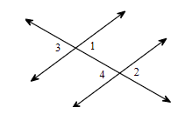

h. Name two pairs of congruent angles in the figure. Justify your answer.

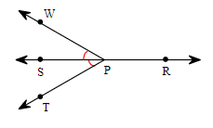

i. Find the value of each variable and the measure of each angle that is represented by an algebraic expression.

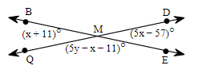

m.  contains points A(5, -4), O(0,0), and X(6,0). Find the coordinates of a point B so that  and  are adjacent complementary angles.