Section 3.1 Relations and Functions

# Objective 1: Understanding the Definitions of Relations and Functions

***Definition*:** A **relation** is a correspondence between two sets *A* and *B* such that each element of set *A* corresponds to one or more elements of set *B.* Set *A* is called the **domain** of the relation and set *B* is called the**range** of the relation.

**Definition:** A **function** is a relation such that for each element in the domain, there corresponds *exactly one and only one* element in the range. In other words, a function is a well-defined relation.

The elements of the domain and range are typically listed in ascending order when using set

notation.

# Objective 2: Determine if Equations Represent Functions

To determine if an equation represents a function, we must show that for any valuein the domain, there is exactly one corresponding value in the range.

# Objective 3: Using Function Notation; Evaluating Functions

When an equation is explicitly solved for *y*, we say that “*y* is a function of *x*” or that the variable *y* depends on the variable *x*. Thus, *x* is the independent variable and *y* is the dependent variable.

 **The symbol does not mean *f* times *x*. The notation refers to the value of the function at *x*.**

 **The expression  does not equal .**

The expression  is called the **difference quotient** and is very important in calculus.

# Objective 4: Using the Vertical Line Test

**The Vertical Line Test**

A graph in the Cartesian plane is the graph of a function if and only if no vertical line intersects the graph more than once.

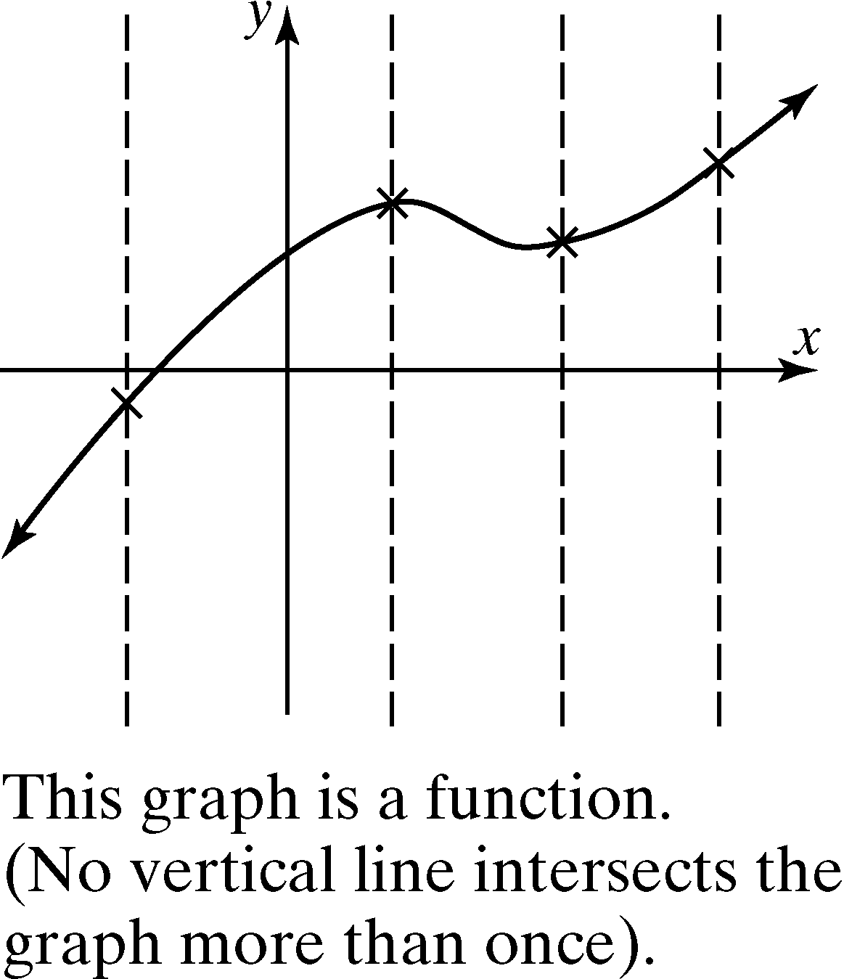 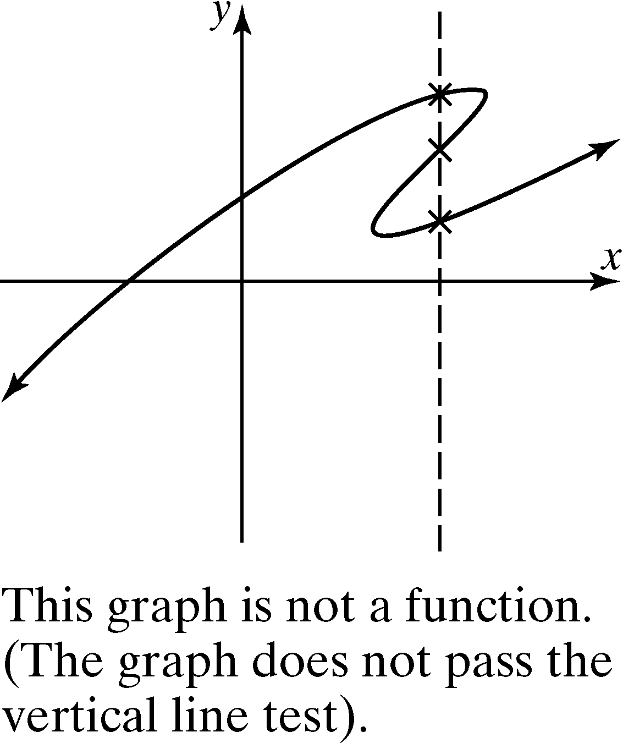

# Objective 5: Determining the Domain of a Function Given the Equation

The domain of a function  is the set of all values of *x* for which the function is defined.

It is very helpful to classify a function to determine its domain.

***Definition:*** The function  is a **polynomial function**

of degree *n* where *n* is a nonnegative integer and  are real numbers. The domain of every polynomial function is .

Many functions can have restricted domains.

***Definition:*** A **rational function** is a function of the form  where *g* and *h* are polynomial functions such that The domain of a rational function is the set of all real numbers such that . If ** , where *c* is a real number, then we will consider the function  to be a polynomial.

***Definition:*** The function  is a **root function** where *n* is a positive integer.

If *n* is *even*, the domain is the solution to the inequality .

If *n* is *odd*, the domain is the set of all real numbers for which  is defined.