Section 3.1 Lines and Angles

# Objective 1: Identify Relationships Between Lines and Planes That Do Not Intersect

**Parallel lines** are coplanar lines that do not intersect. The symbol  means “is parallel to”.

**Skew lines** are noncoplanar. They are not parallel and do not intersect.

**Parallel planes** are planes that do not intersect.

a. In the box shown below, segments are parts of lines and the sides of the box represent planes. Assume that lines (extended segments) and planes that appear to be parallel are parallel and that lines and planes that appear to be perpendicular are perpendicular.

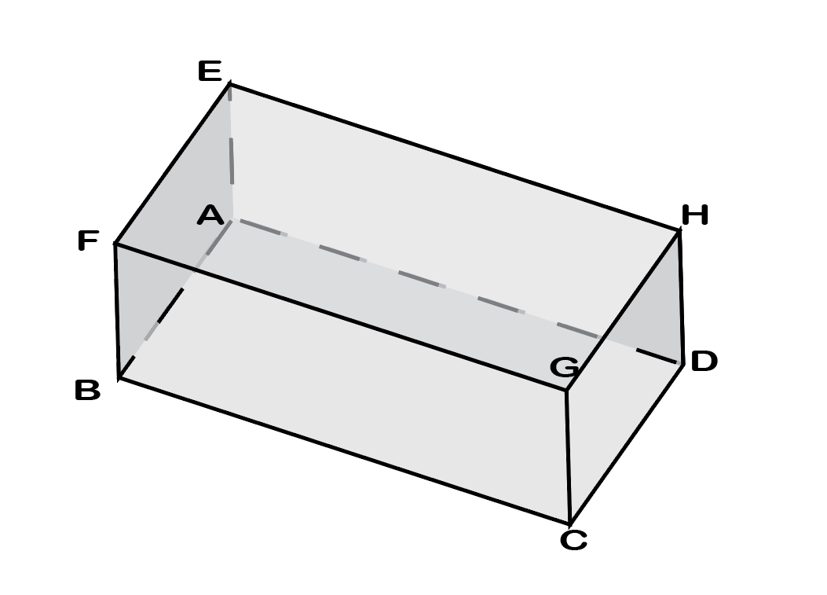

i. Name a plane parallel to plane *ABD*.

ii. Name three lines that are parallel to line .

iii. Name two lines skew to .

iv. What is the relationship between lines and ?

v. What is the relationship between lines and ?

vi. What is the relationship between plane *EFG* and plane *HDC*?

Two segments are parallel if the two lines containing the segments are parallel. If the segments themselves intersect or if the extended lines formed by the segments intersect, then the segments are not parallel. In the figure below, only the first pair of segments are parallel.

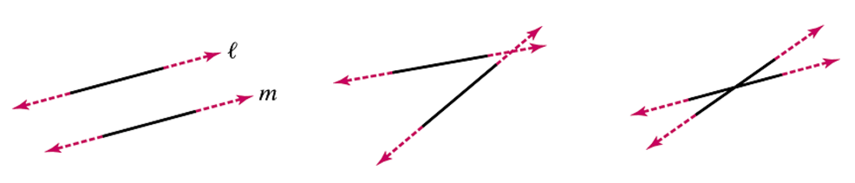

# Objective 2: Learn the Names of Angles Formed by Lines and a Transversal

A **transversal** is a line that intersects two or more coplanar lines at different points. The figure below shows the eight angles formed by a transversal *t* and two lines *l* and *m*.

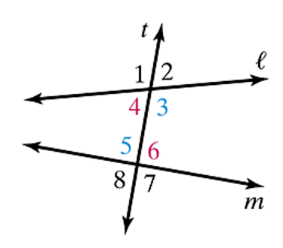

Angles 3, 4, 5, and 6 lie between *l* and *m* in the figure above. They are **interior angles**.

Angles 1, 2, 7, and 8 lie outside of *l* and *m* in the figure above. They are **exterior angles**.

**Alternate interior angles** are nonadjacent interior angles that lie on opposite sides of the transversal. In the figure above, there are two pairs of alternate interior angles: angles 4 and 6 and angles 3 and 5.

**Same-side interior angles** are interior angles that lie on the same side of the transversal. These angles may also be called **consecutive interior angles**. In the figure above, there are two pairs of same-side interior angles: angles 4 and 5 and angles 3 and 6.

**Corresponding angles** lie on the same side of the transversal and in corresponding positions. In the figure above, there are four pairs of corresponding angles: angles 1 and 5, angles 4 and 8, angles 2 and 6, and angles 3 and 7.

**Alternate exterior angles** are nonadjacent exterior angles that lie on opposite sides of the transversal. In the figure above, there are two pairs of alternate exterior angles: angles 1 and 7 and angles 2 and 8.

a. Use the figure below to identify the given pair of angles as corresponding angles, same-side interior angles, alternate interior angles, or alternate exterior angles.

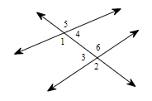

i. angles 1 and 2

ii. angles 2 and 5

iii. angles 4 and 6

iv. angles 1 and 6

b. Use the figure below to answer the following questions. Use only angles that are numbered in the figure.

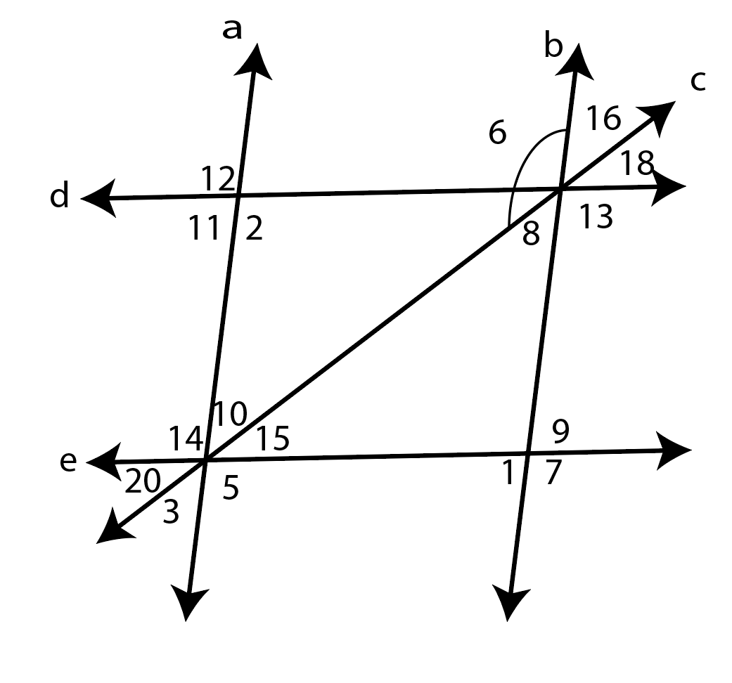

i. Name a pair of corresponding angles for the lines d and e with transversal b.

ii. Name a pair of alternate exterior angles for the lines d and e with transversal c.

iii. Name a pair of same-side interior angles for the lines a and b with transversal e.

iv. Name a pair of alternate interior angles for the lines a and b with transversal c.