Section 3.1 Relations and Functions

# Objective 1: Understanding the Definitions of Relations and Functions

***Definition*:** A **relation** is a correspondence between two sets *A* and *B* such that each element of set *A* corresponds to one or more elements of set *B.* Set *A* is called the **domain** of the relation and set *B* is called the**range** of the relation.

**Definition:** A **function** is a relation such that for each element in the domain, there is *exactly one* corresponding element in the range. In other words, a function is a well-defined relation.

The elements of the domain and range are typically listed in ascending order when using set

notation.

# Objective 2: Determine if Equations Represent Functions

To determine if an equation represents a function, we must show that for any valuein the domain, there is exactly one corresponding value in the range.

# Review of Evaluating Algebraic Expressions for a Given Input

***LSU video “Exponents” (0:00 – 7:10)*** *is available on the course website.*

# Review of Simplifying Polynomial Expressions

***LSU Videos “Adding and Subtracting Polynomials”*** *and* ***“Special Products” (0:00 – 8:20)*** *are found on the course website.*

Polynomials that contain like terms can be simplified by combining the like terms. Like terms are terms that contain exactly the same variables raised to exactly the same powers.

Recall that to square a binomial, the following identities can be used.





# Objective 3: Using Function Notation; Evaluating Functions

When an equation is explicitly solved for *y*, we say that “*y* is a function of *x*” or that the variable *y* depends on the variable *x*. Thus, *x* is the independent variable and *y* is the dependent variable.

 **The symbol does not mean *f* times *x*. The notation refers to the value of the function at *x*.**

 **The expression  does not equal .**

The expression  is called the **difference quotient** and is very important in calculus.

# Objective 4: Using the Vertical Line Test

**The Vertical Line Test**

A graph in the Cartesian plane is the graph of a function if and only if no vertical line intersects the graph more than once.

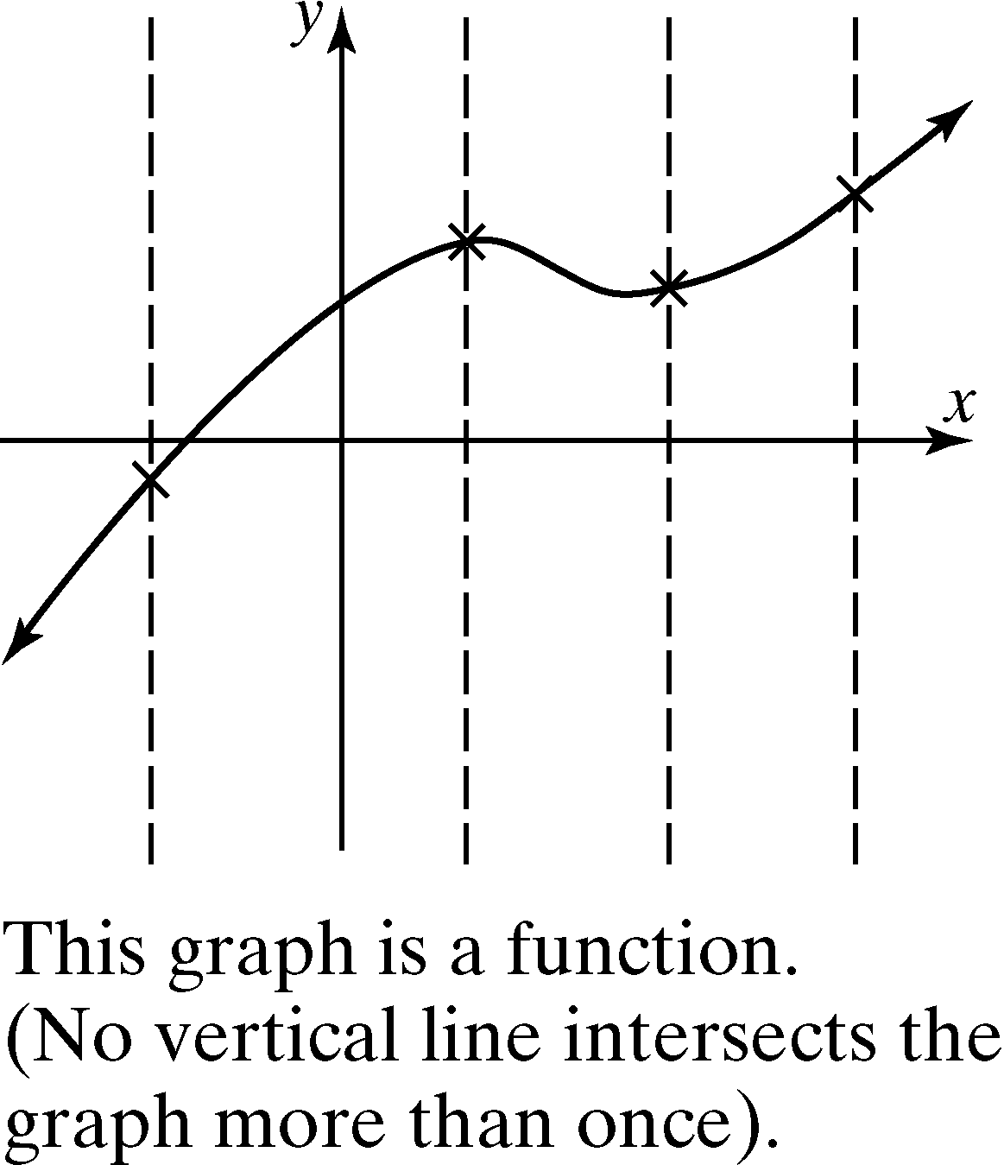 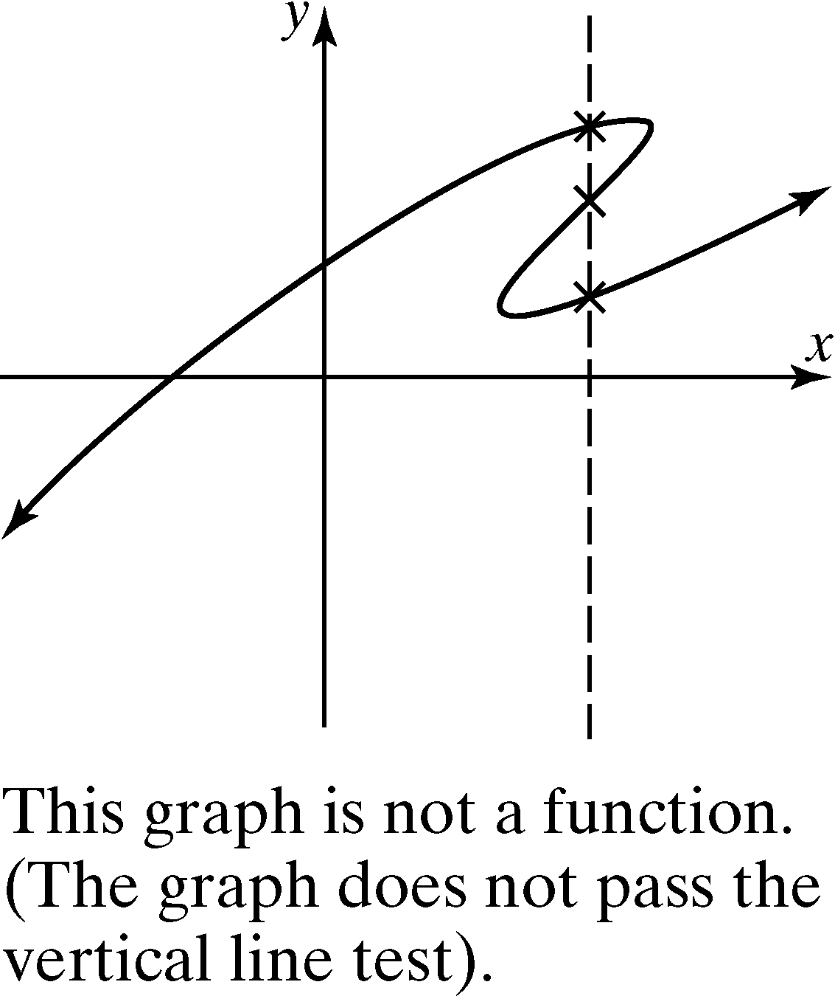

# Review of Solving Linear Equations of the Form and Linear Inequalities of the Form

See Sections 1.1a and 1.7.

# Review of Solving Quadratic Equations

Recall from section 1.4 that two methods for solving a quadratic equation are factoring and using the square root property.

# Objective 5: Determining the Domain of a Function Given the Equation

The domain of a function  is the set of all values of *x* for which the function is defined.

It is very helpful to classify a function to determine its domain.

***Definition:*** The function  is a **polynomial function**

of degree *n* where *n* is a nonnegative integer and  are real numbers.

The domain of every polynomial function is .

Many functions can have restricted domains.

***Definition:*** A **rational function** is a function of the form  where *g* and *h* are polynomial functions such that is any polynomial expression except 0 and the degree of  is greater than zero.If **, where *c* is a real number not equal to zero, then we will consider the function  to be a polynomial.

The domain of a rational function is the set of all real numbers *x* such that .

***Definition:*** The function  is a **root function** where *n* is an integer such that .

If *n* is *even*, the domain is the solution to the inequality .

If *n* is *odd*, the domain is the set of all real numbers for which  is defined.