Section 3.2 Properties of a Function’s Graph

# Objective 1: Determining the Intercepts of a Function

An **intercept** of a functionis a point on the graph of a function where the graph either crosses or touches a coordinate axis. There are two types of intercepts:

1) The *y*-intercept, which is the *y*-coordinate of the point where the graph crosses or touches the *y*-axis.   
2) ­The *x*-intercepts, which are the *x*-coordinates of the points where the graph crosses or touches the *x-*axis.

**The *y*-intercept**:   
A function can have **at most** one *y*-intercept. The *y­*-intercept exists if  is in the domain of the function. The *y-*intercept can be found by evaluating 

**The *x*-intercept(s):**A function may have several (even infinitely many) *x*-intercepts. The *x*-intercepts, also called **real zeros,** can be found by finding all *real solutions* to the equation. Although a function may have several zeros, only the real zeros are *x*-intercepts.

# Objective 2: Determining the Domain and Range of a Function from its Graph

The domain of the graph below is the interval while the range is the interval .

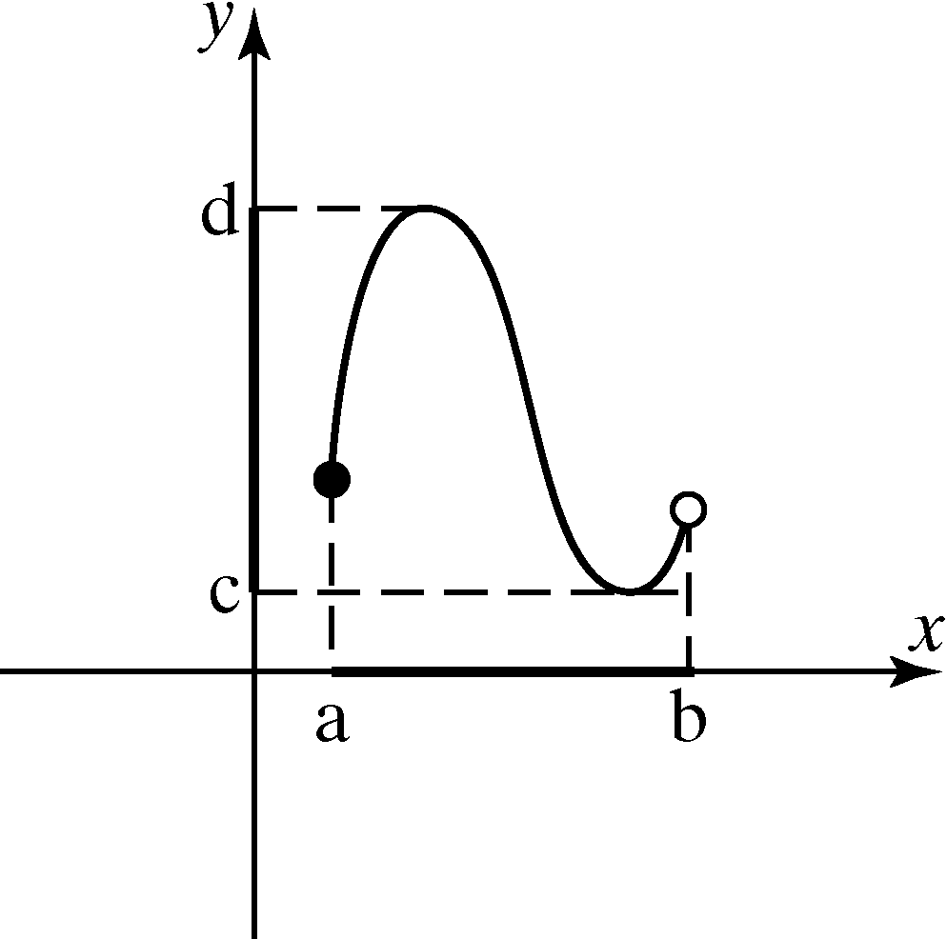

# Objective 3: Determining Where a Function is Increasing, Decreasing or Constant

The graph of *f* rises from left to right on the interval in which *f* is **increasing**.

The graph of *f* falls from left to right on the interval in which *f* is **decreasing**.

A graph is **constant** on an open interval if the values of do not change as *x* gets larger on the interval. In this case, the graph is a horizontal line on the interval.

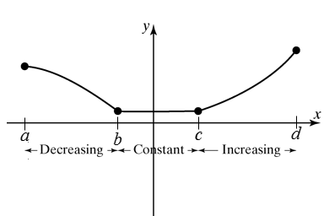

The function shown above is increasing on the interval .

The function shown above is decreasing on the interval .

The function shown above is constant on the interval .

# Objective 4: Determining Relative Maximum and Relative Minimum Values of a Function

When a function changes from increasing to decreasing at a point , then *f* is said to have a relative maximum at . The relative maximum value is .

Similarly, when a function changes from decreasing to increasing at a point , then *f* is said to have a relative minimum at . The relative minimum value is .

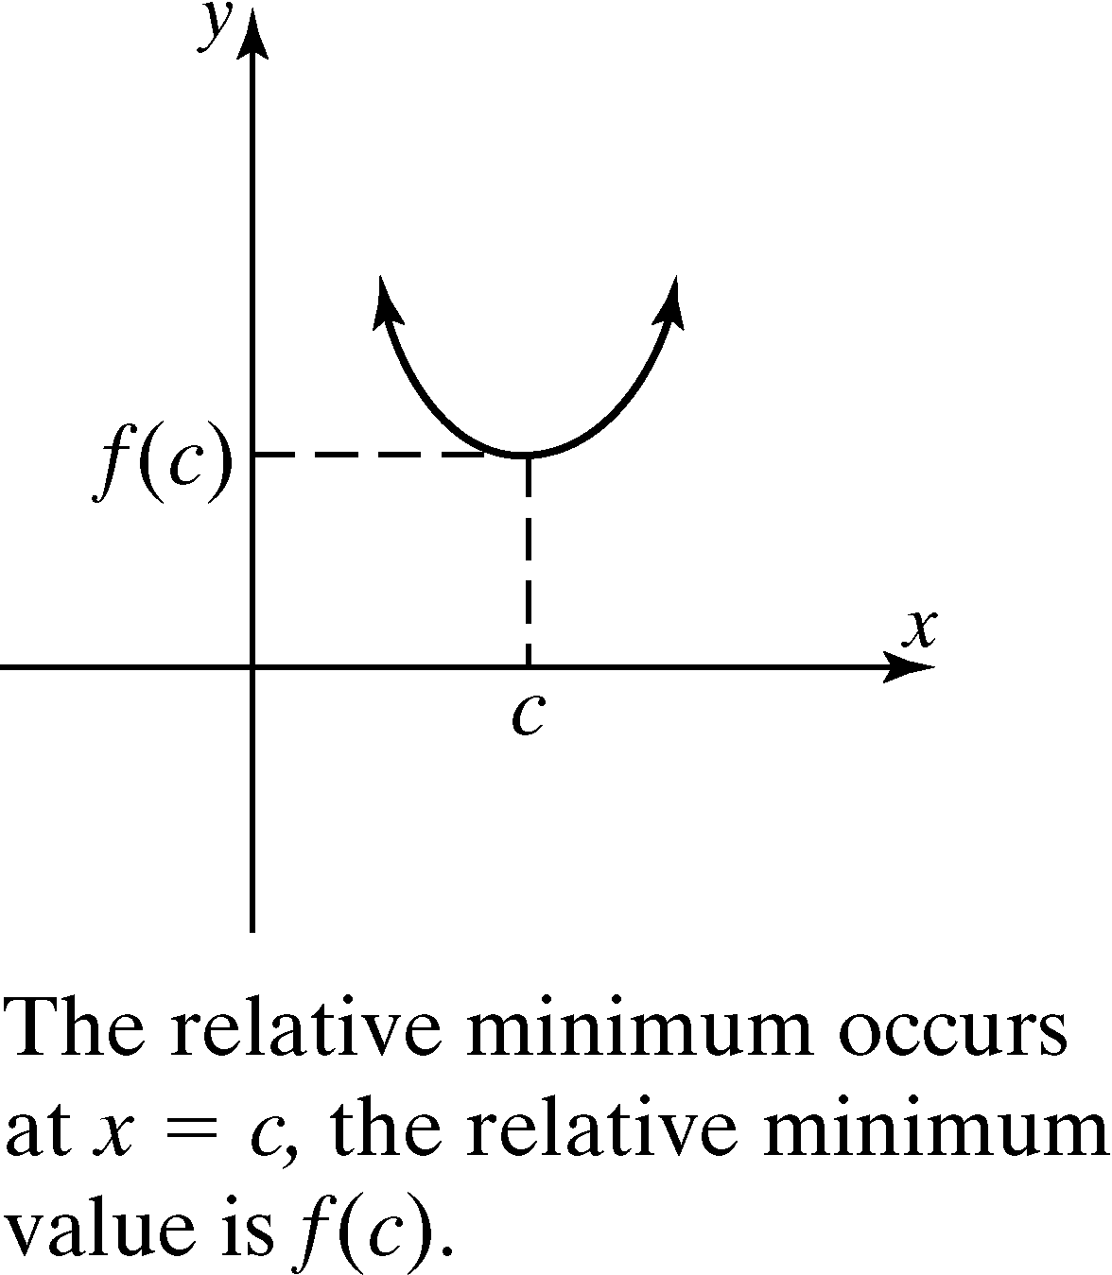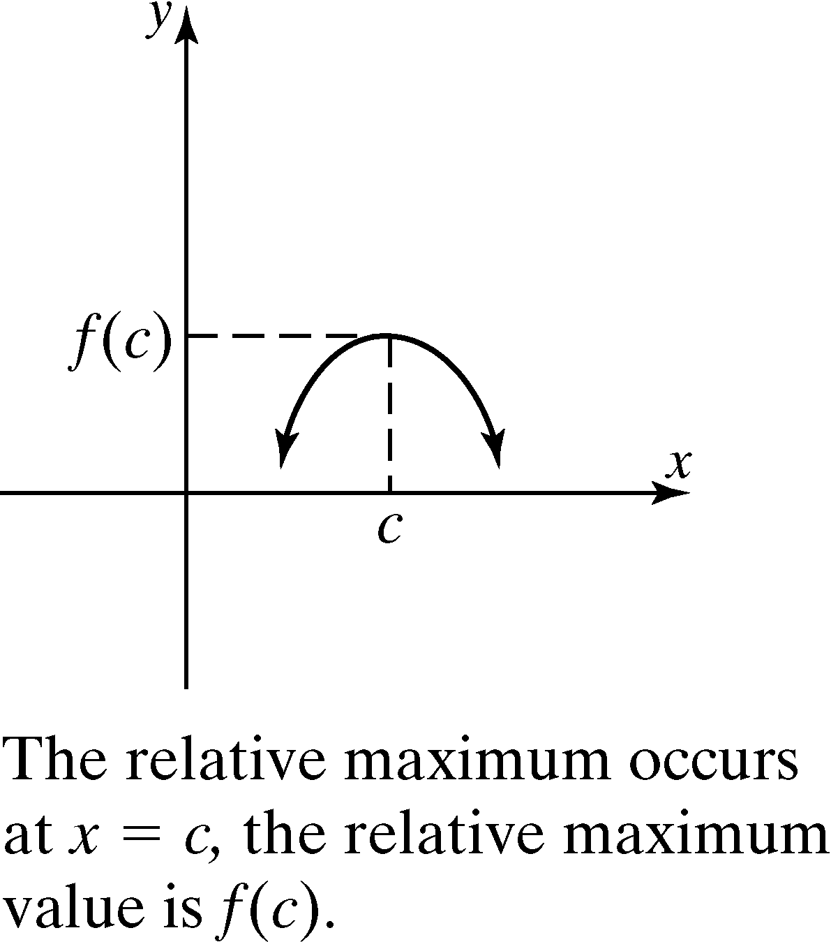

The word “relative” indicates that the function obtains a maximum or minimum value relative to some open interval. It is not necessarily the maximum (or minimum) value of the function on the entire domain.

 A relative maximum cannot occur at an endpoint and must occur in an open interval. This applies to a relative minimum as well.

# Objective 5: Determining if a Function is Even, Odd or Neither

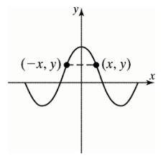 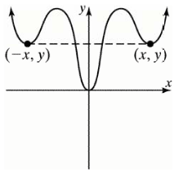 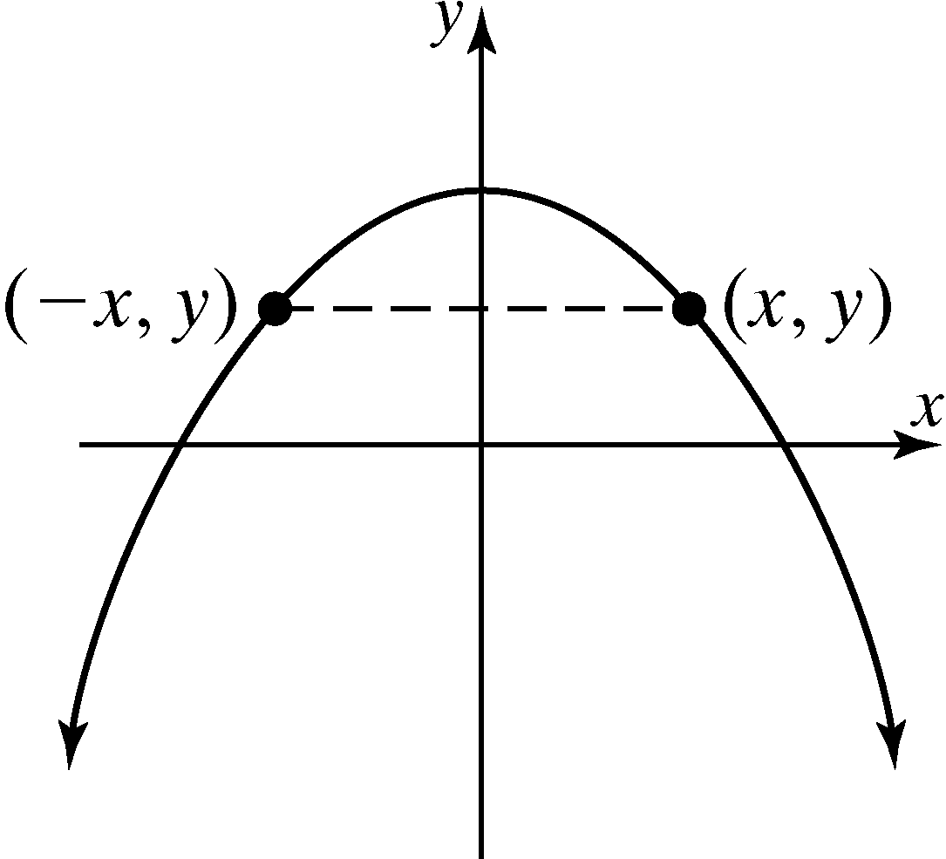

***Definition*:** A function *f* is **even** if for every *x* in the domain, . Even functions are symmetric about the *y-*axis. For each point  on the graph, the point is also on the graph.

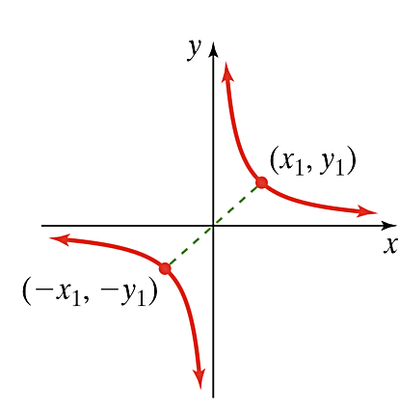 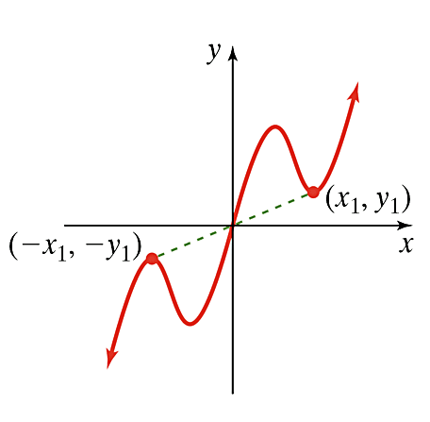 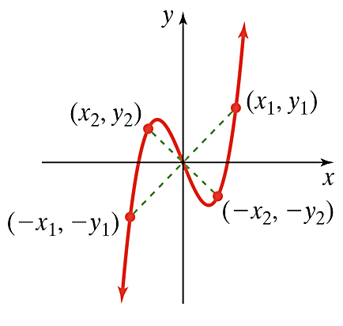

***Definition*:** A function *f* is **odd** if for every *x* in the domain, . Odd functions are symmetric about the origin. For each point  on the graph, the point is also on the graph.

# Objective 6: Determining Information about a Function from a Graph