Section 3.2 Proving Lines are Parallel

# Objective 1: Using Theorems to Prove that Two Lines Are Parallel

**Postulate: Parallel Postulate**

Through a point not on a line, there is one and only one line parallel to the given line.

When two lines are parallel, we indicate this by using the same number of arrows on the two lines.

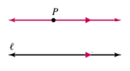

**Postulate: Perpendicular Postulate**

Through a point not on a line, there is one and only one line perpendicular to the given line.

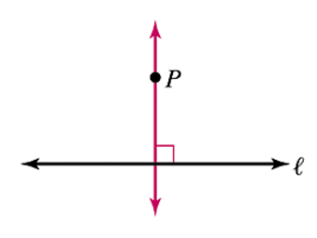

**Theorem*: Two Lines Perpendicular to a Third Line**

In a plane, if two lines are perpendicular to the same line, then they are parallel to each other.

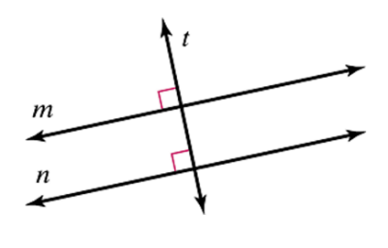

If  and , then .

**Theorem*: Alternate Interior Angles Theorem**

If two lines and a transversal form alternate interior angles that are congruent, then the two lines are parallel.

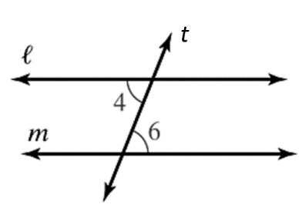

 and  are alternate interior angles formed when lines *l* and *m* are cut by transversal *t*. If , then .

*\*We know all the postulates and theorems required to prove that these theorems are true, but we do need to learn about other proof techniques first. Therefore, the proofs will be shown later in the course.*

**Theorem: Corresponding Angles Theorem**

If two lines and a transversal form corresponding angles that are congruent, then the two lines are parallel.

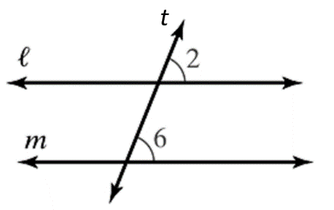

 and  are corresponding angles formed when lines *l* and *m* are cut by transversal *t*. If , then .

a. Write a two-column proof of this theorem using the Alternate Interior Angles Theorem.

Given: 

Prove: 

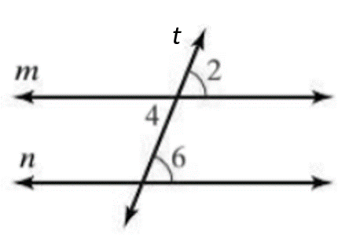

A **flow proof** is another form of proof in which arrows are used to show the logical connections between the statements. Reasons are written below the statements.

b. Write a flow proof of the Corresponding Angles Theorem.

**Theorem: Same-Side Interior Angles Theorem**

If two lines and a transversal form same-side interior angles that are supplementary, then the two lines are parallel.

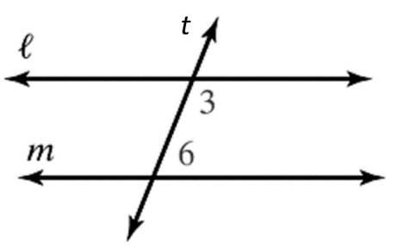

 and  are same-side interior angles formed when lines *l* and *m* are cut by transversal *t*. If , then .

c. Write a two-column proof of the Same-Side Interior Angles Theorem.

**Theorem: Alternate Exterior Angles Theorem**

If two lines and a transversal form alternate exterior angles that are congruent, then the two lines are parallel.

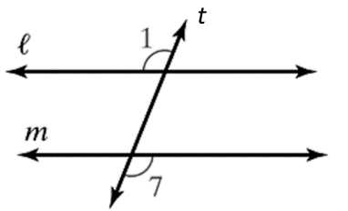

 and  are alternate exterior angles formed when lines *l* and *m* are cut by transversal *t*. If , then .

*The proof of this theorem is left as an exercise.*

a. Use the figure below to answer the following questions.

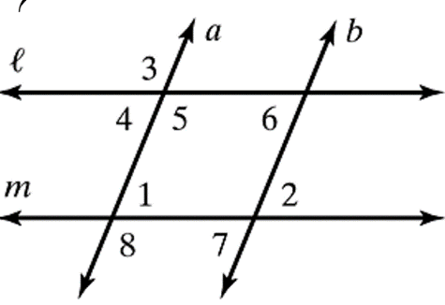

i. Which lines are parallel if ? Justify your answer.

ii. Which lines are parallel if ? Justify your answer.

iii. If , can it be determined that ?

iv. If , can it be determined that ?

b. Which lines, if any, are parallel in the given figures?

i.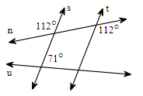

ii. 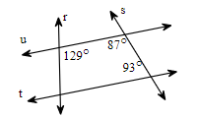

# Objective 2: Use Algebra to Find the Measures of Angles Needed so that Lines are Parallel

Find the value of *x* that makes .

a.

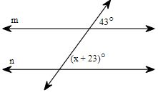

b.

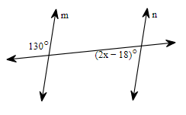

c.

