Section 3.2 Properties of a Function’s Graph

# Review of Solving Quadratic Equations and Higher Order Polynomial Equations by Factoring

Recall from sections 1.4 and 1.6 that some quadratic equations and some higher order polynomial equations can be solved using factoring techniques.

Previously, we discussed finding the intercepts when given an equation in two variables. Now, we consider the intercepts of a function.

# Objective 1: Determining the Intercepts of a Function

An **intercept** of a functionis a point on the graph of a function where the graph either crosses or touches a coordinate axis. There are two types of intercepts:

1) The *y*-intercept, which is the *y*-coordinate of the point where the graph crosses or touches the *y*-axis.   
2) ­The *x*-intercepts, which are the *x*-coordinates of the points where the graph crosses or touches the *x-*axis.

**The *y*-intercept**:   
A function can have **at most** one *y*-intercept. The *y­*-intercept exists if  is in the domain of the function. The *y-*intercept can be found by evaluating 

**The *x*-intercept(s):**A function may have several (even infinitely many) *x*-intercepts. The *x*-intercepts, also called **real zeros,** can be found by finding all *real solutions* to the equation. Although a function may have several zeros, only the real zeros are *x*-intercepts.

# Objective 2: Determining the Domain and Range of a Function from its Graph

The domain of the graph below is the interval  while the range is the interval .

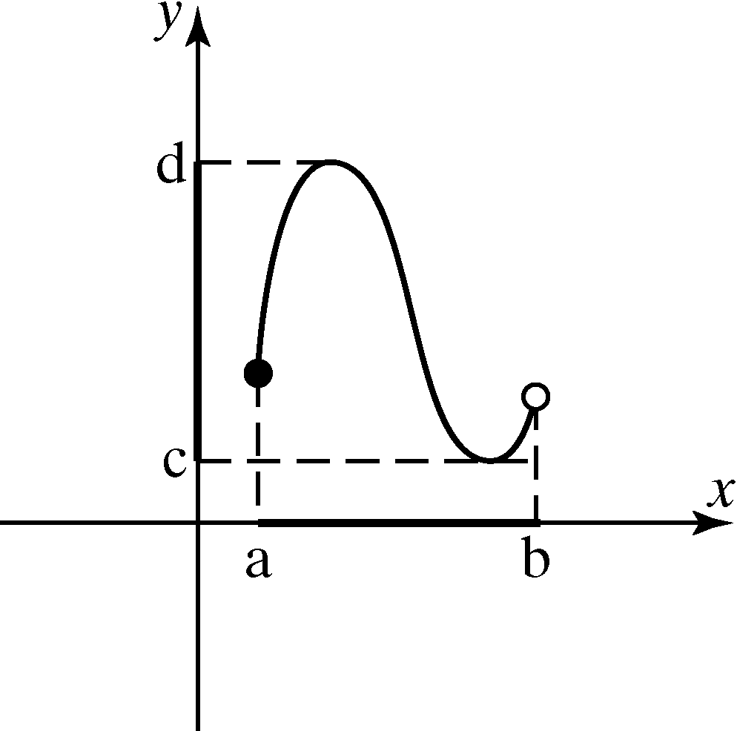

# Objective 3: Determining Where a Function is Increasing, Decreasing or Constant

The graph of *f* rises from left to right on an open interval on which *f* is **increasing**. The values of  get larger as x gets larger on the interval.

The graph of *f* falls from left to right on an open interval in which *f* is **decreasing**. The values of  get smaller as x gets larger on the interval.

The graph of *f* is a horizontal line on an open interval in which *f* is **constant**. The values of do not change as *x* gets larger on the interval.

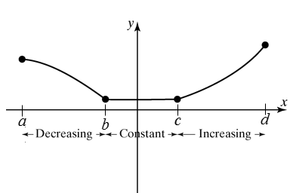

The function shown above is increasing on the interval .

The function shown above is decreasing on the interval .

The function shown above is constant on the interval .

# Objective 4: Determining Relative Maximum and Relative Minimum Values of a Function

When a function changes from increasing to decreasing at a point , then *f* is said to have a relative maximum at . The relative maximum value is .

Similarly, when a function changes from decreasing to increasing at a point , then *f* is said to have a relative minimum at . The relative minimum value is .

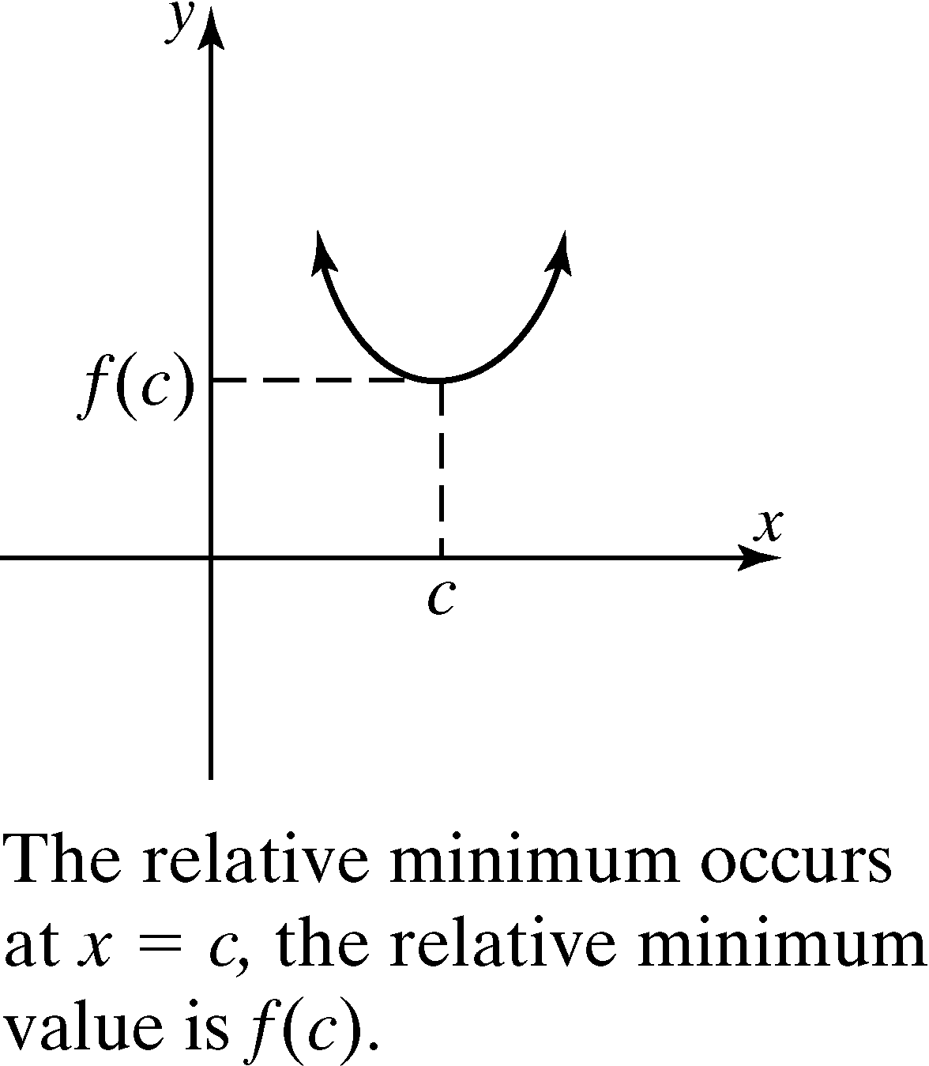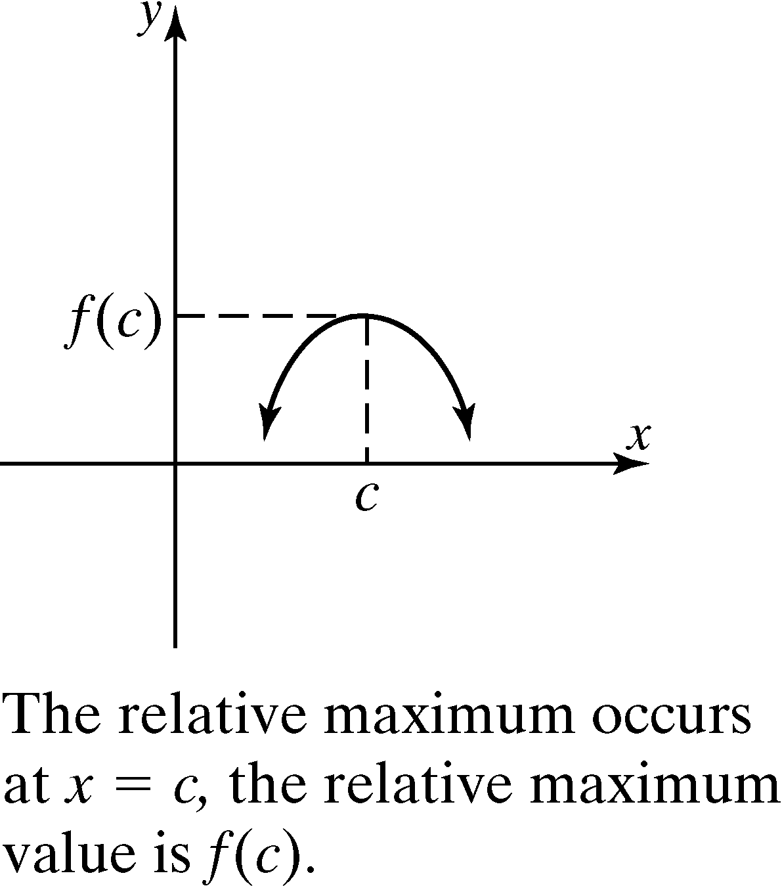

The word “relative” indicates that the function obtains a maximum or minimum value relative to some open interval. It is not necessarily the maximum (or minimum) value of the function on the entire domain.

 A relative maximum cannot occur at an endpoint and must occur in an open interval. This applies to a relative minimum as well.

# Objective 5: Determining if a Function is Even, Odd or Neither

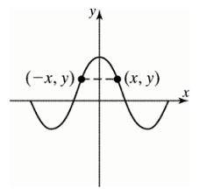 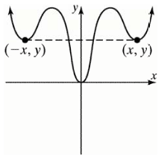 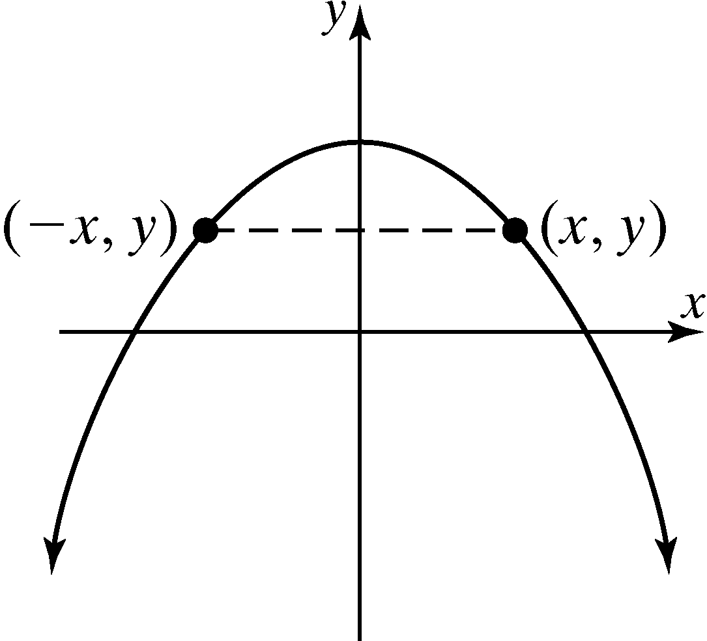

***Definition*:** A function *f* is **even** if for every *x* in the domain, . Even functions are symmetric about the *y-*axis. For each point  on the graph, the point is also on the graph.

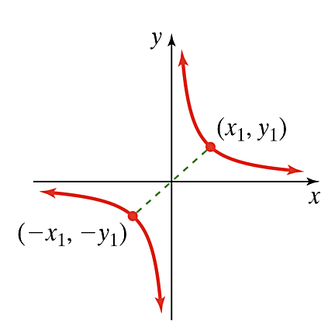 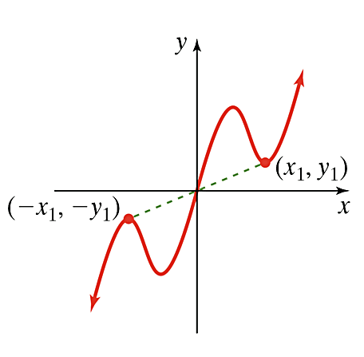 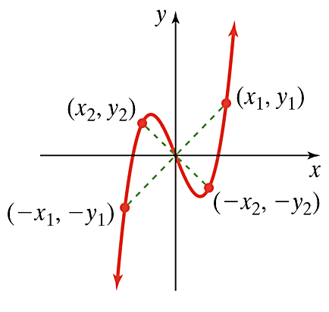

***Definition*:** A function *f* is **odd** if for every *x* in the domain, . Odd functions are symmetric about the origin. For each point  on the graph, the point is also on the graph.

# Objective 6: Determining Information about a Function from a Graph