Section 3.3 Graphs of Basic Functions; Piecewise Functions

**Objective 1: Sketching the Graphs of the Basic Functions**

We begin by discussing the graphs of two specific linear functions. Recall that a linear function has the form  where *m* is the slope of the line and *b* represents the *y­-*coordinate of the *y*-intercept.

We start our discussion of the basic functions by looking at the **constant function**, that is, the linear function with , the graph of which is a horizontal line.

1. The **Constant Function** hasdomain  and range .

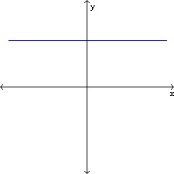

*Notice that there are no arrows used at either end of the graph representing the constant function above. From this point forward in the text, unless the graph contains a definitive endpoint (shown by either an open dot or a closed dot) then it will be understood that the graph extends indefinitely in the same direction.*

The **identity function** defined by  is another linear function with  and  It assigns to each number in the domain the exact same number in the range.

1. The **Identity Function** has domain****and range**.**

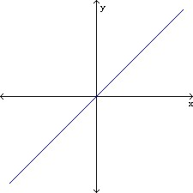

The **square function,** , assigns to each real number in the domain the square of that number in the range. The “u-shaped” graph of the square function is called a parabola.

1. The **Square Function** has domain  and range .

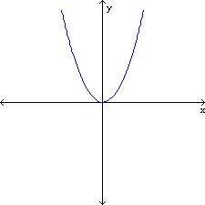

The **cube function**, , assigns to each real number in the domain the cube of that number in the range.

1. The **Cube Function** has domain  and range **.**

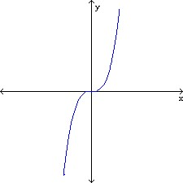

The **absolute value function**, , assigns to each real number in the domain the absolute value of that number in the range.

1. The **Absolute Value Function**has domain  and range .

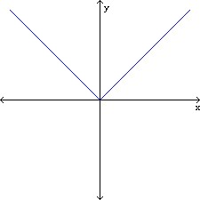

The **square root function**, , is only defined for values of *x* that are greater than or equal to zero. It assigns to each real number in the domain the square root of that number in the range.

1. The **Square Root Function**  has domainand range .

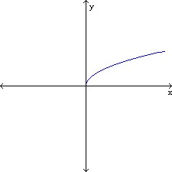

Unlike the square root function which is only defined for values of *x* greater than or equal to zero, the **cube root function, ,** is defined for all real numbers and assigns to each number in the domain the cube root of that number in the range.

1. The **Cube Root Function**  has domain  and range **.**

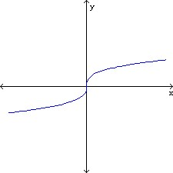

The **reciprocal function**, , is a rational function whose domain is . It assigns to each number *a* in the domain its reciprocal, , in the range. The reciprocal function has two asymptotes. The *y*-axis (the line ) is a vertical asymptote and the *x*-axis (the line) is a horizontal asymptote**.**

1. The **Reciprocal Function** has domain  and range .

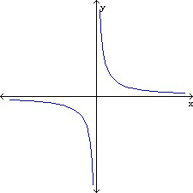

**Objective 2: Sketching the Graphs of Basic Functions with Restricted Domains**

**Objective 3: Analyzing Piecewise Defined Functions**

The absolute value function, , can also be defined by a rule that has two different “pieces.”



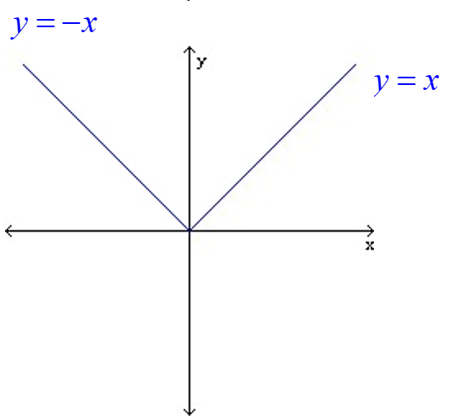

You can see by the graph above that the “left-hand piece” is actually a part of the line  while the “right-hand piece” is a part of the line.

Functions defined by a rule that has more than one “piece” are called piecewise-defined functions.