Section 3.3 Parallel Lines and Angles Formed by Transversals

# Objective 1: Proving and Using Theorems About Parallel Lines and Transversals

A statement of the form “If p, then q” is called a conditional statement. The converse of this statement is “If q, then p”. If the conditional statement is true, then the converse may or may not be true. In this section, we will prove and use the converses of some previously proven theorems regarding angles and parallel lines.

**Theorem*: Alternate Interior Angles Converse**

If two parallel lines are cut by a transversal, then alternate interior angles are congruent.

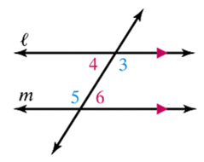

If , then  and .

*\*This theorem can be proven with only the definitions and postulates we know and with only theorems we have previously proven. However, the proof requires the technique of Indirect Proof and will be presented later in this course.*

**Theorem: Corresponding Angles Converse**

If two parallel lines are cut by a transversal, then corresponding angles are congruent.

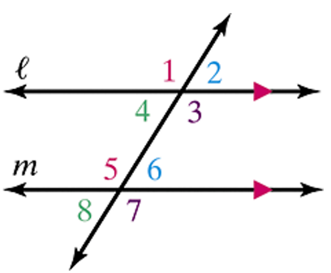

If , then , , , and .

a. Write a two-column proof of the Corresponding Angles Converse.

*The following two theorems can be proven similarly.*

**Theorem: Same-Side Interior Angles Converse**

If two parallel lines are cut by a transversal, then same-side interior angles are supplementary.

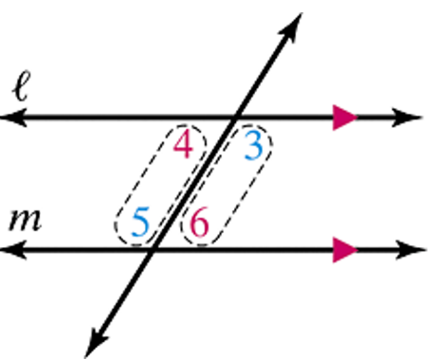

If , then  .

**Theorem: Alternate Exterior Angles Converse**

If two parallel lines are cut by a transversal, then alternate exterior angles are congruent.

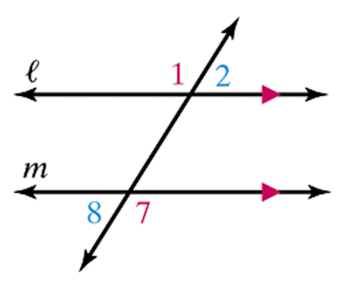

If , then  and .

b. Find the measures of the numbered angles in the figures shown. Justify your answers.

i.

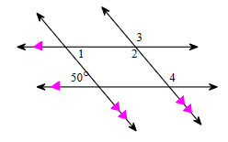

ii.

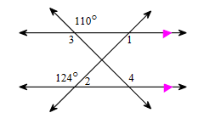

c. Given  and , prove .

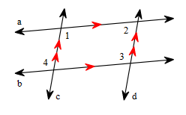

# Objective 2: Using Algebra to Find the Measures of Angles Formed by Parallel Lines and a Transversal

Find the measures of the labeled angles.

a.

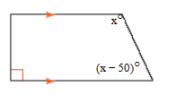

b.

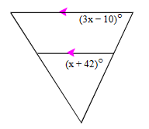

c.

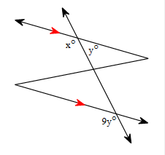

d.

