Section 3.4 Proving Theorems About Parallel and Perpendicular Lines

# Objective 1: Using and Proving Parallel and Perpendicular Theorems

**Theorem: Perpendicular Transversal Theorem**

*In a plane*, let two parallel lines be cut by a transversal. If the transversal is perpendicular to one of the parallel lines, then it is perpendicular to the other parallel line.

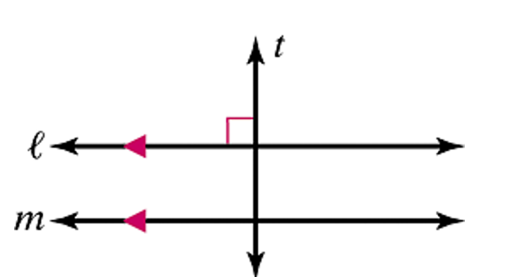

If  and , then .

a. Prove the Perpendicular Transversal Theorem.

b. In the figure shown, line  is parallel to line , and line  is perpendicular to line . What is the relationship between line  and line ?

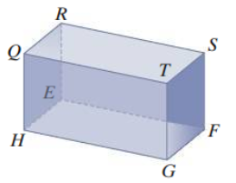

**Theorem: Two Lines Parallel to a Third Line**

If two lines are parallel to the same line, then all three lines are parallel to each other.

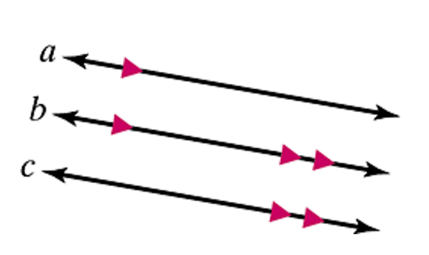

If  and , then .

c. Prove the Two Lines Parallel to a Third Line Theorem.

*Formal proofs of the two following theorems are left as exercises.*

**Theorem: If two lines are perpendicular, then they intersect to form four right angles.**

**Theorem: If two lines intersect to form a linear pair of congruent angles, then the lines are perpendicular to each other.**

# d. The distinct lines a, b, c, and d are in the same plane. Draw a diagram of the relationship given below, and then state the relationship between lines a and d. Justify your answer.

i. , , 

ii. , , 

e. Prove the following:

Given: In a plane, , , , and *a*, *b*, *c*, and *d* are all distinct lines.

Prove: 

# Objective 2: Using Algebra to Find the Measures of Angles with Perpendicular Lines

a. In the figure below,  and .

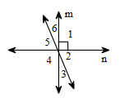

i. If , then what is ?

ii. If the measure of angle 5 is twice the measure of angle 6, find  and .