Section 3.6 One-to-one Functions; Inverse Functions

# Objective 1: Understanding the Definition of a One-to-one Function

***Definition*:** A function *f* is **one-to-one** if for any values in the domain of *f*, .

Interpretation: For  to be a function, we know that for each *x* in the domain there exists one and only one *y* in the range. For to be a one-to-one function*,* both of the following must be true: for each *x* in the domain there exists one and only one *y* in the range, AND for each *y* in the range there exists one and only one *x* in the domain.

# Objective 2: Determining if a Function is One-to-one Using the Horizontal Line Test

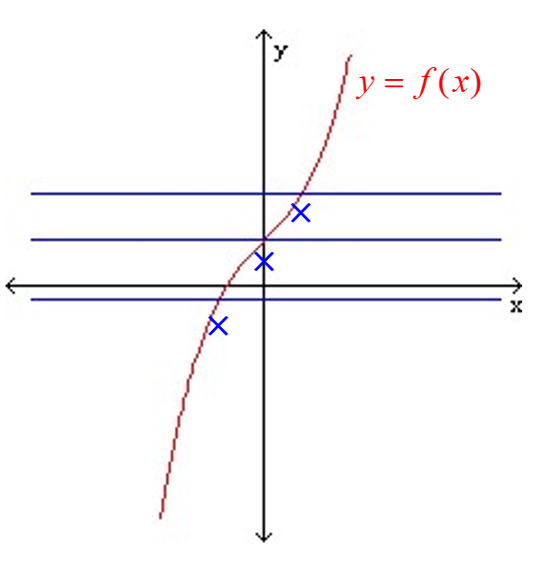 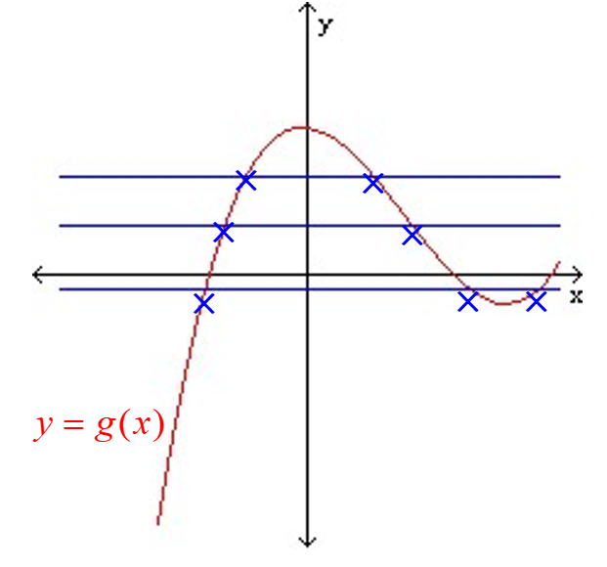

**The Horizontal Line Test**

If every horizontal line intersects the graph of a function *f* at most once, then *f* is one-to-one.

# Objective 3: Understanding and Verifying Inverse Functions

Every one-to-one function has an inverse function.

***Definition*:** Let *f* be a one-to-one function with domain *A* and range *B*. Then  is **the inverse function of** ***f*** with domain *B* and range *A*. Furthermore, if  then .

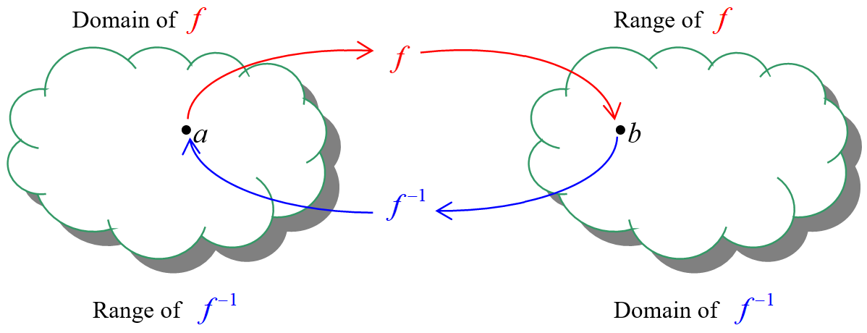

Do not confuse  with . The negative 1 in  is NOT an exponent!

Inverse functions “undo” each other.

**Composition Cancellation Equations:**

 for all *x* in the domain of 

 for all *x* in the domain of *f*

# Objective 4: Sketching the Graphs of Inverse Functions

The graph of  is a reflection of the graph of *f* about the line .

If the functions have any points in common, they must lie along the line .

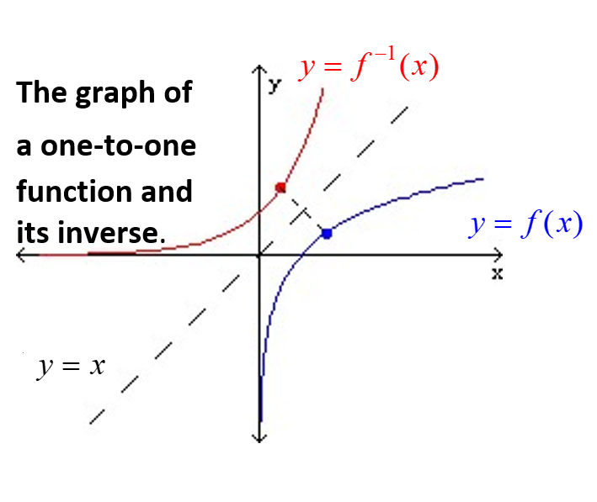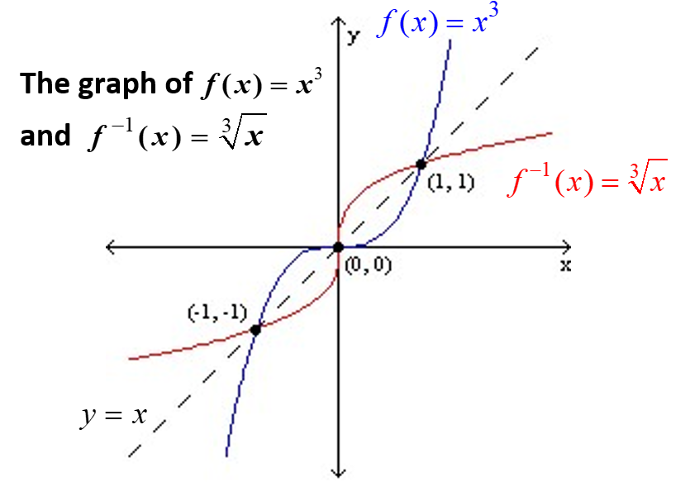

# Objective 5: Finding the Inverse of a One-to-one Function

We know that if a point is on the graph of a one-to-one function, then the point is on the graph of its inverse function.

To find the inverse of a one-to-one function, replace  with *y,* interchange the variables *x* and *y*, and then solve for *y.* This is the function .

**Inverse Function Summary**

1. The inverse function exists if and only if the function *f* is one-to-one.
2. The domain of *f* is the same as the range of  and the range of *f* is the same as the domain of .
3. To verify that two one-to-one functions *f* and *g* are inverses of each other, use the composition cancellation equations to show that .
4. The graph of  is a reflection of the graph of *f* about the line . That is, for any point that lies on the graph of *f,* the point  must lie on the graph of .
5. To find the inverse of a one-to-one function, replace  with *y,* interchange the variables *x* and *y*,and then solve for *y.* This is the function .