Section 4.1 Quadratic Functions

# Objective 1: Understanding the Definition of a Quadratic Function and its Graph

**Definition:** A **quadratic function** is a function of the form  where *a*, *b*, and *c* arereal numbers with  Every quadratic function has a “u-shaped” graph called a *parabola*.

The five basic characteristics of a parabola are its

1. vertex
2. axis of symmetry
3. *y*-intercept
4. *x*-intercept(s) or real zeros, and
5. domain and range.

# Objective 2: Graphing Quadratic Functions Written in Vertex Form

**Vertex Form of a Quadratic Function**

A quadratic function is in **vertex form** if it is written as.

The graph is a parabola with vertex .

The parabola “opens up” if a > 0, and the parabola “opens down” if a < 0.

The domain of the function is .

The line  is the axis of symmetry.

The range is  if a > 0, and the range is  if a < 0.

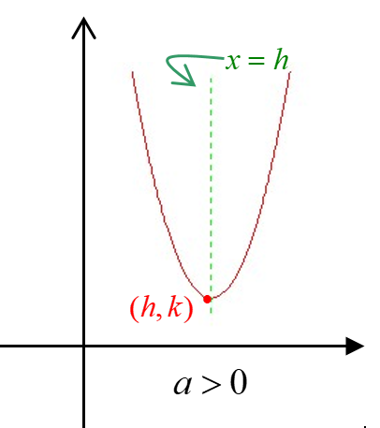 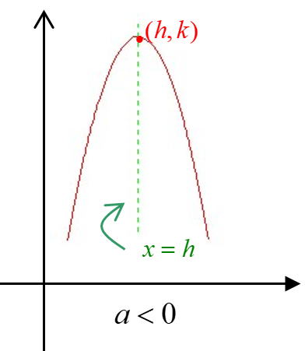

# Objective 4: Graphing Quadratic Functions Using the Vertex Formula

**Formula for the Vertex of a Parabola**

Given a quadratic function of the form, the vertex of the parabola is .

# Objective 5: Determining the Equation of a Quadratic Function Given its Graph