Section 4.1 Types of Triangles

# Objective 1: Learn the Vocabulary of Triangles

A **triangle** is formed by 3 noncollinear points connected by segments. The noncollinear points are called **vertices** (singular is **vertex**). The segments joining the points are called **sides**.

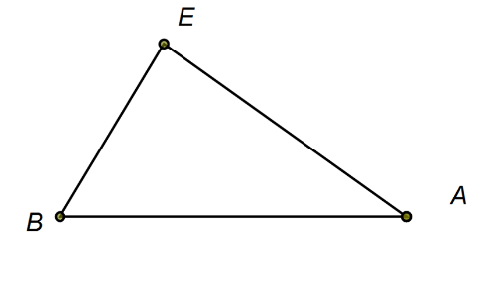

The triangle shown above is named (or  or ). Points *E*, *B*, and *A* are the vertices. The sides are the segments , , and .

**Adjacent sides** are two sides that share a common vertex. In the triangle above,  and  are adjacent sides.

The side not adjacent to an angle is called the **side opposite the angle**. In the triangle above, side  is opposite .

In the triangle above,  is the **included** side of and , and  is the **included** angle of sides  and .

a. Given a triangle with vertices *P*, *Q*, and *R*, answer the following:

i. Which angle is opposite side ?

ii. Which side is opposite  ?

iii. Which angle is included between  and  ?

iv. Which side is included between  and ?

v. Which sides are adjacent sides?

# Objective 2: Classify Triangles by Angles and Sides

Note: ‘equal angles’ means that the angles are equal in measure, and ‘equal sides’ means that the sides are equal in measure.

**Triangles Classified by Angles**

An **acute** triangle has all acute angles.

An **obtuse** triangle has one obtuse angle.

An **equiangular** triangle has all angles equal.

A **right** triangle has one right angle.

**Triangles Classified by Sides**

A **scalene** triangle has no equal sides.

An **isosceles** triangle has at least two equal sides.

An **equilateral** triangle has all sides equal.

Equal sides are indicated with the same number of tick marks per side, and equal angles are indicated with the same number of arcs per angle.

Read the definitions of isosceles triangle and equilateral triangle carefully! The conditional statement “If a triangle is equilateral, then it is isosceles.” is true, but its converse “If a triangle is isosceles, then it is equilateral.” is false.

A **right triangle** has special names for its sides: The longest side is opposite the right angle and is called the **hypotenuse**. The other two sides are called the **legs**.

An **isosceles triangle** also has special names for its sides: Two congruent sides are called the **legs**, and the third side is called the **base**.

a. Classify each triangle by angles and by sides. Use the most specific name. Figures are not drawn to scale.

i. A triangle with angles measuring 52°, 84°, and 44° and no equal sides.

ii.

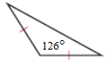

iii.

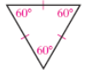

iv.

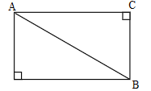

# Objective 3: Find Angle Measures of Triangles

Start with  and extend the 3 sides of the triangle. The three original angles of the triangle are called the interior angles of the triangle. The angles adjacent to the interior angles are called the exterior angles of the triangle. Each interior angle has two exterior angles associated with it. However, these two exterior angles are congruent vertical angles, and it is customary to show only one exterior angle with each interior angle. This is illustrated in the figure below.

There are three pictures of triangle A B C.  The first shows the sides extended and interior angles 1, 2, and 3.  The exterior angles are shown in the second figure with angles 4 and 5 adjacent to angle 1, angles 9 and 8 adjacent to angle 2, and angles 7 and 6 adjacent to angle 3.  In the 3rd figure only angles 6, 4, and 9 are shown.


a. Which of the numbered angles are exterior angles of the triangle?

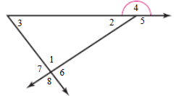

**Theorem: Triangle Angle-Sum Theorem**

The sum of the measures of the interior angles of a triangle is 180°.

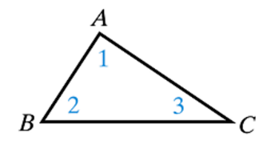

Given: 

Prove: 

The first step in this proof is a construction: By the Parallel Postulate, there is only one line through point *A* that is parallel to side . Construct this line and label points *D* and *E* on this line, one on each side of point *A*.

b. Complete the proof of the Triangle Angle-Sum Theorem.

A **corollary** is a special name given to a theorem that is easy to prove as a direct result of another previously proven theorem.

*The proofs of the following two corollaries are left as homework exercises.*

**Corollary: Exterior Angle of a Triangle**

The measure of each exterior angle of a triangle equals the sum of the measures of its two nonadjacent interior angles.

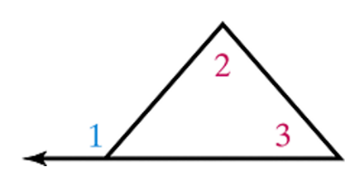



**Corollary: Acute Angles of a Right Triangle**

The two acute angles of a right triangle are complementary.

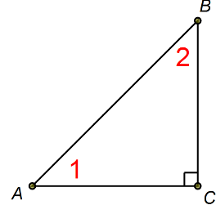



c. Find the measure of each indicated angle.

i.

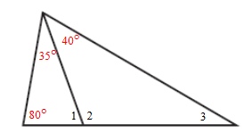

ii.

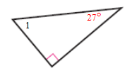

d. Find the value(s) of the variables in each figure.

i.

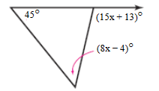

ii.

