Section 4.2 Congruent Figures

**Congruent figures** have the exact same shape and size.

# Objective 1: Identify Corresponding Parts in Congruent Figures

When figures are congruent, their **corresponding sides** are congruent, and their **corresponding angles** are congruent.

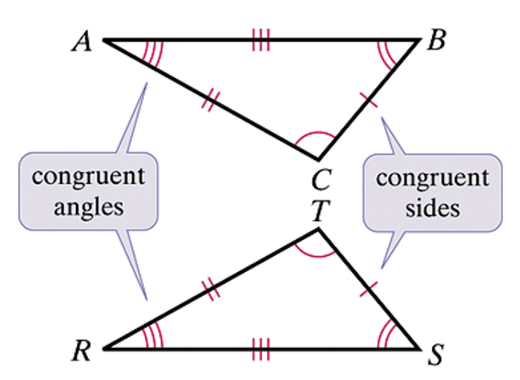

In the figure above, congruent sides are marked with equal numbers of tick marks, and equal angles are marked with equal numbers of arcs.

It is important in writing the congruent figures that you list the congruent angles in the same order. For the triangles shown above, you could correctly say  or , for example, but it would *not* be correct to say .

a. Given , complete the following statements:

i.  ?

ii.  ?

iii.  ?

b. Complete the congruence statement based on the figure shown. Is your answer unique?

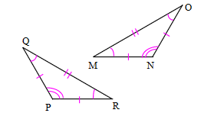

 ?

**Theorem: Third Angles Theorem**

If two angles of one triangle are congruent to two angles of another triangle, then the third angles are congruent.

*The proof of this theorem is left as an exercise.*

c. If , find the values of *x* and *y* in the figure below.

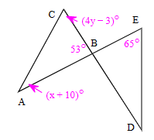

d. If find the value of *x*, if possible, given , , , and 

# Objective 2: Prove Triangles are Congruent

Two triangles are congruent if they have the same shape and size. This means all three pairs of corresponding sides are congruent and all three pairs of corresponding angles are congruent.

*As you proceed through this course, you will learn ‘shortcuts’ for proving triangles are congruent.*

a. Write a congruence statement for each pair of triangles shown.

