Section 4.2 Applications and Modeling of Quadratic Functions

With application problems involving functions, we are often interested in finding the maximum or minimum value of the function. For example, a professional golfer may want to control the trajectory of a struck golf ball. Thus, he may be interested in determining the maximum height of the ball given certain parameters such as swing velocity and club angle. An economist may want to minimize a cost function or maximize a revenue or profit function. A builder with a fixed amount of fencing may want to maximize an area function.

In a calculus course, you will learn how to maximize or minimize a wide variety of functions. In this section, we will concentrate only on quadratic functions. Quadratic functions are relatively easy to maximize or minimize because we know a formula for finding the coordinates of the vertex. Recall that if, we know that the coordinates of the vertex are . If *a* > 0, the parabola *opens up* and has a minimum value at the vertex. If *a* < 0, the parabola *opens down* and has a maximum value at the vertex.

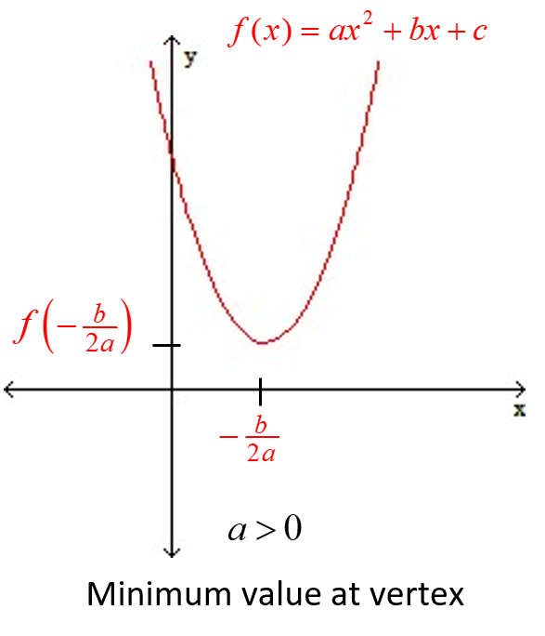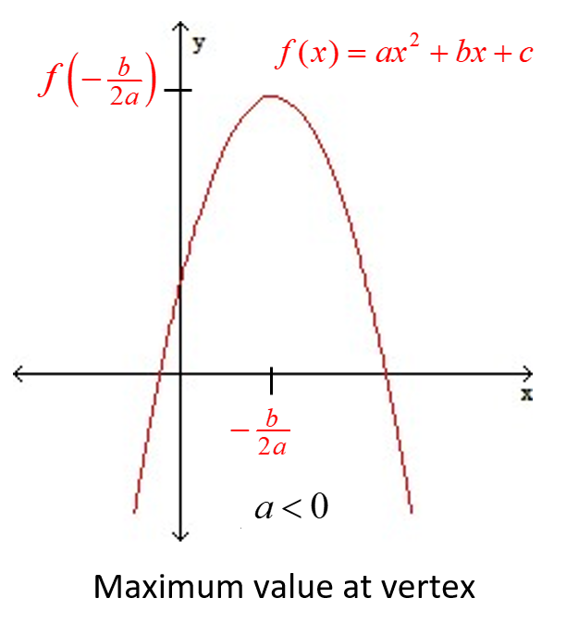

**Objective 1 Maximizing Projectile Motion Functions**

An object launched, thrown, or shot vertically into the air with an initial velocity of  meters/second (m/s) from an initial height of  meters above the ground can be modeled by the function  where is the height of the projectile *t* seconds after its departure*.

*Note that the leading coefficient of the projectile motion model is . This constant is derived using calculus and the acceleration of gravity on earth, which is 9.8 meters per second per second. If the height was measured in feet, the leading coefficient of the projectile motion model would be derived using calculus and acceleration of gravity on earth, which is 32 feet per second per second. **Objective 2 Maximizing Functions in Economics (Math 1021 only)**

Revenue is defined as the dollar amount received by selling *x* items at a price of *p* dollars per item, that is, . For example, if a child sells 50 cups of lemonade at a price of $0.25 per cup, then the revenue generated is  . The Law of Supply and Demand states that as the quantity, *x*,increases, the price, *p,* tends to decrease. Likewise, if the quantity decreases, the price tends to increase.

**Objective 2 Maximizing Area Functions (Math 1023 only)**

Suppose you are asked to use 3000 feet of fencing to build a rectangular enclosure that borders a river. No fencing will be required along the side of the river. There are infinitely many ways to construct such an enclosure, but there is only one way to build the enclosure in order to maximize its area.