Section 4.3 The Graphs of Polynomial Functions

# Objective 1: Understanding the Definition of a Polynomial Function

***Definition*:** The function  is a **polynomial function**

**of degree *n*** where *n* is a nonnegative integer. The numbers  are called the **coefficients** of the polynomial function. The numberis called **the leading coefficient** and is called the **constant coefficient**.

# Objective 2: Sketching the Graphs of Power Functions

The graphs of five power functions are shown below:

**(a)  (b)  (c)  (d)  (e) **

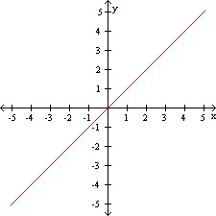 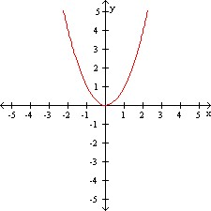 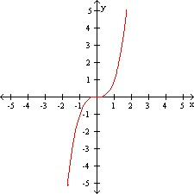 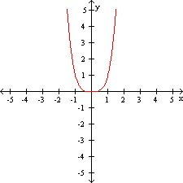 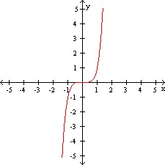

# Objective 3: Determining the End Behavior of Polynomial Functions

**Process for Determining the End Behavior of a Polynomial Function**

**.**

If the degree *n* is odd, the graph has opposite left-hand and right-hand end behavior, that is, the graph “starts” and “finishes” in **opposite** directions.

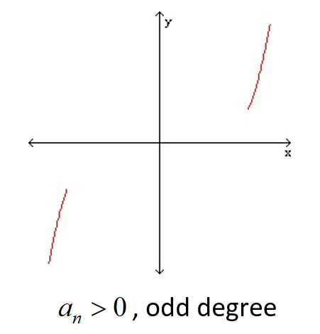 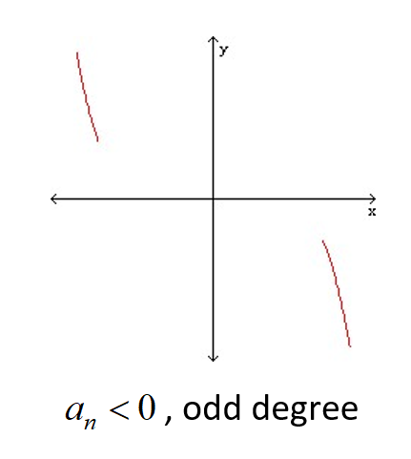

If the degree *n* is even, the graph has the same left-hand and right-hand end behavior, that is, the graph “starts” and “finishes” in the **same** direction.

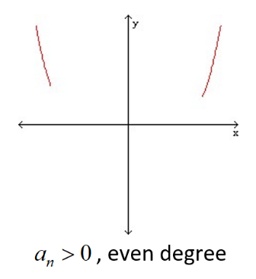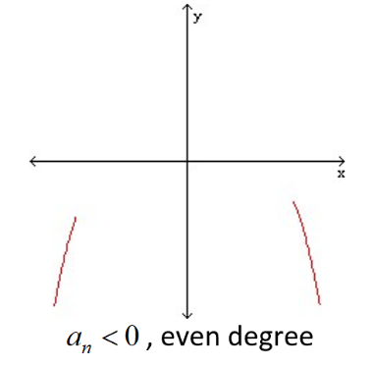

When a polynomial is given in factored form, the sign of the leading coefficient and the degree of the polynomial are not obvious, and it is usually not convenient, nor is it necessary, to multiply the polynomial out completely to get it in the form  where they are visible. We need only determine the term . Here is an example:

Let .

First, we notice that  is a factor of .

Next, consider. If we were to raise  to the 6th power, the largest power of *x* we would obtain is  . The coefficient of  would be 1 since the coefficient of  is 1 and  . Therefore, contributes a factor of  to the term .

Finally, consider . If we were to raise  to the 3rd power, the largest power of *x* we would obtain is . The coefficient of  would be . Therefore, contributes a factor of to the term .

Multiplying the three factors we have found, we see that . This means the leading coefficient of *f* is positive and the degree of *f* is odd.

# Objective 4: Determining the Intercepts of a Polynomial Function

Every polynomial has a *y*-intercept that can be found by evaluating .

The number  is called a **zero** of a function *f* if . If *c* is a real number, then *c* is an *x-*intercept. Therefore, to find the *x*-intercepts of a polynomial function, we must find the real solutions of the equation.

# Objective 5: Determining the Real Zeros of Polynomial Functions and Their Multiplicities

**The Shape of the Graph of a Polynomial Function Near a Zero of Multiplicity *k****.*

Suppose *c* is a real zero of a polynomial function *f* of multiplicity *k*, that is,   
is a factor of *f*. Then the shape of the graph of *f* near *c* is as follows:

If  and *k* is even, then the graph touches the *x-*axis at *c.*

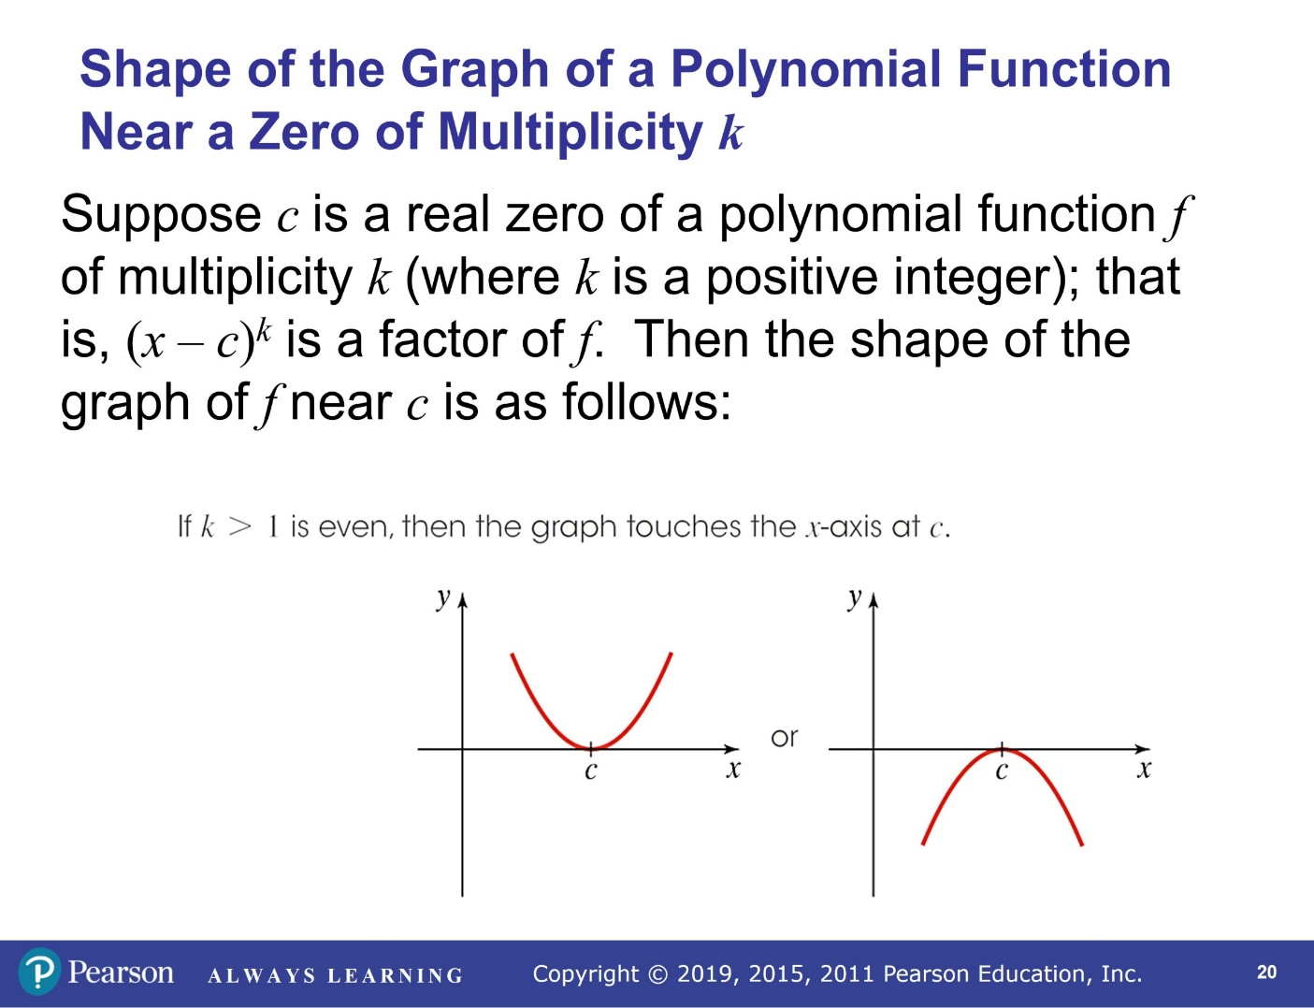

If and *k* is odd, then the graph crosses the *x*-axis at *c*.

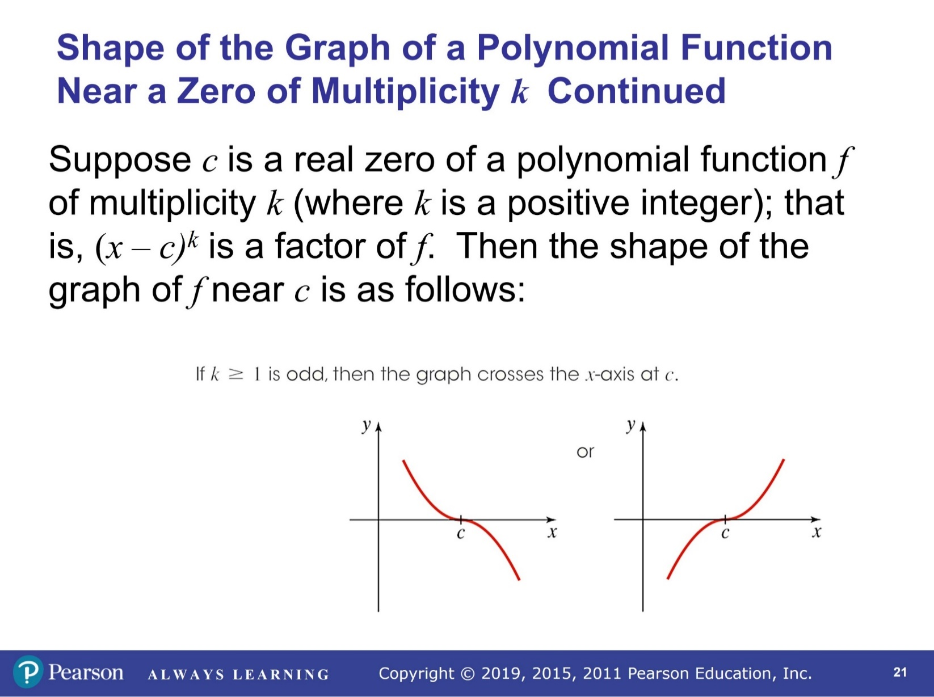

# Objective 6: Sketching the Graph of a Polynomial Function

**Four-Step Process for Sketching the Graph of a Polynomial Function**

1. Determine the end behavior.

2. Plot the y-intercept .

3. Completely factor *f* to find all real zeros and their multiplicities*.

4. Choose a test value between each real zero and sketch the graph.

(Remember, without calculus, there is no way to precisely determine the exact coordinates of the

turning points.)

**\*** This is the most difficult step and will be discussed in further detail in the subsequent sections of this chapter.

# Objective 7: Determining a Possible Equation of a Polynomial Function Given its Graph