Section 4.3 Congruent Triangles by SSS and SAS

# Objective 1: Prove Two Triangles are Congruent Using the SSS and SAS Postulates

If two triangles have three pairs of congruent corresponding angles and three pairs of congruent corresponding sides, then the two triangles are congruent. However, it is not necessary to show that *all* six pairs of corresponding parts are congruent.

Remember that a postulate is an accepted statement of fact; we do not need to prove it.

**Postulate: Side-Side-Side (SSS) Postulate**

If the three sides of one triangle are congruent to the three sides of another triangle, then the two triangles are congruent.

**Postulate: Side-Angle-Side (SAS) Postulate**

If two sides and the included angle of one triangle are congruent to two sides and the included angle of another triangle, then the two triangles are congruent.

a. Would you use SAS or SSS to prove the triangles are congruent, or is there not enough information to use either SAS or SSS? Explain your answer. If the triangles are congruent, write a congruence statement.

i. 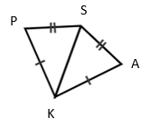 ii.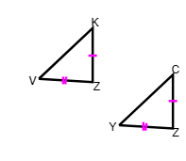 iii.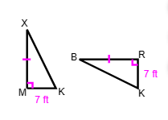

iv.  and  with , , and .

v.

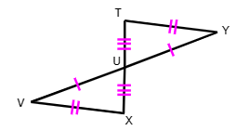

b. Given:  and 

Prove: 

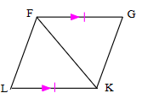

c. Use the distance formula to determine if the two triangles are congruent.





d. Given: , , and 

Prove: 

