Section 4.4 Congruent Triangles by ASA and AAS

# Objective 1: Prove Two Triangles are Congruent Using the ASA and AAS Postulates

We already know that we can prove two triangles are congruent if

* three pairs of sides are congruent (SSS), or if
* two pairs of sides and their included angles are congruent (SAS).

Here are two more ways to prove triangles are congruent.

**Postulate: Angle-Side-Angle (ASA) Postulate**

If two angles and the included side of one triangle are congruent to two angles and the included side of another triangle, then the two triangles are congruent.

**Theorem: Angle-Angle-Side (AAS) Theorem**

If two angles and a nonincluded side of one triangle are congruent to two angles and a nonincluded angle of another triangle, then the two triangles are congruent.

*The proof of this theorem is left as an exercise.*

# Objective 2: Identify When to Use SSS, SAS, ASA, or AAS

a. Determine whether the triangles are congruent. If​ so, name the postulate or theorem that justifies your answer and write a congruence statement. If​ not, explain.

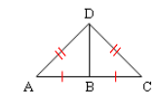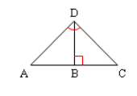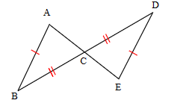

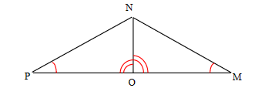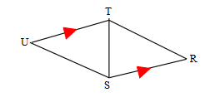 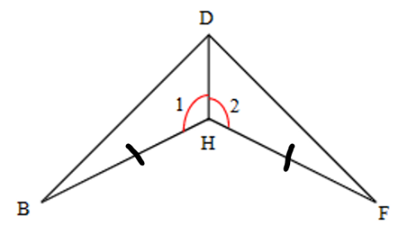

b. Given: , line *l* bisects  at *Q*

Prove: 

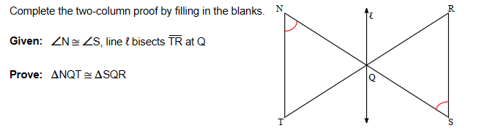

c. Given:  and 

Prove: 

