Section 4.5 Proofs Using Congruent Triangles

# Objective 1: Use Triangle Congruence and Corresponding Parts of Congruent Triangles to Prove that Parts of Two Triangles are Congruent

We have learned to prove two triangles are congruent using three congruent parts of the two triangles (SSS, SAS, ASA, AAS). Once we have proven that two triangles are congruent, we know that the other corresponding parts of these congruent triangles are congruent. For example, if we prove two triangles are congruent using SSS, we then know that the three pairs of corresponding angles are also congruent.

In proofs, we sometimes abbreviate the statement “Corresponding parts of congruent triangles are congruent” with **cpoctac**.

a. Given:  and 

Prove:  bisects 

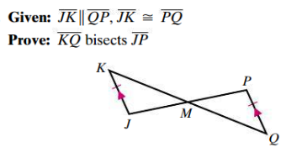

b. Given:  and 

Prove: 

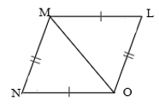

# Objective 2: Prove Two Triangles are Congruent Using Other Congruent Triangles

When working with triangles that overlap, it is sometimes easier to separate and redraw the triangles so that they do not overlap.

a. Identify a pair of overlapping congruent triangles in the diagram and explain why they must be congruent based on the given information.

i. Given: , , and 

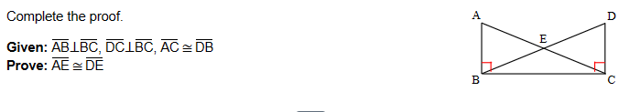

ii. Given:  and 

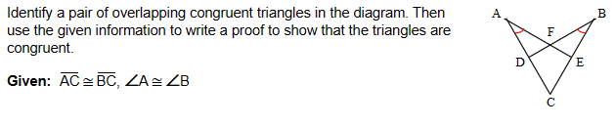

Some proofs may require that one pair of triangles must be proven congruent before any other pairs of triangles can be proven congruent.

b. Given:  and *D* is the midpoint of 

Prove: 

segments G C and A E intersect at point D.  segments G E and A C are drawn forming triangle E D G and triangle A D C.
Segment  B F is drawn through point D with point B on segment G E and point B on segment A C.

c. Given: ,  and  and  are right angles.

Prove: 

