Section 4.6 Rational Functions and Their Graphs

***Definition*:** A **rational function** is a function of the form  where *g* and *h* are polynomial functions such that If  where *c* is a real number, then we will consider the function  to be a polynomial.

# Objective 1: Finding the Domain and Intercepts of Rational Functions

Rational functions are defined for all values of *x* **except** those for which the denominator is equal to zero.

If has a *y-*intercept, it can be found by evaluating provided that is defined.

If  has any *x-*intercepts, they can be found by solving the equation(provided that *g* and *h* do not share a common factor).

# Objective 2: Identifying Vertical Asymptotes

***Definition*:** The vertical line is a **vertical asymptote** of a function if *at least* one of the following occurs:

1. 
2. 
3. 
4. 

The figures below illustrate each of these cases.

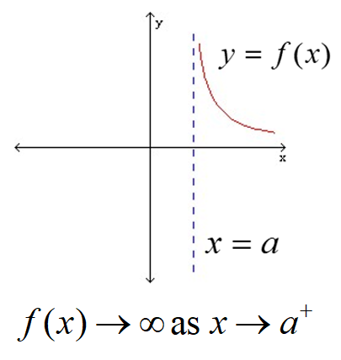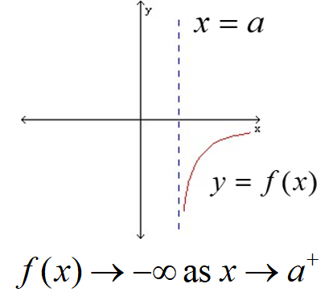 the graph of the function f just to the left of the line x equals a:  a small curve with one end pointing left, rising slightly at first and then more and more quickly as the curve gets closer and closer to the line x equals a
the graph of the function f just to the left of the line x equals a:  a small curve with one end pointing left, rising slightly at first and then more and more quickly as the curve gets closer and closer to the line x equals a


A rational function of the form where and have no common factors will have a vertical asymptote at  if .

 **It is essential to cancel any common factors before locating the vertical asymptotes**.

 **If there is an *x-*intercept near the vertical asymptote, it is essential to choose a test value that is between the *x­-*intercept and the vertical asymptote.**

# Objective 3: Identifying Horizontal Asymptotes

***Definition*:** A horizontal line  is a **horizontal asymptote** of a function *f* if the values of approach some fixed number *H* as the values of *x* approach  or .

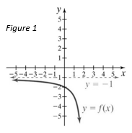 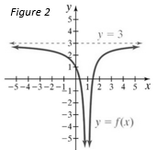 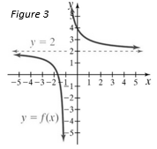

In Figure 1 above on the left, the line  is a horizontal asymptote because the values ofapproach as *x* approaches .

In Figure 2 above in the middle, the line is a horizontal asymptote because the values ofapproach 3 as *x* approaches .

In Figure 3 above on the right, the line is a horizontal asymptote because the values ofapproach 2 as *x* approaches .

**Properties of Horizontal Asymptotes of Rational Functions**

* Although a rational function can have many vertical asymptotes, it can have at most one horizontal asymptote.
* The graph of a rational function will never intersect a vertical asymptote but may intersect a horizontal asymptote.
* A rational function  that is written in lowest terms (all common factors of the numerator and denominator have been cancelled) will have a horizontal asymptote whenever the degree of is greater than or equal to the degree of .

**Finding Horizontal Asymptotes of a Rational Function**

Let ,  where *f* is written in lowest terms, *n* is the degree of *g*, and *m* is the degree of *h*.

* If , then  is the horizontal asymptote.
* If , then the horizontal asymptote is , the ratio of the leading coefficients.
* If , then there are no horizontal asymptotes.

# Objective 4: Using Transformations to Sketch the Graphs of Rational Functions

**The graphs of**  **and** 

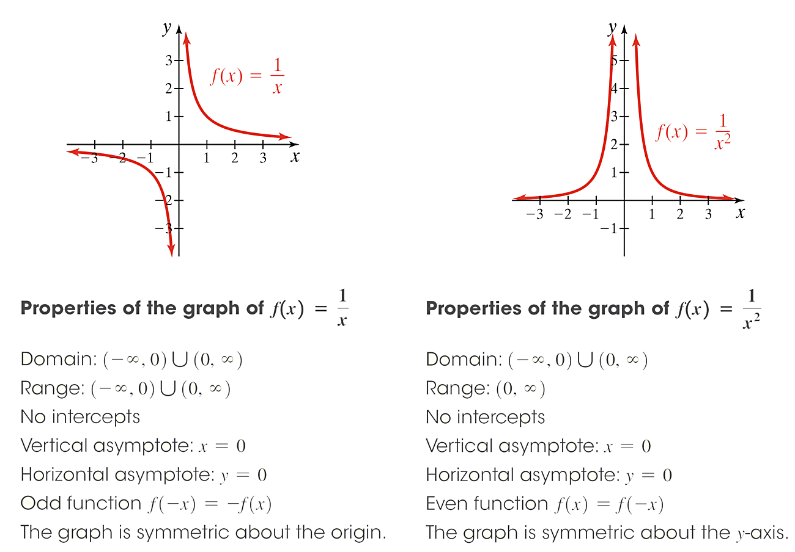 

**Properties of the graphs of**  and 

1. Domain: 
2. Range of : 

Range of : 

1. No intercepts
2. Vertical Asymptote: 
3. Horizontal Asymptote: 
4. is an odd function. Its graph is symmetric about the origin and .is an even function. Its graph is symmetric about the *y*-axis and .

# Objective 5: Sketching Rational Functions Having Removable Discontinuities

A rational function may sometimes have a “hole” in its graph. In calculus, these “holes” are called **removable discontinuities.**  Removable discontinuities occur when and share a common factor.

# Objective 7: Sketching Rational Functions

**Steps for Graphing Rational Functions of the Form**

1. Find the domain.
2. If and have common factors, cancel all common factors determining the *x-*coordinates of any removable discontinuities and rewrite *f* in lowest terms.
3. Check for symmetry.
4. If , then the graph of is *odd* and thus symmetric about the origin.
5. If , then the graph of is *even* and thus symmetric about the *y*-axis.
6. Find the *y­-*intercept by evaluating.
7. Find the *x*-intercepts by finding the zeros of the numerator of *f*, being careful to use the new numerator if a common factor has been removed.
8. Find the vertical asymptotes by finding the zeros of the denominator of *f*, being careful to use the new denominator if a common factor has been removed. Use test values to determine the behavior of the graph on each side of the vertical asymptotes.
9. Determine if the graph has any horizontal asymptotes.
10. Plot points, choosing values of *x* between each intercept and choosing values of *x* on either side of the all vertical asymptotes.
11. Complete the sketch.