Section 4.6 Isosceles, Equilateral, and Right Triangles

# Objective 1: Use Properties of Isosceles and Equilateral Triangles

If an isosceles triangle has exactly two congruent sides, then these two sides are its legs. The third side is the base. The angle opposite the base is the **vertex angle.** The other two angles adjacent to the base (and opposite the legs) are the **base angles**.

**Theorem: Isosceles Base Angles Theorem**

If two sides of a triangle are congruent, then the angles opposite those sides are congruent.

a. Prove the Isosceles Base Angles Theorem

**Theorem: Converse of the Isosceles Base Angles Theorem**

If two angles of a triangle are congruent, then the sides opposite those angles are congruent.

*The proof of the Converse of the Isosceles Base Angles Theorem is left as an exercise.*

b. Use the figure below to answer the following:

i. Which segment is congruent to ? Explain.

ii. Which segment is congruent to  and ?

iii. Why is ?

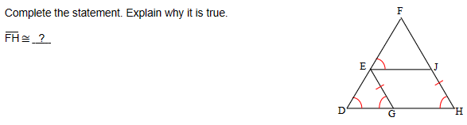

**Theorem: Perpendicular Bisector of the Base of an Isosceles Triangle**

If a line bisects the vertex angle of an isosceles triangle, then the line is also the perpendicular bisector of the base.

*To prove this theorem, start by constructing the angle bisector of the vertex angle of an isosceles triangle. The completion of this proof is left as an exercise.*

**Corollary: If Equilateral then Equiangular Triangle**

If a triangle is equilateral, then the triangle is equiangular.

**Corollary: If Equiangular then Equilateral Triangle**

If a triangle is equiangular, then the triangle is equilateral.

*The above corollaries are quickly proven using the Isosceles Base Angles Theorem and its converse.*

c. Use the figure below to answer the following questions:

i. If  inches and inches, what is ?

ii. Which angle is congruent to ?

iii. What is the measure of angle 1?

iv. If the measure of angle C is 63 degrees, what is ?

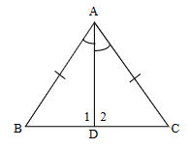

d. What is the measure of angle ABC?

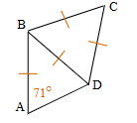

e. Given:  and 

Prove:  is isosceles.

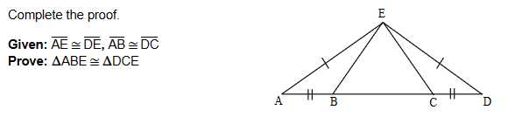

# Objective 2: Use Properties of Right Triangles

In a right triangle, the side opposite the right angle is called the hypotenuse. It is the longest side in the triangle. The other two sides are called legs.

**Theorem: Hypotenuse-Leg (H-L) Theorem**

If the hypotenuse and a leg of one right triangle are congruent to the hypotenuse and a leg of another right triangle, then the triangles are congruent.

*The proof of the H-L Theorem uses previously learned constructions and postulates and previously proven theorems and is left as an exercise.*

The Hypotenuse-Leg Theorem is a special instance of Side-Side-Angle (SSA) where the angle is a right angle. There is no SSA congruence postulate or theorem for triangles in general.

a. Is there enough information to prove the triangles are congruent? If so, write the congruence statement.

i. 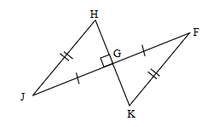 ii. 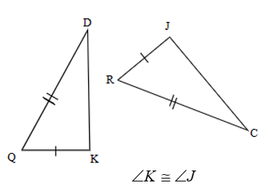

b. Given:  is isosceles with base 

 and 

*K* is the midpoint of 

Prove: 

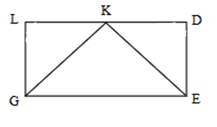

e. Find the values of the variables.

