Section 5.1a Exponential Functions

# Objective 1: Understanding the Characteristics of Exponential Functions

***Definition*:** An **exponential function** is a function of the form where *x* is any real number and such that . The constant, *b*, is called the base of the exponential function.

**Characteristics of Exponential Functions**

For , , the exponential function with base *b* is defined by .

The domain of is  and the range is . The graph of has one of the

following two shapes depending on the value of *b*:

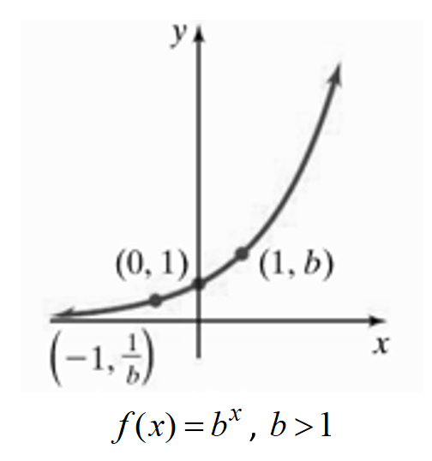 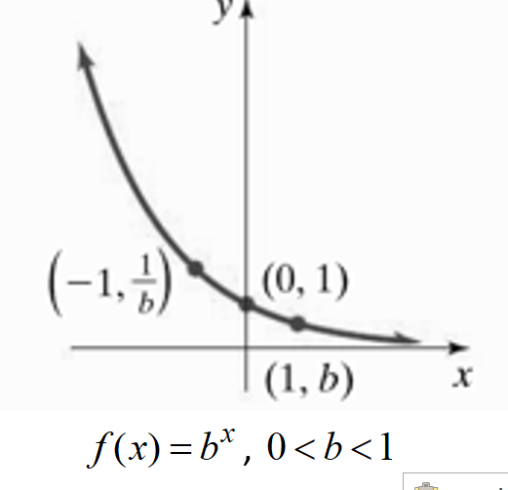

The graph of , , , has the following properties:

1. The graph intersects the *y-*axis at .
2. The graph contains the points  and .
3. If , then  as  and  as .

If , then  as  and  as .

1. The line  is a horizontal asymptote.
2. The function is one-to-one.

The number *e* is an irrational number that is defined as the value of the expression as *n* approaches infinity. The table below on the left shows the values of the expression  for increasingly large values of *n.* As the values of *n* get large, the value *e* (rounded to 6 decimal places) is 2.718281.

The function  is called the **natural exponential function.** The graph below on the right shows that the graph of  lies between the graphs of  and  when graphed on the same coordinate system.

|  |  |
| --- | --- |
| ***n*** |  |
| 1 | 2 |
| 2 | 2.25 |
| 10 | 2.5937424601 |
| 100 | 2.7048138294 |
| 1000 | 2.7169239322 |
| 10,000 | 2.7181459268 |
| 100,000 | 2.7182682372 |
| 1,000,000 | 2.7182804693 |
| 10,000,000 | 2.7182816925 |
| 100,000,000 | 2.7182818149 |

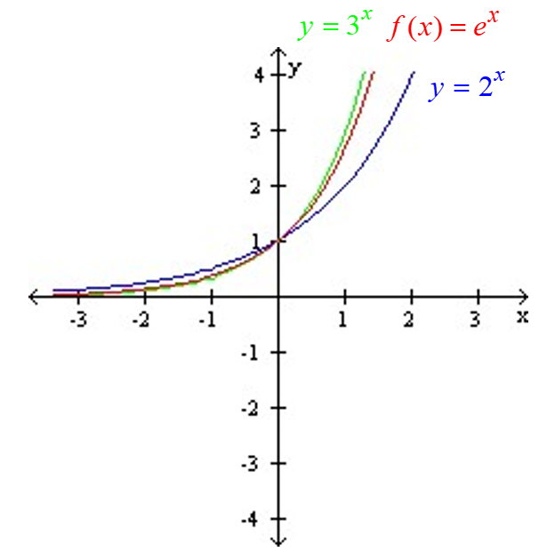

**Characteristics of the Natural Exponential Function**

The Natural Exponential Function is the exponential function with base *e* and is defined as . The domain of is  and the range is .

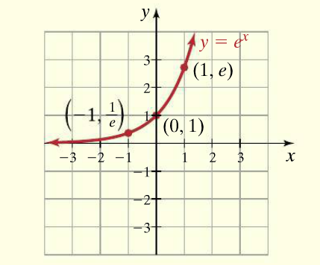

The graph of  intersects the *y-*axis at .

The graph contains the points  and .

 as  and  as .

The line  is a horizontal asymptote.

The function is one-to-one.

# Objective 2: Sketching the Graphs of Exponential Functions Using Transformations

The graph of can be obtained by vertically shifting the graph of  down one unit.The function  is graphed below on the left. It contains the points , and  and has horizontal asymptote . To shift the graph of this function down one unit, subtract 1 from each of the *y*-coordinates of the points on the graph. The resulting graph of , shown below on the right, contains the points , and  and has horizontal asymptote .

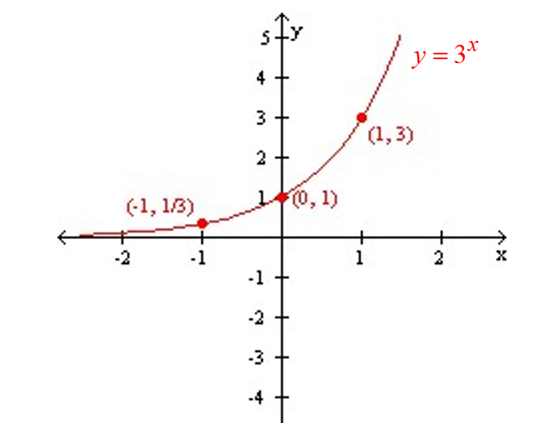 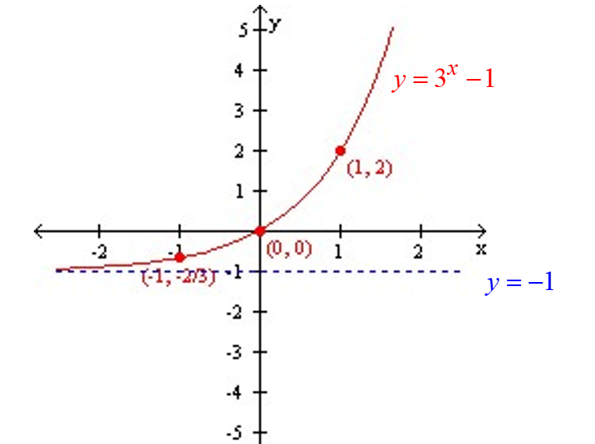

# Objective 3: Solving Exponential Equations by Relating the Bases

The functionis one-to-one because the graph of *f* passes the horizontal line test. Therefore, if the bases of an exponential equation of the form  are the same, then the exponents must also be the same.

To solve an exponential equation using the **Method of Relating the Bases,** first rewrite the equation in the form . Then .

Note that not all exponential equations can be written in the form . Other methods for solving exponential equations will be discussed in Section 5.4.