Section 5.2 Logarithmic Functions

# Objective 1: Understanding the Definition of a Logarithmic Function

Every exponential function of the form , where  and , is one-to-one and thus has an inverse function. The graph of and its inverse, , are shown below. Recall from Section 5.1, the graph of  contains the points , and , and since as , the *x*-axis is a horizontal asymptote for the graph. Recall from Section 3.6 that the graph of  is obtained by reflecting the graph of *f* about the line . Therefore, the graph of  will contain the points , and , and the *y*-axis will be a vertical asymptote for the graph.

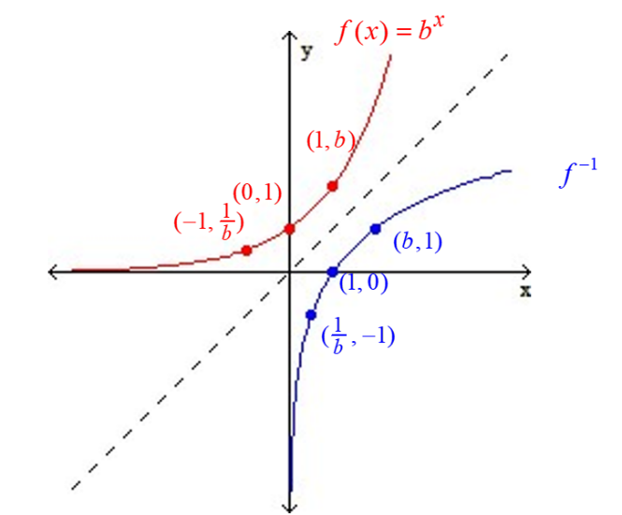

To find the equation of , we begin with the process from Section 3.6:

**Step 1: Change to *y*:** 

**Step 2: Interchange *x* and *y*: **

**Step 3: Solve for *y*:** ??

Before we can solve for *y*, we must introduce the following definition:

***Definition*:** For , the **logarithmic function with base *b*** is defined by  if and only if ****.

**Step 3. Solve for *y*: ** can be written as 

**Step 4. Change *y* to :** 

# Objective 2: Evaluating Logarithmic Expressions

The expression is the exponent to which *b* must be raised to in order to get *x.*

# Objective 3: Understanding the Properties of Logarithms

**General Properties of Logarithms**

For ,

(1)  and

(2) .

**Cancellation Properties of Exponentials and Logarithms**

For ,

(1)  and

(2) .

# Objective 4: Using the Common and Natural Logarithms

***Definition*:** For the **common logarithmic function** is defined by  if and only if **.**

***Definition*:** For the **natural logarithmic function** is defined by  if and only if **.**

# Objective 5: Understanding the Characteristics of Logarithmic Functions

**Characteristics of Logarithmic Functions**

For , the logarithmic function with base *b* is defined by .

The domain of is  and the range is . The graph of has one of the following two shapes depending on the value of *b*:

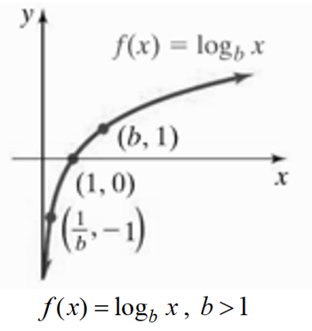 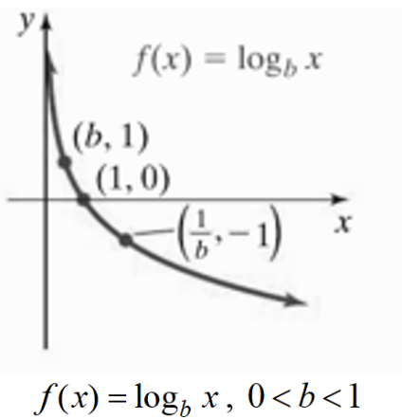

The graph of , has the following properties:

1. The graph intersects the x-axis at (1,0).
2. The graph contains the points (*b,*1) and .
3. If , the graph is increasing on the interval $\left(0,∞\right)$.

If , the graph is decreasing on the interval $\left(0,∞\right)$.

1. The *y*-axis (*x* = 0) is a vertical asymptote.
2. The function is one-to-one.

# Objective 6: Sketching the Graphs of Logarithmic Functions Using Transformations

# Objective 7: Finding the Domain of Logarithmic Functions

If , then the domain of *f* can be found by solving the inequality.