Section 5.2 Logarithmic Functions

# Objective 1: Understanding the Definition of a Logarithmic Function

Every exponential function of the form , where  and , is one-to-one and thus has an inverse function. The graph of and its inverse, , are shown below. Recall from Section 5.1, the graph of  contains the points , and , and since as , the *x*-axis is a horizontal asymptote for the graph. Recall from Section 3.6 that the graph of  is obtained by reflecting the graph of *f* about the line . Therefore, the graph of  will contain the points , and , and the *y*-axis will be a vertical asymptote for the graph.

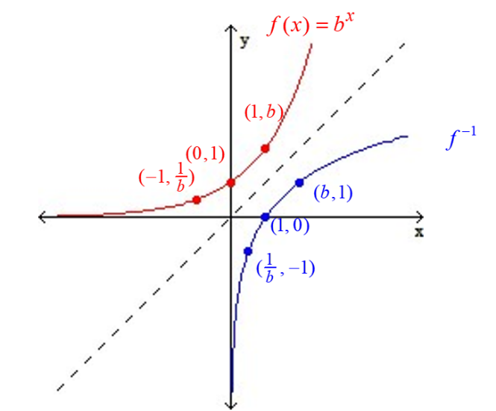

To find the equation of , we begin with the process from Section 3.6:

**Step 1: Change to *y*:** 

**Step 2: Interchange *x* and *y*: **

**Step 3: Solve for *y*:** ??

Before we can solve for *y*, we must introduce the following definition:

***Definition*:** For , the **logarithmic function with base *b*** is defined by  if and only if ****.

**Step 3. Solve for *y*: ** can be written as 

**Step 4. Change *y* to :** 

# Review of Rules of Exponents and Rewriting an Expression in the Form

See Section 5.1a.

# Review of Evaluating Expressions with Negative and Rational Exponents

***LSU Videos “Negative Exponents” and “Rational Exponents”*** *(0:00 – 16:30) are found on the course website.*

# Objective 2: Evaluating Logarithmic Expressions

The expression is the exponent to which *b* must be raised to in order to get *x.*

# Objective 3: Understanding the Properties of Logarithms

**General Properties of Logarithms**

For ,

(1)  and

(2) .

**Cancellation Properties of Exponentials and Logarithms**

For ,

(1)  and

(2) .

# Objective 4: Using the Common and Natural Logarithms

***Definition*:** For the **common logarithmic function** is defined by  if and only if **.**

***Definition*:** For the **natural logarithmic function** is defined by  if and only if **.**

# Objective 5: Understanding the Characteristics of Logarithmic Functions

**Characteristics of Logarithmic Functions**

For , the logarithmic function with base *b* is defined by .

The domain of is  and the range is . The graph of has one of the following two shapes depending on the value of *b*:

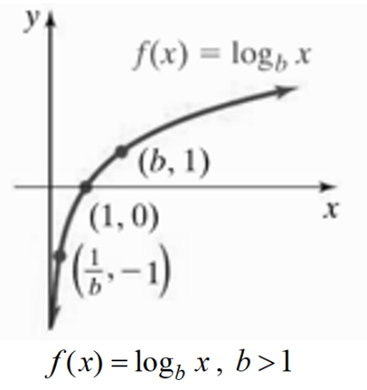 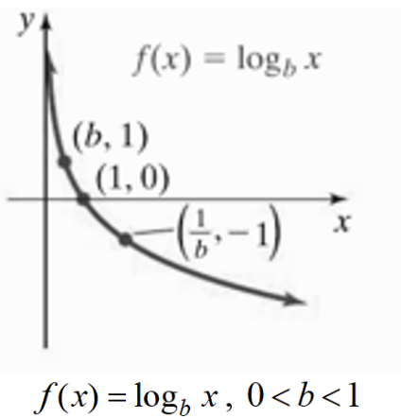

The graph of ,  has the following properties:

1. The graph intersects the *x*-axis at .
2. The graph contains the points  and .
3. If , the graph is increasing on the interval .

If , the graph is decreasing on the interval .

1. The *y*-axis (**) is a vertical asymptote.
2. The function is one-to-one.

# Review of Using Transformations to Graph Functions

See Section 3.4.

# Objective 6: Sketching the Graphs of Logarithmic Functions Using Transformations

The graph of can be obtained by horizontally shifting the graph of  to the right one unit.The graph of the function  is shown below on the left. It contains the points , and  and has vertical asymptote . To shift the graph of this function right one unit, add 1 to each of the *x*-coordinates of the points on the graph. The resulting graph of , shown below on the right, contains the points , and  and has vertical asymptote . The domain of is  and the range is .

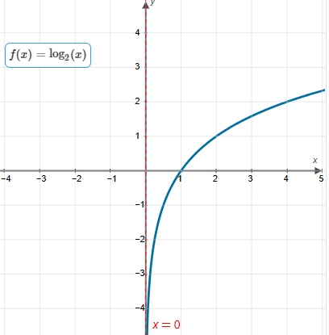 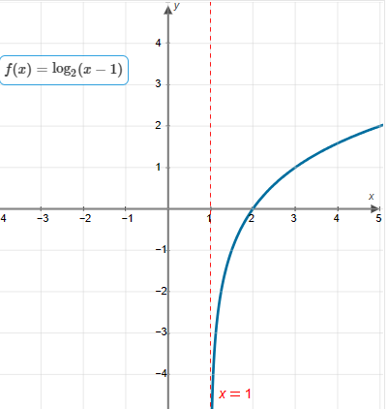

# Review of Solving Linear Inequalities of the form

See Section 1.7.

# Objective 7: Finding the Domain of Logarithmic Functions

If , then the domain of *f* can be found by solving the inequality.