Section 5.3 Medians and Altitudes of a Triangle

# Objective 1: Use Properties of the Medians of a Triangle

A **median of a triangle** is a segment whose endpoints are a vertex and the midpoint of the opposite side. A triangle’s three medians are always concurrent.

**Theorem: Concurrency of Medians Theorem**

The medians of a triangle are concurrent at a point that is two-thirds the distance from each vertex to the midpoint of the opposite side.

*The proof of this theorem is left as an exercise.*

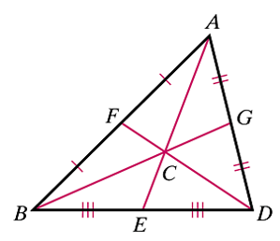

In the figure above, , , and .

In a triangle, the point of concurrency of the medians is called the **centroid of the** **triangle**, also known as the *center of gravity* of the triangle because it is the point where a triangular shape of uniform thickness will balance. The centroid is always inside the triangle.

a.  is isosceles with base and centroid *X* . If, , and , find the perimeter of . (Figure not drawn to scale.)

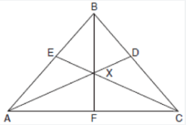

b. A triangle has vertices with coordinates , , and .

i. Find the coordinates of *M*, the midpoint of side .

ii. Find the length of median .

iii. Find the coordinates of the centroid, *P*.

# Objective 2: Use Properties of the Altitudes of a Triangle

An **altitude of a triangle** is the perpendicular segment from a vertex of the triangle to the line containing the opposite side. An altitude of a triangle can be inside or outside the triangle, or it can be a side of the triangle.

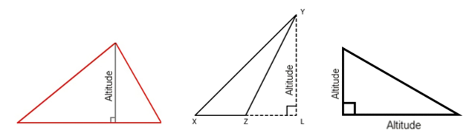

**Theorem: Concurrency of Altitudes Theorem**

The lines that contain the altitudes of a triangle are concurrent.

*The proof of this theorem is left as an exercise.*

The lines that contain the altitudes of a triangle are concurrent at the **orthocenter of the triangle**. The orthocenter of a triangle can be inside, on, or outside the triangle.

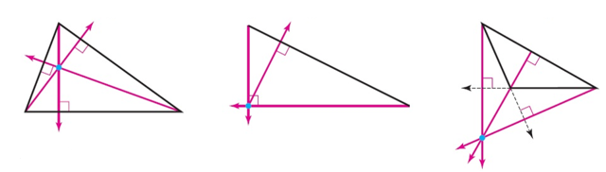

a. Given the figure below,

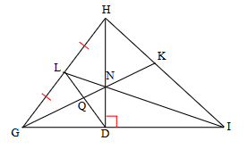

i. Name a median of and a median of .

ii. Name an altitude of and an altitude of .

b. Identify the centroid and the orthocenter of .

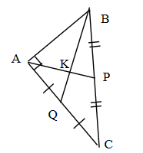

c. Find the coordinates of the orthocenter in the triangle with coordinates , , and .

d. Segments  and  are altitudes, and . Find .

