Section 5.4 Midsegments of Triangles

# Objective 1: Use Properties of Midsegments of Triangles

A **midsegment of a triangle** is a segment connecting the midpoints of two sides of the triangle.

**Theorem: Triangle Midsegment Theorem**

If a segment joins the midpoints of two sides of a triangle, then the segment is parallel to the third side and is half as long.

*The proof of this theorem is left as an exercise.*

a. Name the midsegments and sides that are parallel. Then write, in equation form, the relationships between the lengths of the midsegments and the lengths of the sides of the triangle.

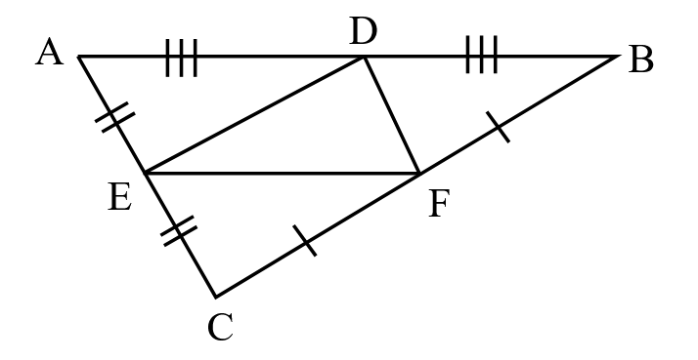

b. Find *x* and *y*.

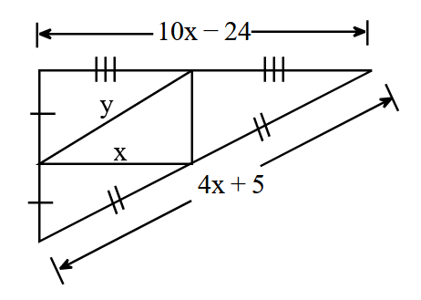

c. In the figure, *X* is the midpoint of , *Y* is the midpoint of , and *T* is the midpoint of . If  and , find  and .

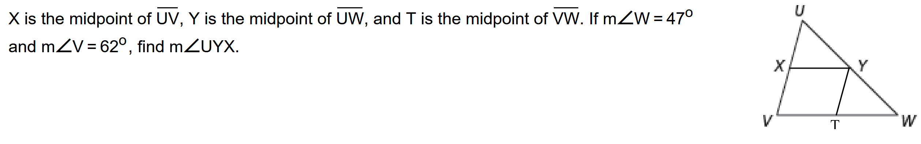

# Objective 2: Use Coordinate Geometry with Midsegments

a. Find the coordinates of the midpoint *H* of  and the coordinates of the midpoint *J* of . Show that  is parallel to , and then show . *This example verifies, but does not prove, the Triangle Midsegment Theorem.*

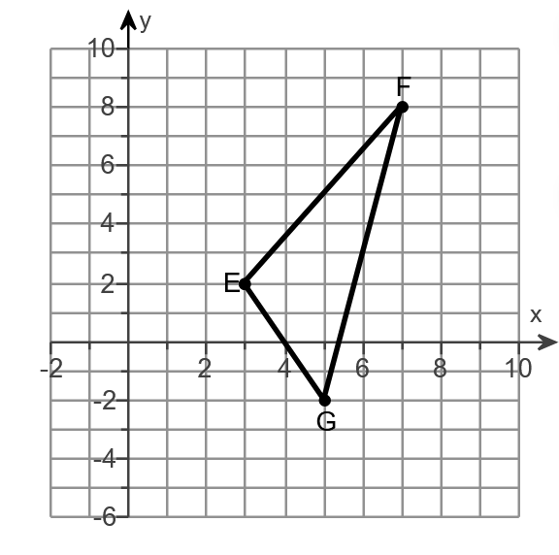

# Objective 3: Solve Applications of Midsegments

a. You want to paddle your kayak across a lake. To determine how far you must paddle, you pace out a triangle counting the number of strides as shown in the figure.

i. If your strides average 3.5 ft, what is the length of the longest side of the triangle.

ii. What distance in feet must you paddle across the lake?

