Section 5.5 Applications of Exponential and Logarithmic Functions

# Objective 1: Solving Compound Interest Applications

The **Periodic Compound Interest Formula** is, where *A* is the total amount in the account after *t* years, *P* is the principal (original investment amount), *r* is the annual interest rate as a decimal, and *n* is the number of times interest is compounded per year.

The **Continuous Compound Interest Formula** is, where *A* is the total amount in the account after *t* years, *P* is the principal (original investment amount), and *r* is the annual interest rate as a decimal.

# Objective 2: Exponential Growth and Decay Applications

**Exponential Growth**

A model that describes the population, *P*, after a certain time, *t,* iswhere is the initial population and is a constant called the **relative growth rate**. (Note: *k* may be given as a percent.)

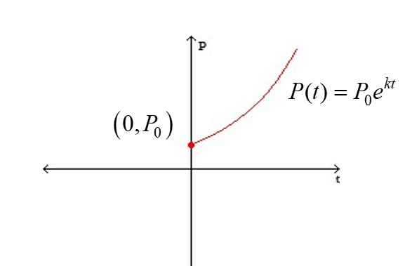

**Exponential Decay**

A model that describes the exponential decay of a population, quantity or amount *A*, after a certain time, *t,* iswhere is the initial quantity and is a constant called the **relative decay constant**. (Note: *k* is sometimes given as a percent.)

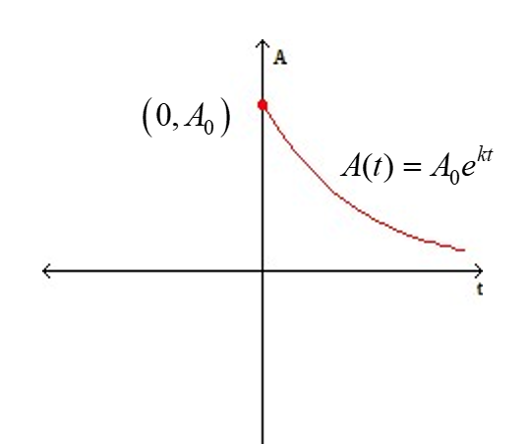

**Half-Life:** Every radioactive element has a half-life, which is the required time for a given quantity of that element to decay to half of its original mass.