Section 5.5 Indirect Proofs and Inequalities in One Triangle

# Objective 1: Use Indirect Reasoning to Write Proofs

In **indirect reasoning**, all possibilities are considered and then all but one are proven false. The remaining possibility must be true.

A proof involving indirect reasoning is an **indirect proof**. These are the basic steps for writing an indirect proof:

1. Identify the statement you are trying to prove is true.
2. Assume that the *opposite* of the statement in step 1 is true.
3. Logically try to prove that the statement in step 2 is true, but a *contradiction* should occur.
4. If you arrive at a contradiction, then the statement is step true is false. Thus, the original statement we wanted to prove (step 1) must be true.

An indirect proof is sometimes called a *proof by contradiction*.

a. Suppose you want to write an indirect proof of each statement. What should you assume as the second step of the proof?

i.  is equilateral.

ii. At least one angle in a given figure is a right angle.

b. In each of the following, determine which two of the three given statements contradict each other.

i. *A*, *B*, and *C* are coplanar.

 is an acute triangle.

*B* is the midpoint of .

ii. Each of the two items Elena purchased costs more than $13.

Neither of the two items Elena purchased costs more than $15.

Elena spent over $30 for the two items.

c. Given that is not congruent to  in the figure below, write an indirect proof that line *m* is not parallel to line *n*.

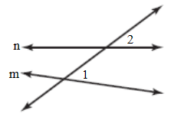

d. Write an indirect proof of the statement “A triangle has at most one right angle.”

# Objective 2: Learn the Triangle Relationship Between Length of a Side and Size of Its Opposite Angle

**Property: Comparison Property of Inequality**

If  and , then .

*This property is known from the study of algebra.*

**Corollary to the Triangle Exterior Angle Theorem**

The measure of an exterior angle of a triangle is greater than the measure of either of its remote interior angles.

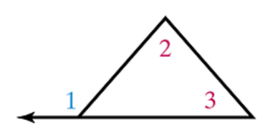

 and 

*Since the measures of the angles of a triangle are positive numbers, apply the Comparison Property of Inequality to the results of the Triangle Exterior Angle Theorem to prove this corollary.*

**Theorem: Triangle Inequality Theorem**

If two sides of a triangle are not congruent (one longer and one shorter), then the angle opposite the longer side is greater than the angle opposite the shorter side.

*The proof of this theorem uses the above property and corollary and is left as an exercise.*

**Theorem: Converse of the Triangle Inequality Theorem**

If two angles of one triangle are not congruent (one greater and one lesser), then the side opposite the greater angle is longer than the side opposite the lesser angle.

a. Prove the Converse of the Triangle Inequality Theorem.

b. List the angles of the triangle in order from smallest to largest.

i.  where , , and 

ii. The triangle shown below which is not drawn to scale.

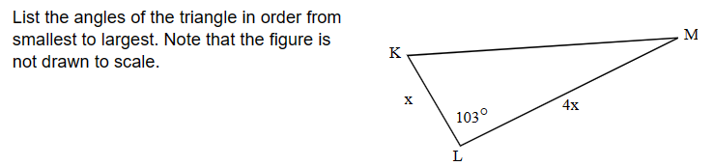

c. List the sides of  in order from shortest to longest given , , and .

d. What is the shortest segment in the figure, which is not drawn to scale?

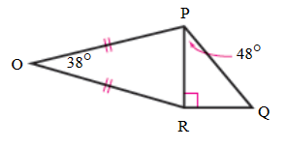

# Objective 3: Use the Triangle Inequality Theorem

**Theorem: Triangle Inequality Theorem for Sum of Lengths of Sides**

The sum of the lengths of any two sides of a triangle is greater than the length of the third side.

*The proof of this theorem is left as an exercise.*

a. Can a triangle have sides with the given lengths? Explain?

i. 4 inches, 8 inches, 20 inches

ii. 5 meters, 10 meters, 11 meters

b. A triangle has sides of lengths 11 centimeters and 12 centimeters. What can you say about the length of the third side?