Section 5.6 Inequalities in Two Triangles

# Objective 1: Use the Hinge Theorem and Its Converse to Compare Measures of Sides and Angles in Two Triangles

To extend the comparison of sides and angles within a single triangle to comparing sides and angles in two triangles, we will use the Hinge Theorem and its Converse. The Hinge Theorem is so named because it can be modeled using the opening of a door on hinges: When a door is opened, the door and the door frame do not change length. As the door is opened, the hinge angle increases, and so does the opening of the door (the distance from the end of the door to the frame).

**Theorem: The Hinge Theorem (SAS Inequality Theorem)**

If two sides of one triangle are congruent to two sides of another triangle and the included angles are not congruent, then the longer third side is opposite the larger included angle.

*The proof of this theorem requires a construction and congruent triangle postulates or theorems and is left as an exercise.*

**Theorem: Converse of the Hinge Theorem (SSS Inequality Theorem)**

If two sides of one triangle are congruent to two sides of another triangle and the third sides are not congruent, then the larger included angle is opposite the longer third side.

*The proof of this theorem is by contradiction, requires the Hinge Theorem, and is left as an exercise.*

a. Use the Hinge Theorem, its converse, or a congruence postulate or theorem to fill in the blank with >, <, or =. Figures not drawn to scale.

i.  

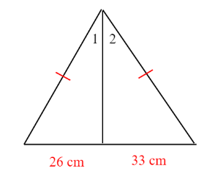

ii.  

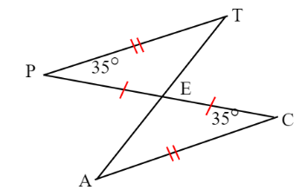

iii.  

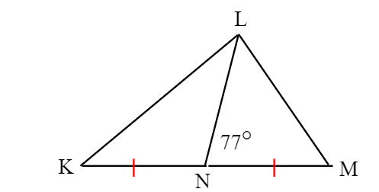

iv.  

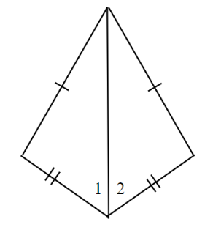

b. Find the range of possible values for the variable.

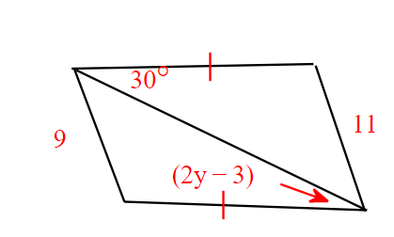

c. Ship A and Ship B leave from the same point in the ocean. Ship A travels 375 miles due west, turns 55° toward north, and then travels another 250 miles. Ship B travels 375 miles due east, turns 65° toward south, and then travels another 250 miles. Which ship is farther from the starting point? Explain.

d. Given: *E* is the midpoint of , , and 

Prove: 

